Unit 5 Lesson 19: Estimating a Hemisphere

1 Notice and Wonder: Two Shapes (Warm up)

Student Task Statement
Here are two shapes.
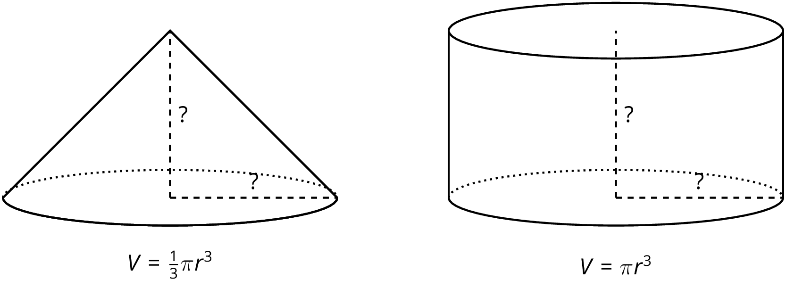
What do you notice? What do you wonder?

2 Hemispheres in Boxes

Student Task Statement
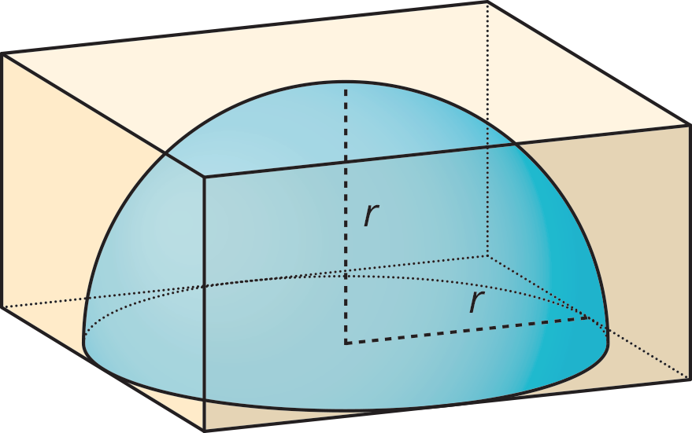
- Mai has a dome paperweight that she can use as a magnifier. The paperweight is shaped like a hemisphere made of solid glass, so she wants to design a box to keep it in so it won't get broken. Her paperweight has a radius of 3 cm.
  - What should the dimensions of the inside of box be so the box is as small as possible?
  - What is the volume of the box?
  - What is a reasonable estimate for the volume of the paperweight?
- Tyler has a different box with side lengths that are twice as long as the sides of Mai's box. Tyler's box is just large enough to hold a different glass paperweight.
  - What is the volume of the new box?
  - What is a reasonable estimate for the volume of this glass paperweight?
  - How many times bigger do you think the volume of the paperweight in this box is than the volume of Mai's paperweight? Explain your thinking.

3 Estimating Hemispheres

Images for Launch
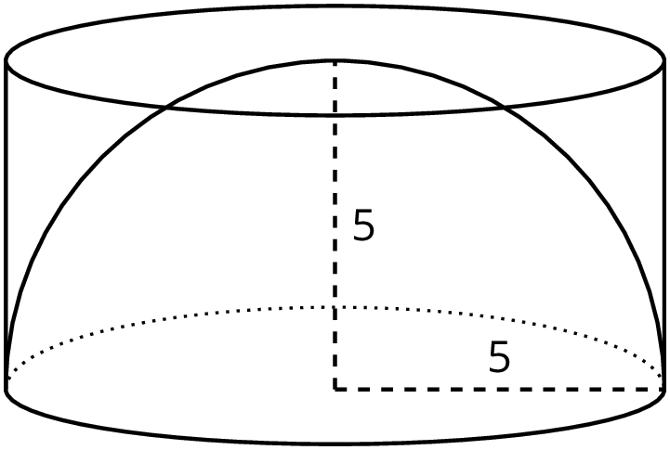

Student Task Statement
- A hemisphere with radius 5 units fits snugly into a cylinder of the same radius and height.
  - Calculate the volume of the cylinder.
  - Estimate the volume of the hemisphere. Explain your reasoning.
- A cone fits snugly inside a hemisphere, and they share a radius of 5.
- 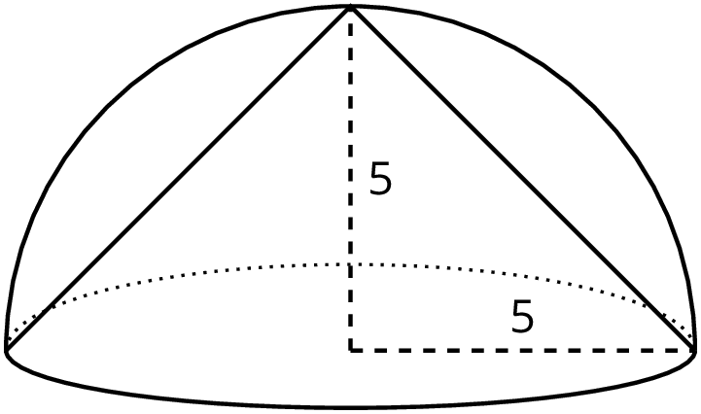
  - What is the volume of the cone?
  - Estimate the volume of the hemisphere. Explain your reasoning.
- Compare your estimate for the hemisphere with the cone inside to your estimate of the hemisphere inside the cylinder. How do they compare to the volumes of the cylinder and the cone?
© CC BY Open Up Resources. Adaptations CC BY IM.

