Unit 6 Lesson 17: Interpret Diagrams

WU Estimation Exploration: Fraction of a Whole Number (Warm up)

Student Task Statement
$\frac{5}{3}×9,​625$
Record an estimate that is:
too low | about right | too high

1 Match the Diagram

Student Task Statement
- Match the expressions and diagrams.
- $\frac{2}{7}×3$
- $\frac{9}{7}×3$
- $\frac{2}{7}×5$
- $\frac{9}{7}×5$
- 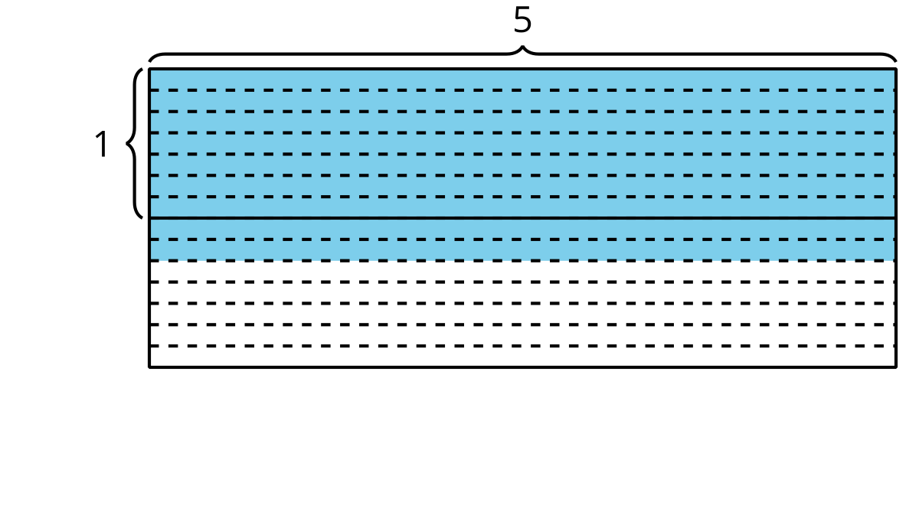
- 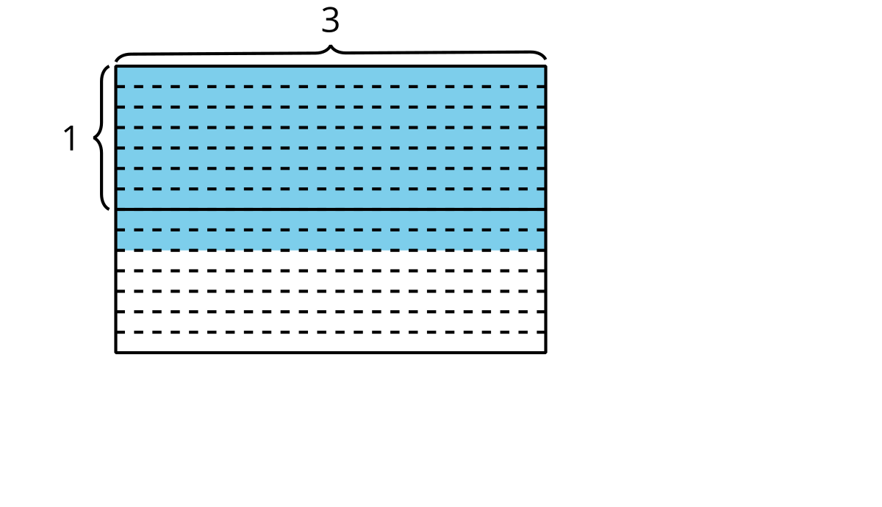
- 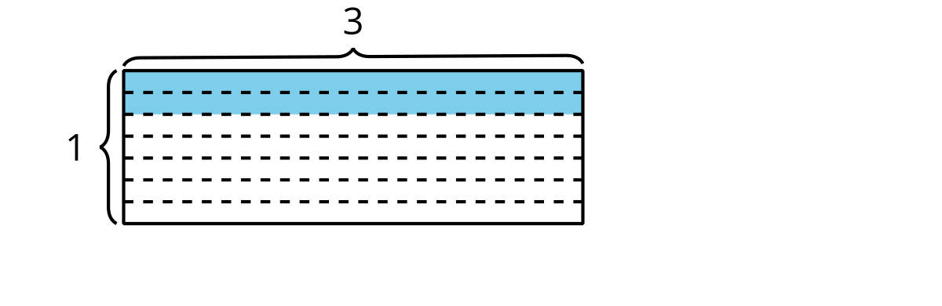
- 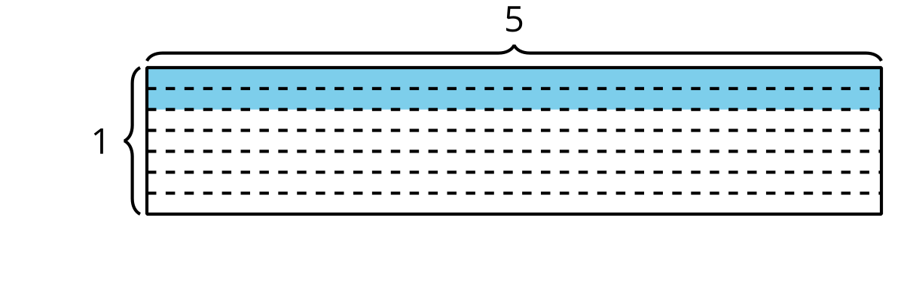
- Write $<$ or $>$ in each blank to make the inequality true.
  - $\frac{2}{7}×3 \underset{_}{} 3$
  - $\frac{9}{7}×3 \underset{_}{} 3$
  - $\frac{2}{7}×5 \underset{_}{} 5$
  - $\frac{9}{7}×5 \underset{_}{} 5$

2 Who Ran Farther?

Student Task Statement
- Priya ran to her grandmother’s house.
- Jada ran twice as far as Priya.
- Han ran $\frac{6}{7}$ as far as Priya.
- Clare ran $\frac{14}{8}$ as far as Priya.
- Mai ran $\frac{3}{5}$ times as far as Priya.
- Which students ran farther than Priya?$\underset{_}{}$
- Which students did not run as far as Priya?$\underset{_}{}$
- List the runners in order from shortest distance run to longest. Explain or show your reasoning.
- The point P represents how far Priya ran. Write the initial of each student in the blank that shows how far they ran. One of the students will be missing.
- Label the distance for the missing student on the number line above.
© CC BY 2021 Illustrative Mathematics®

