Unit 2 Lesson 19: End Behavior of Rational Functions

1 Different Divisions, Revisited (Warm up)

Student Task Statement
Complete all three representations of the polynomial division following the forms of the integer division.
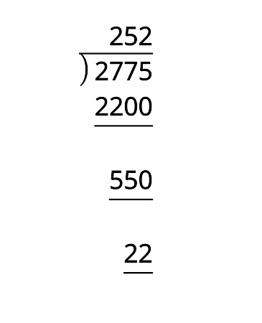
2x2+7x+55x+12x3+7x2+7x+5
$2775=11(252)+3$
$2x^{3}+7x^{2}+7x+5=$
$\frac{2775}{11}=252+\frac{3}{11}$
$\frac{2x^{3}+7x^{2}+7x+5}{x+1}=$

2 Combined Fuel Economy

Student Task Statement
In 2000, the Environmental Protection Agency (EPA) reported a combined fuel efficiency for cars that assumes 55% city driving and 45% highway driving. The expression for the combined fuel efficiency of a car that gets $x$ mpg in the city and $h$ mpg on the highway can be written as $\frac{100xh}{55x+45h}$.
- Several conventional cars have a fuel economy for highway driving is that is about 10 mpg higher than for city driving. That is, $h=x+10$. Write a function $f$ that represents the combined fuel efficiency for cars like these in terms of $x$.
- Rewrite $f$ in the form $q(x)+\frac{r(x)}{b(x)}$ where $q(x)$, $r(x)$, and $b(x)$ are polynomials.

3 Exploring End Behavior

Student Task Statement
function | degree  of num. | degree  of den. | rewritten in the form of  $q(x)+\frac{r(x)}{b(x)}$ | end behavior
$g(x)=\text{-}\frac{5}{x+2}$
$h(x)=\frac{7x−5}{x+2}$
$j(x)=\frac{3x^{2}+7x−5}{x+2}$
$k(x)=\frac{2x^{3}+3x^{2}+7x−5}{x+2}$
$m(x)=\frac{x+2}{2x^{3}+3x^{2}+7x−5}$
- Complete the table to explore the end behavior for rational functions.
- What do you notice about the end behavior of different types of rational functions?
© CC BY 2019 by Illustrative Mathematics

