Lesson 15: Identify Pennies, Nickels, and Dimes

Standards Alignments
Addressing | 2.MD.C.8, 2.NBT.A.2, 2.NBT.B.5, 2.NBT.B.6, 2.NBT.B.8
Building Towards | 2.MD.C.8

Teacher-facing Learning Goals
- Identify pennies, nickels, and dimes and know their values.
- Use skip counting and counting on by 5 and 10 to find the value of a set of coins.

Student-facing Learning Goals
- Let’s learn about coins and their values.

Lesson Purpose
The purpose of this lesson is for students to identify pennies, nickels, and dimes and find the total value of a set of coins.
In previous units, students learned to use a ten when adding or subtracting within 100. They also used counting on or counting back as a strategy when adding or subtracting, including counting on or counting back by 5 and 10.
In this lesson, students recognize dimes, nickels, and pennies and learn their values. Students find the value of a set of coins by adding within 100. They may also use skip counting or counting on to find the value of a set of coins. When finding total values of a mixed combination of coins, students may group like coins, use multiples of 10 to add within 100, or count on. Students use the cent symbol when writing total values of coin collections.

Access for:

Students with Disabilities
- Action and Expression (Activity 2)

English Learners
- MLR2 (Activity 2)

Instructional Routines
What Do You Know About _____? (Warm-up)

Materials to Gather
- Scissors: Activity 2

Materials to Copy
- Money Poster Images (groups of 0): Activity 1
- Coins to Cut and Count (groups of 1): Activity 2

Lesson Timeline
Warm-up | 10 min
Activity 1 | 20 min
Activity 2 | 15 min
Lesson Synthesis | 10 min
Cool-down | 5 min

Teacher Reflection Question
What did you learn about your students’ understanding of money during this lesson? What did you notice in their work from today’s lesson that you might leverage in that future lesson?

Cool-down
(to be completed at the end of the lesson) 5min
Do I Have Enough?

Standards Alignments
Addressing | 2.MD.C.8, 2.NBT.B.5

Student-facing Task Statement
Jada has a group of coins.
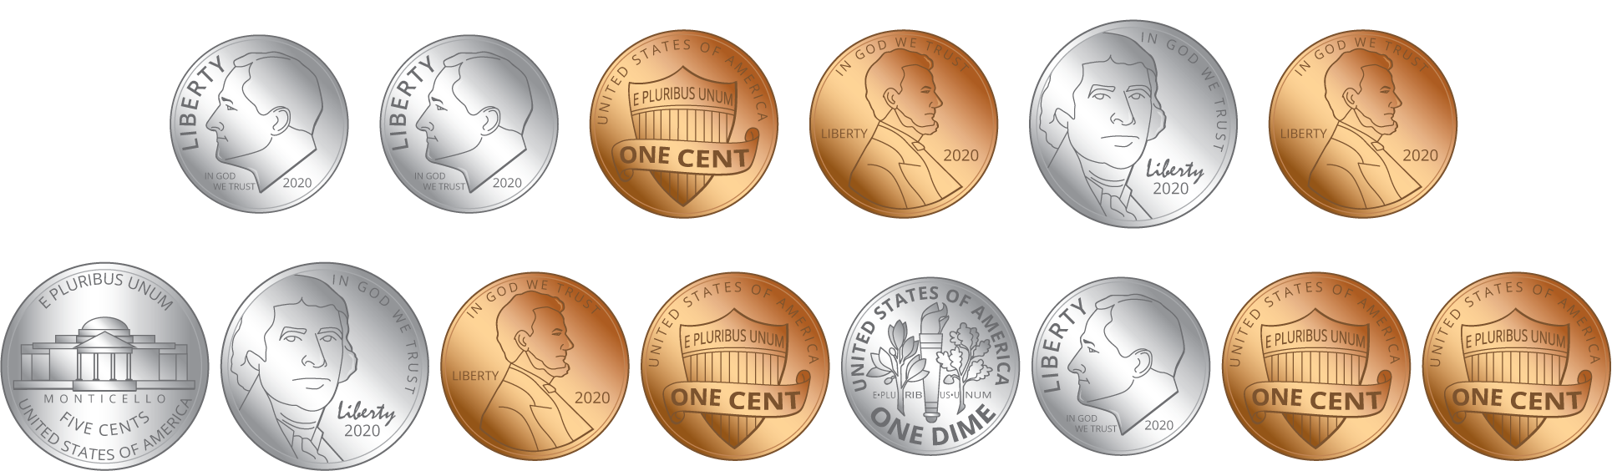
- How many pennies does Jada have? ___________
- How many nickels does Jada have? ___________
- How many dimes does Jada have? ___________
- What is the value of her coins? Show your thinking using numbers, words, drawings, or equations.

Student Responses
- 7 pennies
- 3 nickels
- 4 dimes
- Jada has 62¢. Sample response: $40+15+7=55+5+2=60+2=62$

