Unit 1 Lesson 8: More Questions about Scaled Bar Graphs

WU Number Talk: Repeated Addition (Warm up)

Student Task Statement
Find the value of each expression mentally.
- $2+2+2+2+2$
- $2+2+2+2+2+2$
- $5+5+5+5+5+5$
- $5+5+5+5+5+5+5$

1 New School Year

Student Task Statement
A group of students were asked, “How are you feeling about the new school year?” Their responses are shown in this bar graph:
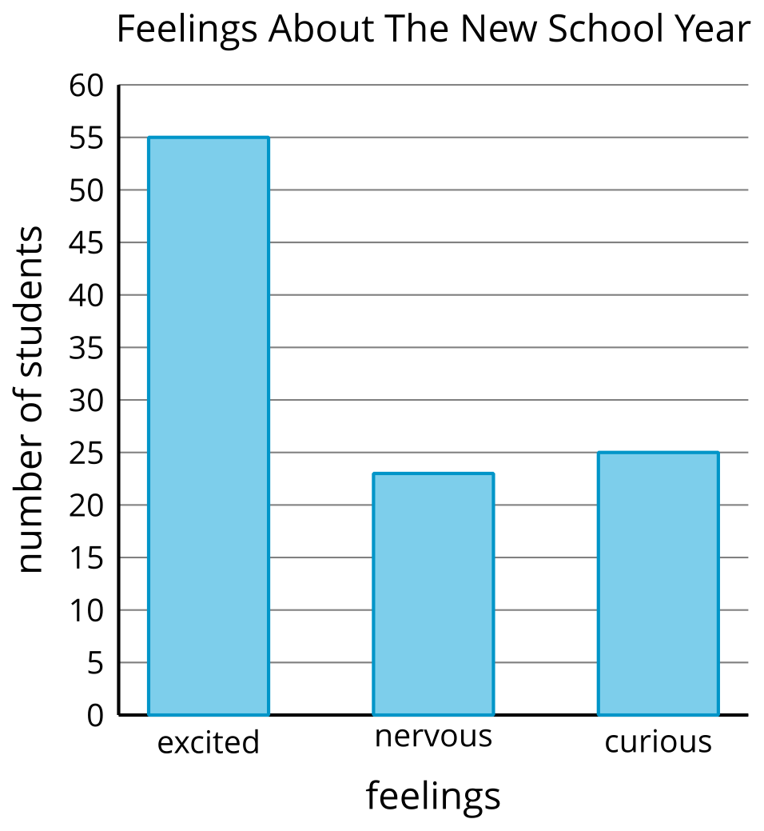
How many more students are excited about the new school year than are nervous or curious?

2 Use Bar Graphs to Solve Problems

Student Task Statement
The bar graph shows how many of each type of tree Clare saw on the way home. Use the graph to answer the questions. Show your thinking using expressions or equations.
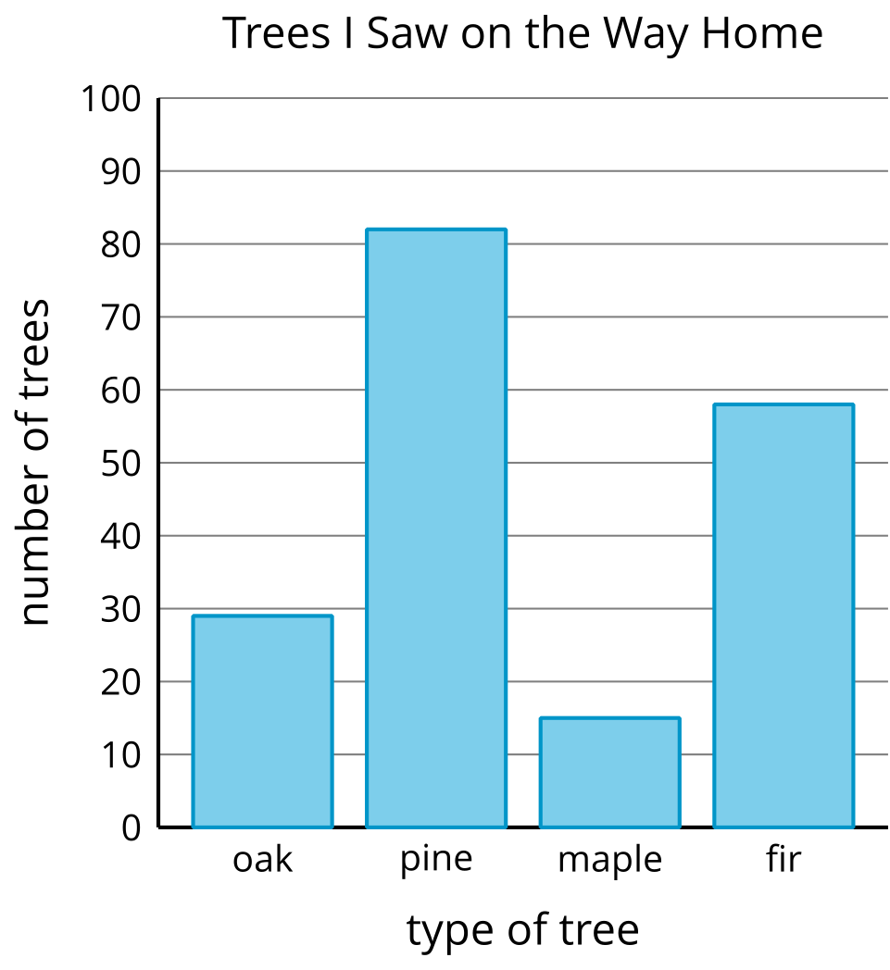
- How many more pine trees did Clare see than fir trees?
- How many more pine trees did Clare see than oak or maple trees?
- How many fewer oak trees did Clare see than pine trees?
- How many fewer maple or oak trees did Clare see than fir trees?
© CC BY 2021 Illustrative Mathematics®

