Unit 2 Lesson 6 Cumulative Practice Problems
- Triangle $DAC$ is isosceles with congruent sides $AD$ and $AC$. Which additional given information is sufficient for showing that triangle $DBC$ is isosceles? Select all that apply.
- 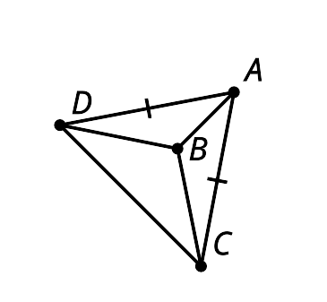
  - Line $AB$ is an angle bisector of $DAC$.
  - Angle $BAD$ is congruent to angle $ABC$.
  - Angle $BDC$ is congruent to angle $BCD$.
  - Angle $ABD$ is congruent to angle $ABC$.
  - Triangle $DAB$ is congruent to triangle $CAB$.
- Tyler has written an incorrect proof to show that quadrilateral $ABCD$ is a parallelogram. He knows segments $AB$ and $DC$ are congruent. He also knows angles $ABC$ and $ADC$ are congruent. Find the mistake in his proof.
- Segment $AC$ is congruent to itself, so triangle $ABC$ is congruent to triangle $ADC$ by Side-Angle-Side Triangle Congruence Theorem. Since the triangles are congruent, so are the corresponding parts, and so angle $DAC$ is congruent to $ACB$. In quadrilateral $ABCD$, $AB$ is congruent to $CD$ and $AD$ is parallel to $CB$. Since $AD$ is parallel to $CB$, alternate interior angles $DAC$ and $BCA$ are congruent. Since alternate interior angles are congruent, $AB$ must be parallel to $CD$. Quadrilateral $ABCD$ must be a parallelogram since both pairs of opposite sides are parallel.
- 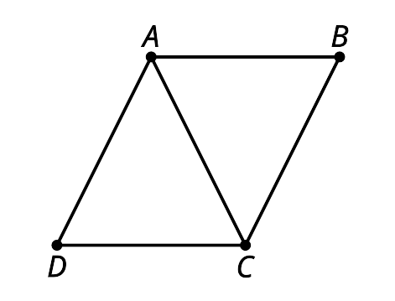
- Triangles $ACD$ and $BCD$ are isosceles. Angle $BAC$ has a measure of 18 degrees and angle $BDC$ has a measure of 48 degrees. Find the measure of angle $ABD$.

- $\overline{AD}≅\overline{AC}$ and $\overline{BD}≅\overline{BC}$
- 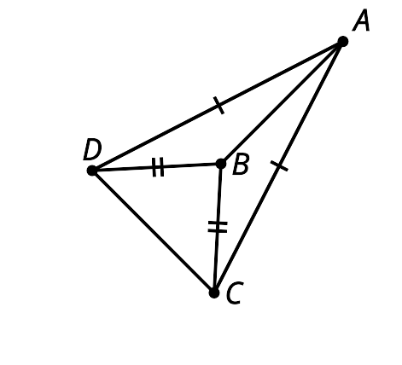
- Here are some statements about 2 zigzags. Put them in order to prove figure $ABC$ is congruent to figure $DEF$.
- 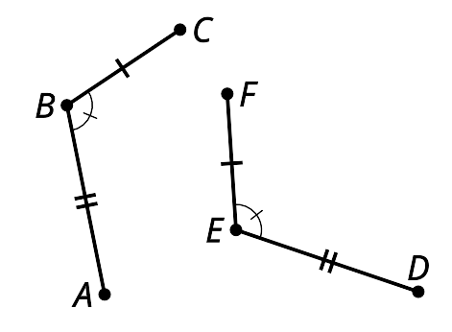
  - 1: If necessary, reflect the image of figure $ABC$ across $DE$ to be sure the image of $C$, which we will call $C^{′}$, is on the same side of $DE$ as $F$.
  - 2: $C^{′}$ must be on ray $EF$ since both $C^{′}$ and $F$ are on the same side of $DE$ and make the same angle with it at $E$.
  - 3: Segments $AB$ and $DE$ are the same length so they are congruent. Therefore, there is a rigid motion that takes $AB$ to $DE$. Apply that rigid motion to figure $ABC$.
  - 4: Since points $C^{′}$ and $F$ are the same distance along the same ray from $E$ they have to be in the same place.
  - 5: Therefore, figure $ABC$ is congruent to figure $DEF$.
- (From Unit 2, Lesson 5.)
- Match each statement using only the information shown in the pairs of congruent triangles.
  - The 2 angles and the included side of one triangle are congruent to 2 angles and the included side of another triangle.
  - In the 2 triangles there are 3 pairs of congruent sides.
  - The 2 sides and the included angle of one triangle are congruent to 2 sides and the included angle of another triangle.
  - 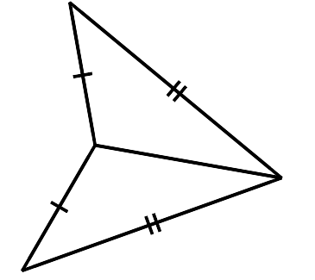
  - 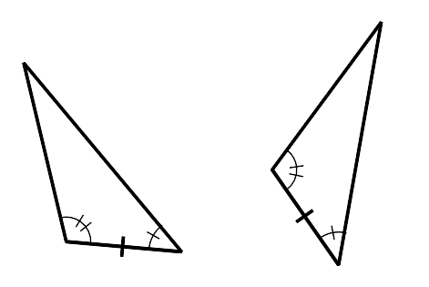
  - 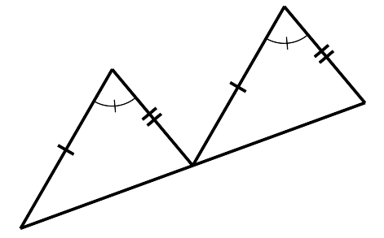
- (From Unit 2, Lesson 4.)
- Triangle $ABC$ is congruent to triangle $EDF$. So, Priya knows that there is a sequence of rigid motions that takes $ABC$ to $EDF$.
- Select all true statements after the transformations:
- 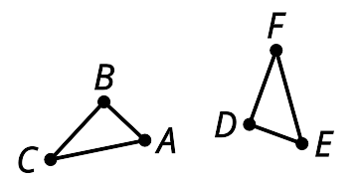
  - Segment $AB$ coincides with segment $EF$.
  - Segment $BC$ coincides with segment $DF$.
  - Segment $AC$ coincides with segment $ED$.
  - Angle $A$ coincides with angle $E$.
  - Angle $C$ coincides with angle $F$.
- (From Unit 2, Lesson 3.)
© CC BY 2019 by Illustrative Mathematics

