Lesson 4: Same Size, Related Sizes
- Let’s find some fractions that are the same size.

Warm-up: Notice and Wonder: A Fraction Strip and a Number Line
What do you notice? What do you wonder?
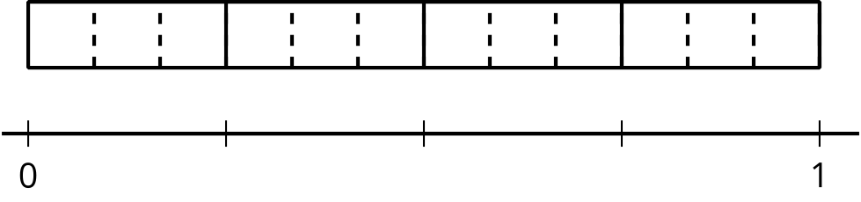

4.1: Same Size, Different Numbers
Here’s a diagram of fraction strips, with two strips added for tenths and twelfths.
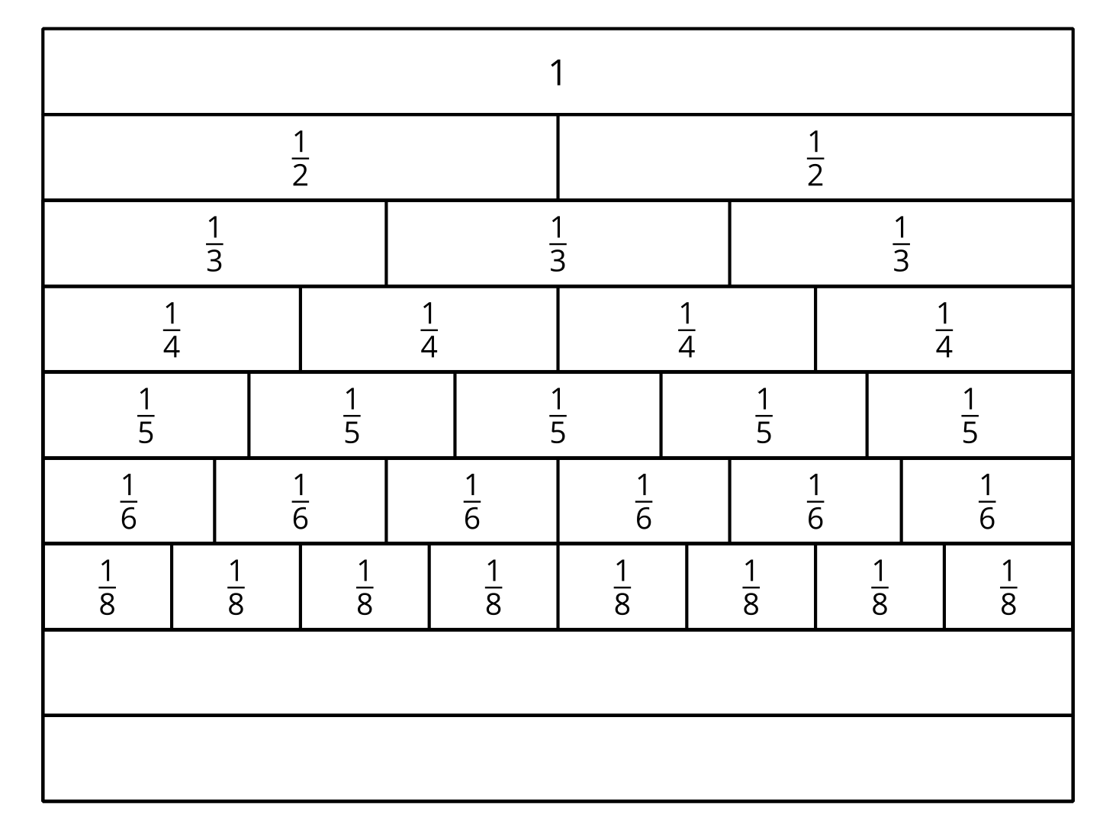
- Use a blank strip to show tenths. Label the parts. How did you partition the strip?
- Use a blank strip to show twelfths. Label the parts. How did you partition the strip?
- Jada says, “I noticed that one part of $\frac{1}{2}$ is the same size as two parts of $\frac{1}{4}$ and three parts of $\frac{1}{6}$. So $\frac{1}{2}$, $\frac{2}{4}$, and $\frac{3}{6}$ must be equivalent.”
- Find a fraction that is equivalent to each of the following fractions. Be prepared to explain your reasoning.
  - $\frac{1}{6}$
  - $\frac{2}{10}$
  - $\frac{3}{3}$

4.2: Fractions on Number Lines
- Here are some number lines. The point on this number line shows the fraction $\frac{1}{2}$.
- 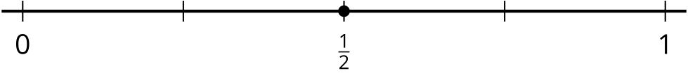
- Label the tick marks on each number line.
- Suppose you are to locate $\frac{1}{6}$, $\frac{1}{8}$, and $\frac{1}{10}$ on one of the number lines.
  - Which number line would you use for each fraction? Be prepared to explain your reasoning.
  - Locate and label each fraction ($\frac{1}{6}$, $\frac{1}{8}$, and $\frac{1}{10}$) on a different number line.
- Locate and label each of the following fractions on one of the number lines.
- $\frac{2}{3}$
- $\frac{2}{8}$
- $\frac{2}{5}$
- $\frac{3}{5}$
- $\frac{4}{6}$
- $\frac{4}{8}$
- $\frac{4}{10}$
- $\frac{6}{6}$
- $\frac{6}{10}$
- $\frac{8}{8}$
© CC BY 2021 Illustrative Mathematics®

