Unit 4 Lesson 15: The Nearest Multiples of 1,000, 10,000, and 100,000

WU Estimation Exploration: What Could It Be? (Warm up)

Student Task Statement
What number could this point represent?
Record an estimate that is:
too low | about right | too high

1 Closer to This or That?

Student Task Statement
- Answer each question. Use the number lines if they are helpful.
  - Is 16 closer to 10 or to 20?
  - Is 816 closer to 800 or to 900?
  - Is 3,816 closer to 3,000 or 4,000?
  - Is 73,816 closer to 70,000 or 80,000?
  - Is 573,816 closer to 500,000 or 600,000?
- For 816:
  - The nearest multiple of 1,000 is 1,000.
  - The nearest multiple of 100 is 800.
  - The nearest multiple of 10 is 820.
- Complete the table with the nearest multiple of 10, 100, 1,000, 10,000, and 100,000 for each number.
- 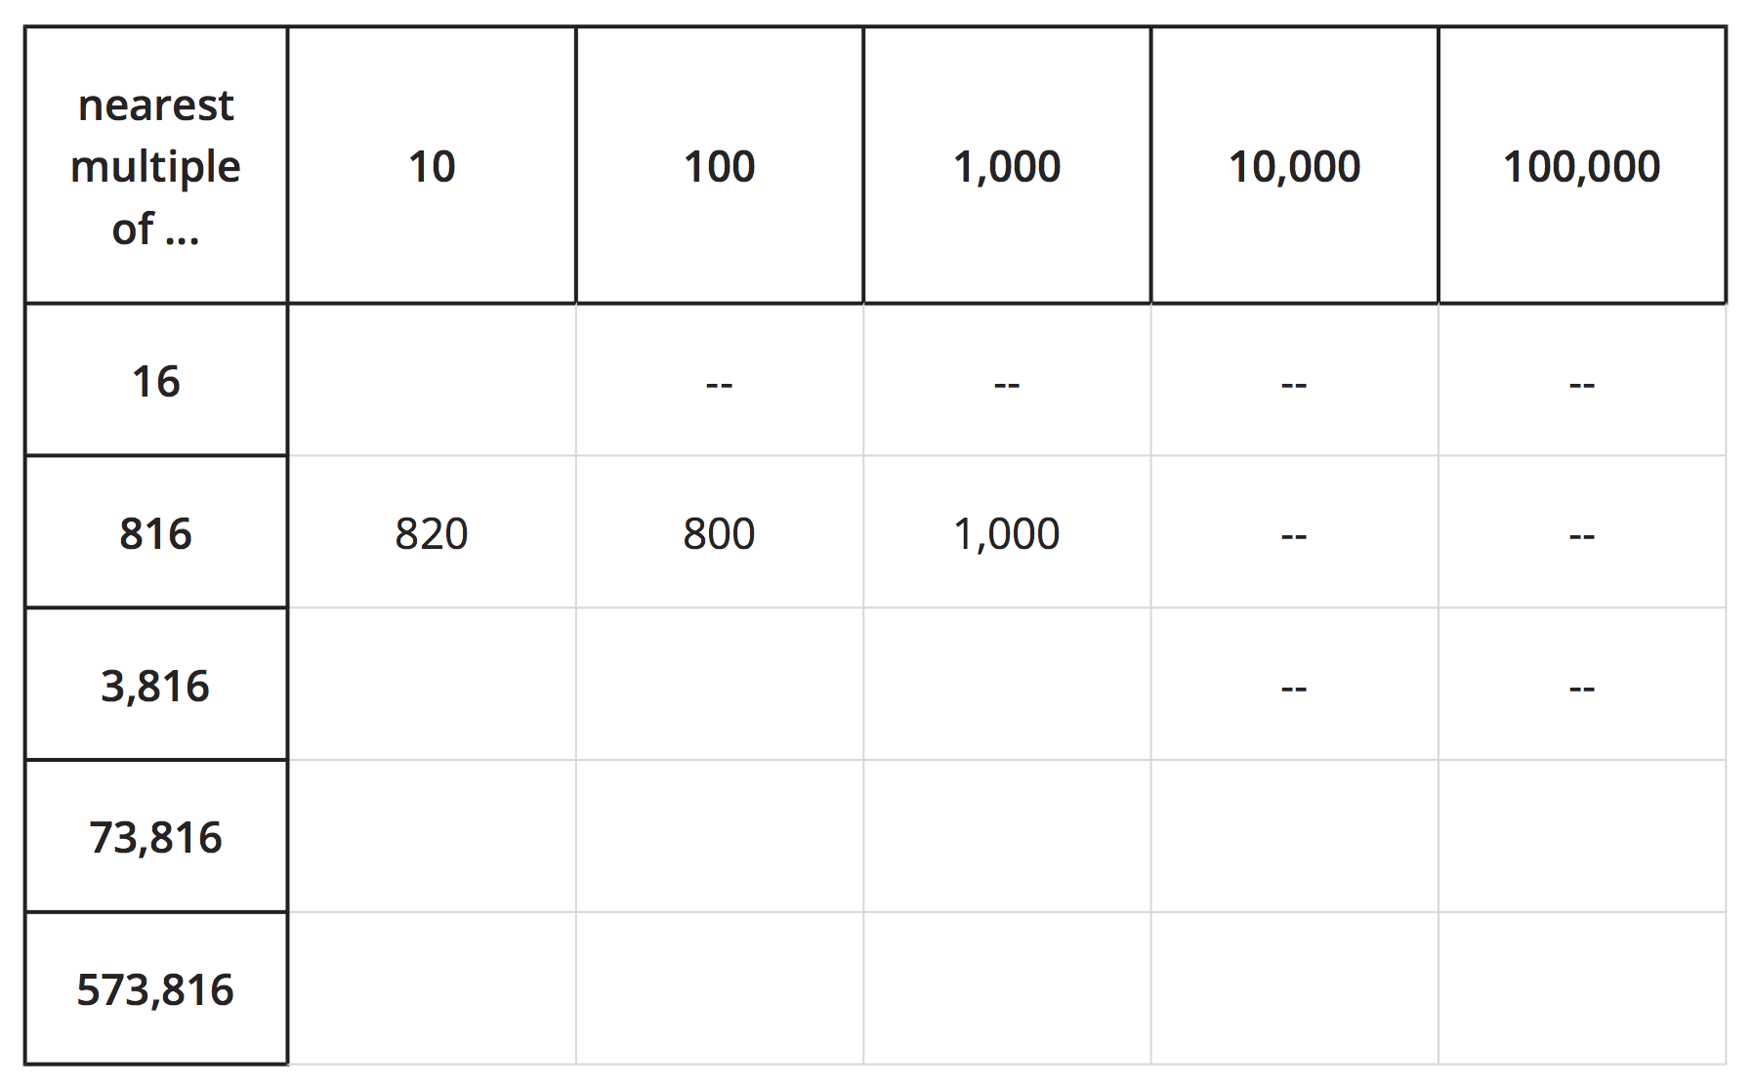

2 Closer to Which Number? (Optional)

Student Task Statement
- Answer each question. Label and use the number lines if they are helpful.
  - Is 425,193 closer to 400,000 or 500,000?
  - Is 425,193 closer to 420,000 or 430,000?
  - Is 425,193 closer to 425,000 or 426,000?
  - Is 425,193 closer to 425,100 or to 425,200?
  - Is 425,193 closer to 425,190 or to 425,200?
- For the number 425,193:
  - The nearest multiple of 100,000 is _______________.
  - The nearest multiple of 10,000 is _______________.
  - The nearest multiple of 1,000 is _______________.
  - The nearest multiple of 100 is _______________.
  - The nearest multiple of 10 is _______________.

3 What’s the Nearest Multiple?

Student Task Statement
- For the number 136,850, Han can name the nearest multiple of 100,000, 10,000, and 1,000.
- He is stuck when trying to name the nearest multiple of 100.
- 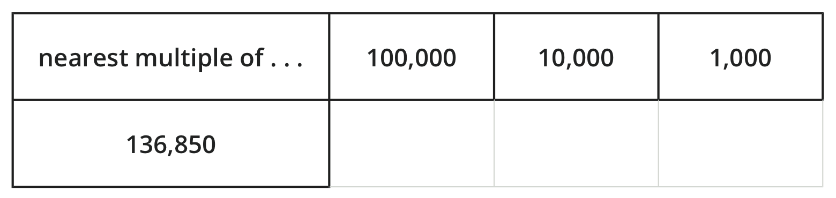
  - In the table, write the nearest multiples that Han knows for each place value. Use number lines if they are helpful.
  - Why might it be tricky to name the nearest multiple of 100 for 136,850? What do you think it is?
- Name the nearest multiples of 100,000, 10,000, 1,000, and 100 for each number.
- 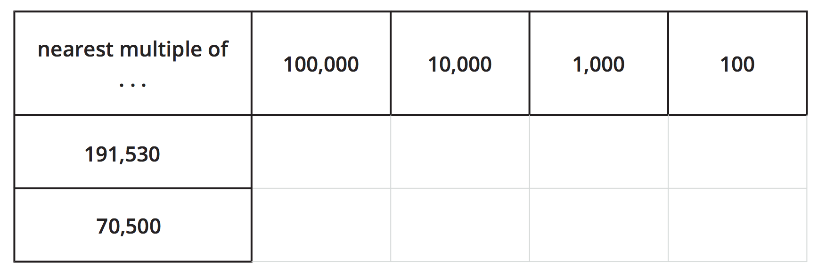
© CC BY 2021 Illustrative Mathematics®

