Unit 8 Lesson 9: The Converse

1 The Hands of a Clock (Warm up)

Student Task Statement
Consider the tips of the hands of an analog clock that has an hour hand that is 3 centimeters long and a minute hand that is 4 centimeters long.
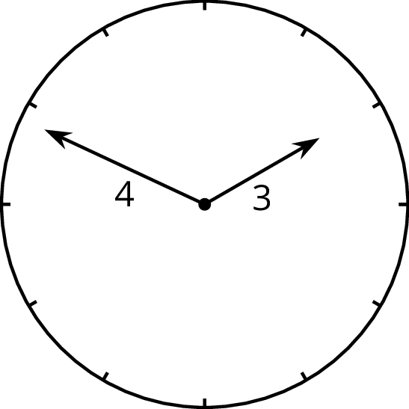
Over the course of a day:
- What is the farthest apart the two tips get?
- What is the closest the two tips get?
- Are the two tips ever exactly five centimeters apart?

2 Proving the Converse

Student Task Statement
Here are three triangles with two side lengths measuring 3 and 4 units, and the third side of unknown length.
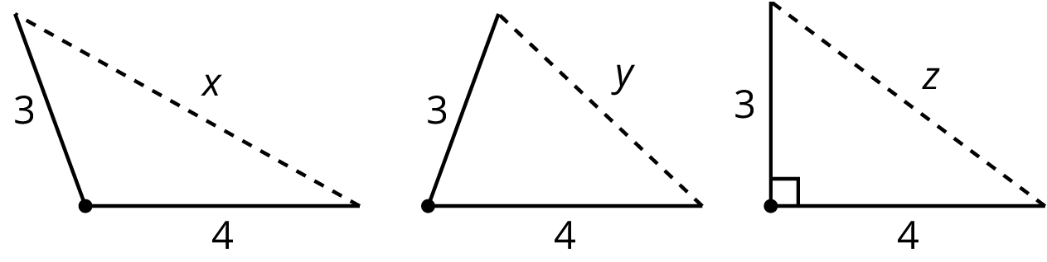
Sort the following six numbers from smallest to largest. Put an equal sign between any you know to be equal. Be ready to explain your reasoning.
$1 5 7 x y z$

Activity Synthesis
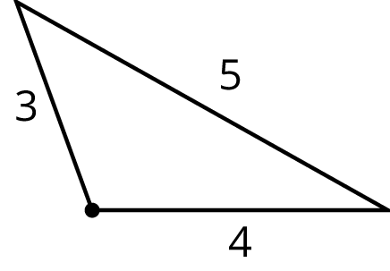
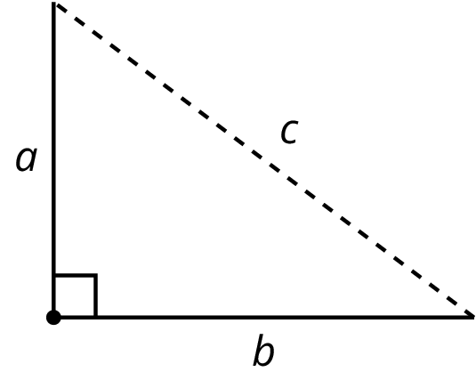

3 Calculating Legs of Right Triangles

Student Task Statement
- Given the information provided for the right triangles shown here, find the unknown leg lengths to the nearest tenth.
- 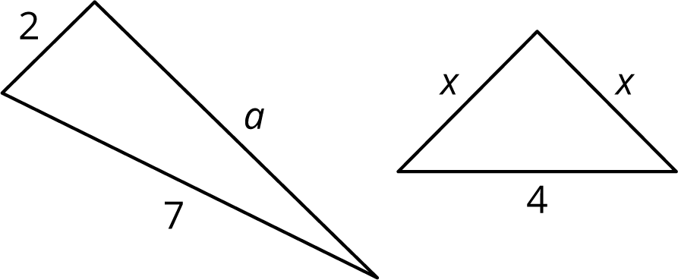
- The triangle shown here is not a right triangle. What are two different ways you change one of the values so it would be a right triangle? Sketch these new right triangles, and clearly label the right angle.
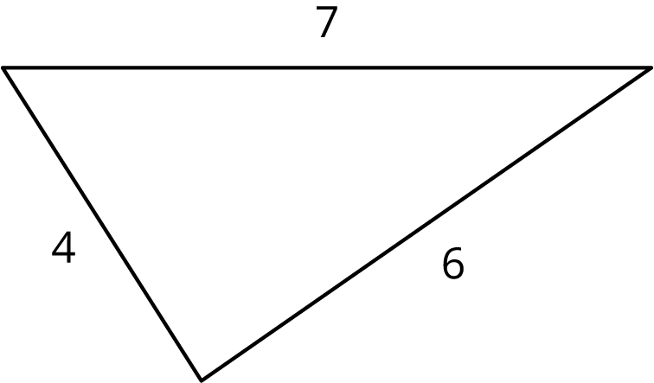

Images for Activity Synthesis
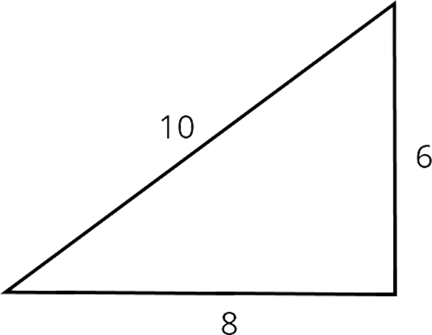
© CC BY Open Up Resources. Adaptations CC BY IM.

