Lesson 6: Multipliquemos fracciones

Standards Alignments
Addressing | 5.NF.B.4, 5.NF.B.4.b

Teacher-facing Learning Goals
- Represent multiplication of two non-unit fractions with expressions.

Student-facing Learning Goals
- Multipliquemos dos fracciones no unitarias usando diagramas y expresiones.

Lesson Purpose
The purpose of this lesson is for students to calculate areas of rectangles where both side lengths are non-unit fractions.
As in previous lessons, students represent a product of fractions with a diagram. This diagram represents the product $\frac{3}{6}×\frac{4}{5}$. The diagram shows $\frac{3}{6}$ of $\frac{4}{5}$ of the square so that’s $\frac{3}{6}×\frac{4}{5}$. The number of shaded pieces is $3×4$, the product of the numerators. The number of pieces in the whole square is $6×5$, the product of the denominators. So the value of the product can also be written as $\frac{3×4}{6×5}$. In the first activity, students relate expressions to the area in diagrams like this and then they use this structure to find products of non-unit fractions in the second activity.
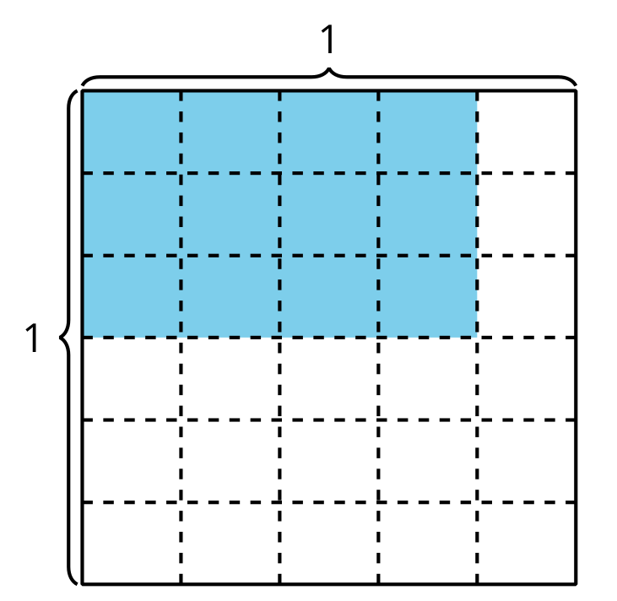

Access for:

Students with Disabilities
- Action and Expression (Activity 2)

Instructional Routines
Which One Doesn’t Belong? (Warm-up)

Lesson Timeline
Warm-up | 10 min
Activity 1 | 15 min
Activity 2 | 20 min
Lesson Synthesis | 10 min
Cool-down | 5 min

Teacher Reflection Question
With which math ideas from today’s lesson did students grapple most? Did this surprise you or was this what you expected?

Cool-down
(to be completed at the end of the lesson) 5min
¿Cuál es el área?

Standards Alignments
Addressing | 5.NF.B.4.b

Student-facing Task Statement

  - Escribe una expresión de multiplicación que represente el área de la región coloreada, en unidades cuadradas.
  - 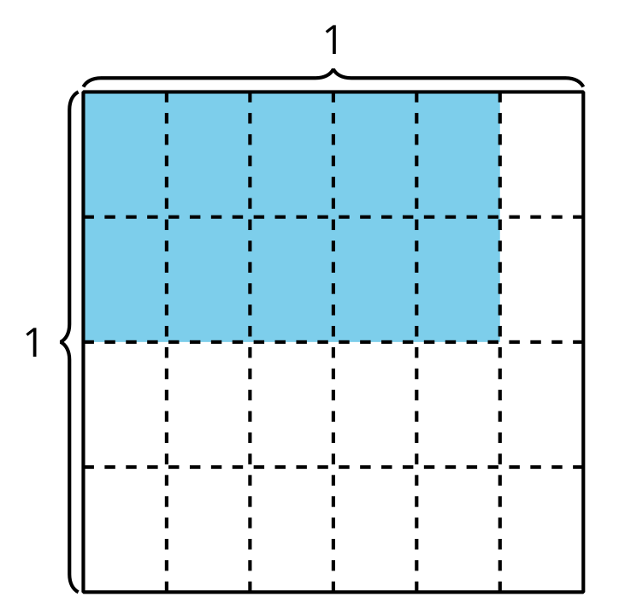
  - ¿Cuál es el área de la región coloreada, en unidades cuadradas?

Student Responses

  - $\frac{2}{4}×\frac{5}{6}$ or equivalent
  - $\frac{10}{24}$ or equivalent

