Lesson 25 Practice Problems
- Jada has $p$ pennies and $n$ nickels that add up to more than 40 cents. She has fewer than 20 coins altogether.
  - Write a system of inequalities that represents how many pennies and nickels that Jada could have.
  - Is it possible that Jada has each of the following combinations of coins? If so, explain or show how you know. If not, state which constraint—the amount of money or the number of coins—it does not meet.
    - 15 pennies and 5 nickels
    - 16 pennies and 2 nickels
    - 10 pennies and 8 nickels
- A triathlon athlete swims at an average rate 2.4 miles per hour, and bikes at an average rate of 16.1 miles per hour. At the end of one training session, she has swum and biked more than 20 miles in total.
- The inequality $2.4s+16.1b>20$ and this graph represent the relationship between the hours of swimming, $s$, the hours of biking, $h$, and the total distance the athlete could have traveled in miles.
- 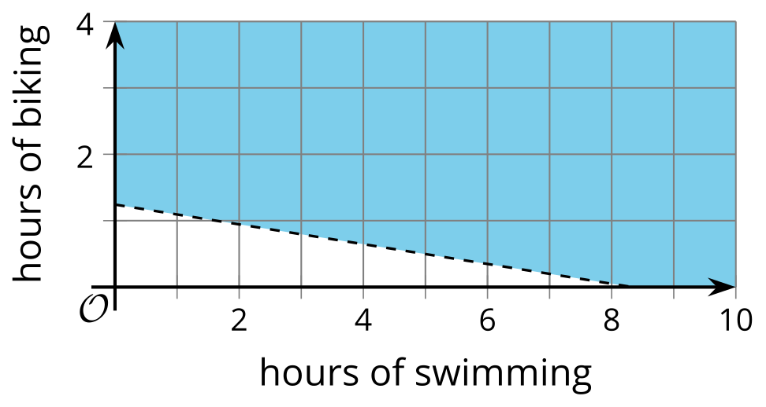
- Mai said, "I'm not sure the graph is right. For example, the point $\left(10,3\right)$ is in the shaded region, but it's not realistic for an athlete to swim for 10 hours and bike for 3 hours in a training session! I think triathlon athletes generally train for no more than 2 hours a day."
  - Write an inequality to represent Mai's last statement.
  - Graph the solution set to your inequality.
  - Determine a possible combination of swimming and biking times that meet both the distance and the time constraints in this situation.
- Elena is considering buying bracelets and necklaces as gifts for her friends. Bracelets cost $3, and necklaces cost $5. She can spend no more than $30 on the gifts. Elena needs at least 7 gift items.
- This graph represents the inequality $3b+5n≤30$, which describes the cost constraint in this situation.
- Let $b$ represent the number of bracelets and $n$ the number of necklaces.
- 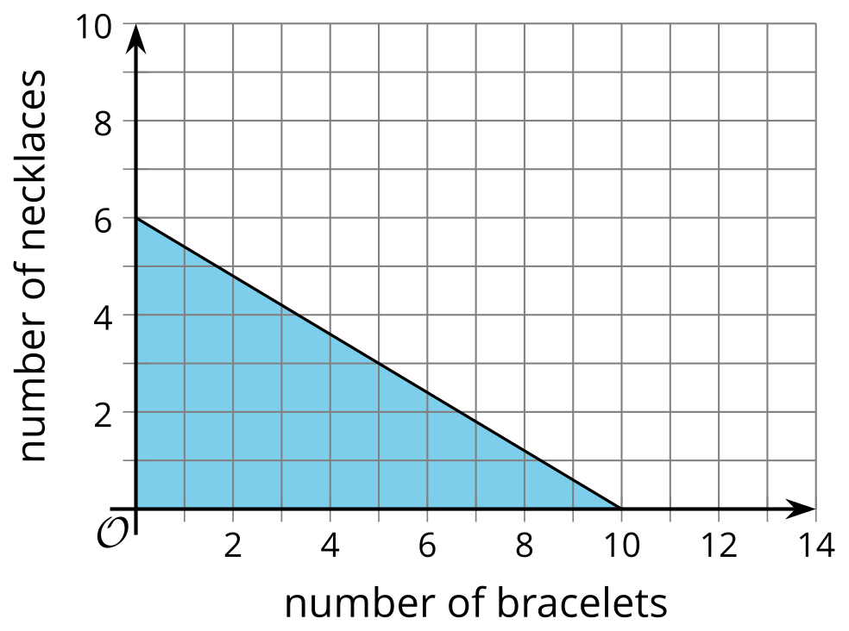
- ​​​​​​
  - Write an inequality that represents the number of gift items that Elena needs.
  - On the same coordinate plane, graph the solution set to the inequality you wrote.
  - Use the graphs to find at least two possible combinations of bracelets and necklaces Elena could buy.
  - Explain how the graphs show that the combination of 2 bracelets and 5 necklaces meet one constraint in the situation but not the other constraint.
- A gardener is buying some topsoil and compost to fill his garden. His budget is $70. Topsoil costs $1.89 per cubic foot, and compost costs $4.59 per cubic foot.
- Select all statements or representations that correctly describe the gardener's constraints in this situation. Let $t$ represent the cubic feet of topsoil and $c$ the cubic feet of compost.
  - The combination of 7.5 cubic feet of topsoil and 12 cubic feet of compost is within the gardener's budget.
  - If the line represents the equation $1.89t+4.59c=70$, this graph represents the solutions to the gardener's budget constraint.
  - 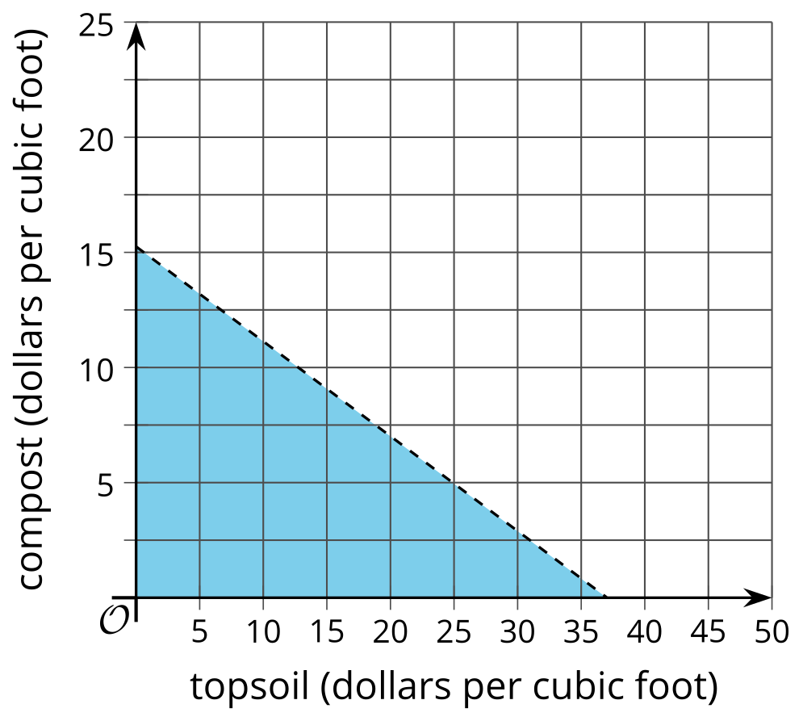
  - $1.89t+4.59c≥70$
  - The combination of 5 cubic feet of topsoil and 20 cubic feet of compost is within the gardener's budget.
  - $1.89t+4.59c≤70$
  - If the line represents the equation $1.89t+4.59c=70$, this graph represents the solutions to the gardener's budget constraint.
  - 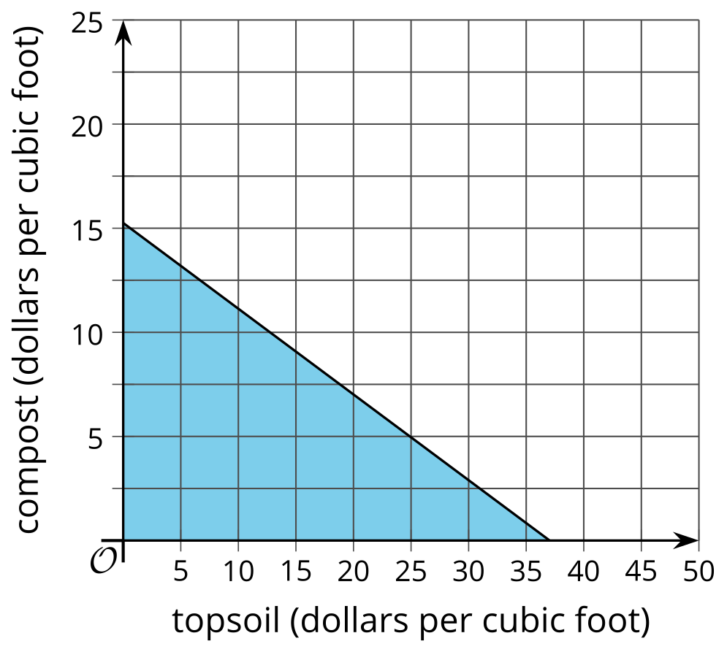
- (From Unit 2, Lesson 22.)
- Priya writes the equation $y=\text{-}\frac{1}{2}x−7$. Write an equation that has:
  - exactly one solution in common with Priya's equation
  - no solutions in common with Priya's equation
  - infinitely many solutions in common with Priya's equation, but looks different than hers
- (From Unit 2, Lesson 17.)
- Two inequalities are graphed on the same coordinate plane.
- Which region represents the solution to the system of the two inequalities?
- 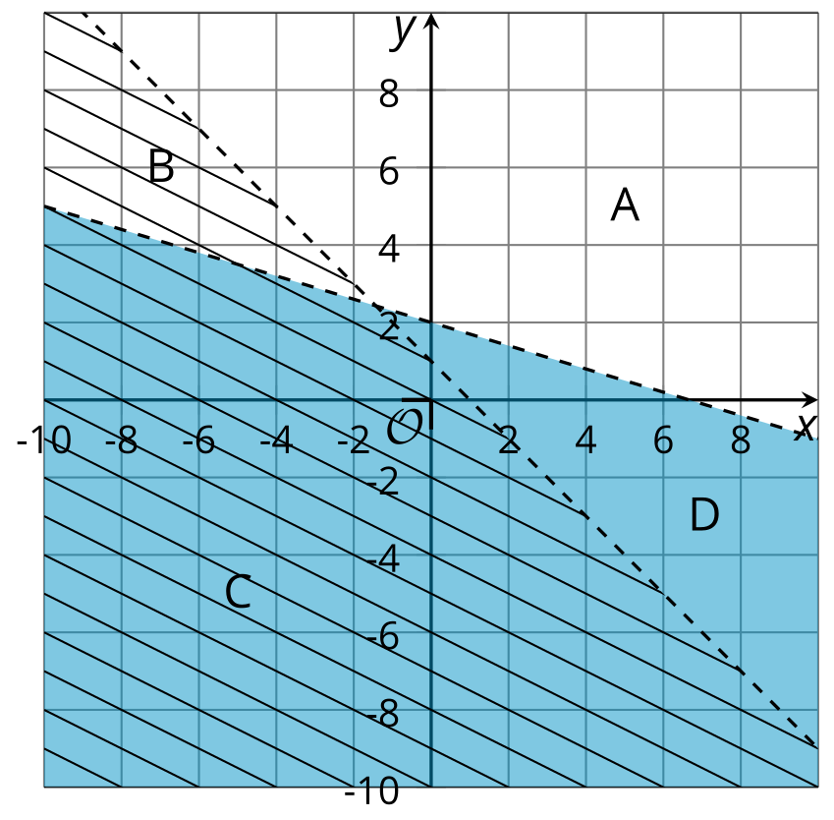
- (From Unit 2, Lesson 24.)
- Here is a riddle:
  - The sum of two numbers is less than 10.
  - If we subtract the second number from the first, the difference is greater than 3.
- Write a system of inequalities that represents this situation. Let $f$ represent the first number and $s$ represent the second number.
- (From Unit 2, Lesson 24.)
© CC BY 2019 by Illustrative Mathematics®

