Unit 7 Lesson 5: Triangles in Circles

1 One Perpendicular Bisector (Warm up)

Student Task Statement
The image shows a triangle.
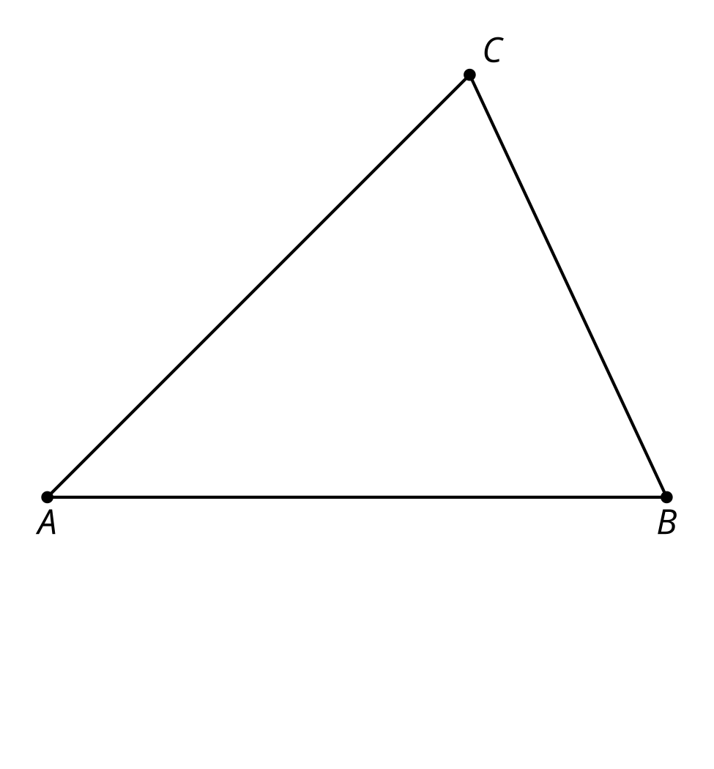
- Construct the perpendicular bisector of segment $AB$.
- Imagine a point $D$ placed anywhere on the perpendicular bisector you constructed. How would the distance from $D$ to $A$ compare to the distance from $D$ to $B$? Explain your reasoning.

Activity Synthesis
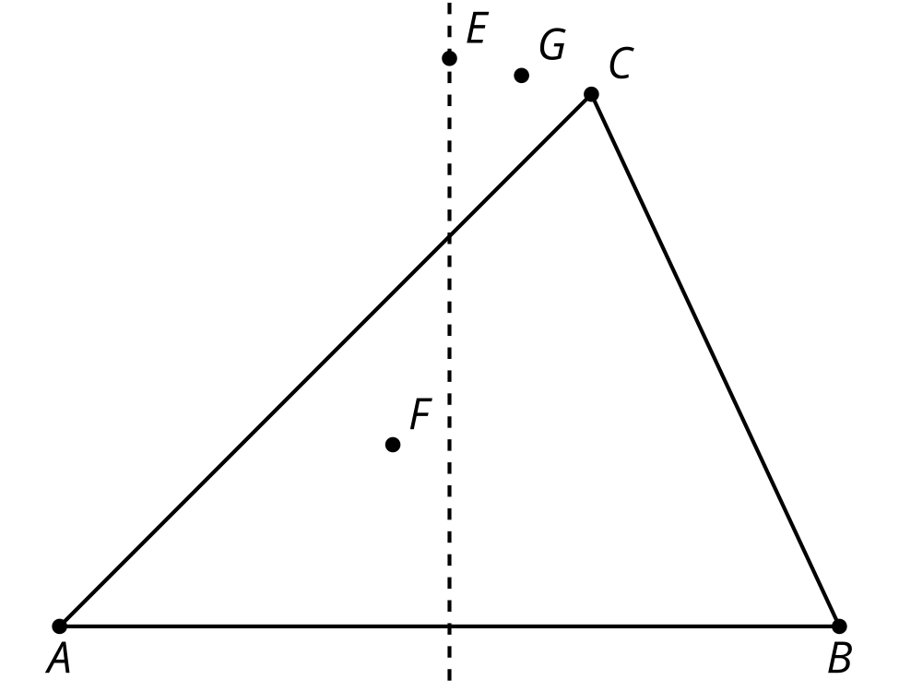

2 Three Perpendicular Bisectors

Student Task Statement
- Construct the perpendicular bisector of segment $BC$ from the earlier activity. Label the point where the 2 perpendicular bisectors intersect as $P$.
- Use a colored pencil to draw segments $PA,PB,$ and $PC$. How do the lengths of these segments compare? Explain your reasoning.
- Imagine the perpendicular bisector of segment $AC$. Will it pass through point $P$? Explain your reasoning.
- Construct the perpendicular bisector of segment $AC$.
- Construct a circle centered at $P$ with radius $PA$.
- Why does the circle also pass through points $B$ and $C$?

Activity Synthesis
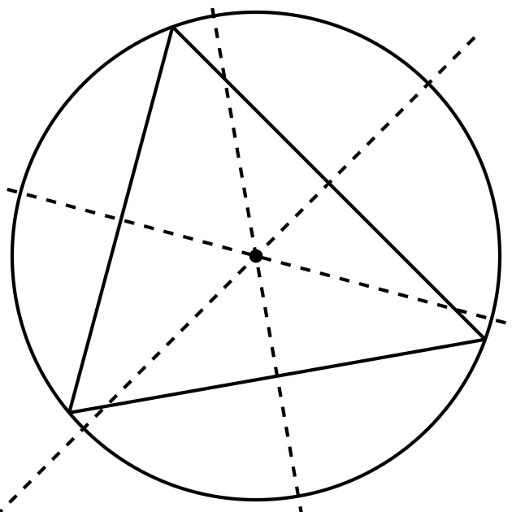

3 Wandering Centers

Student Task Statement
Each student in your group should choose 1 triangle. It’s okay for 2 students to choose the same triangle as long as all 3 are chosen by at least 1 student.
- Construct the circumscribed circle of your triangle.
- After you finish, compare your results. What do you notice about the location of the circumcenter in each triangle?
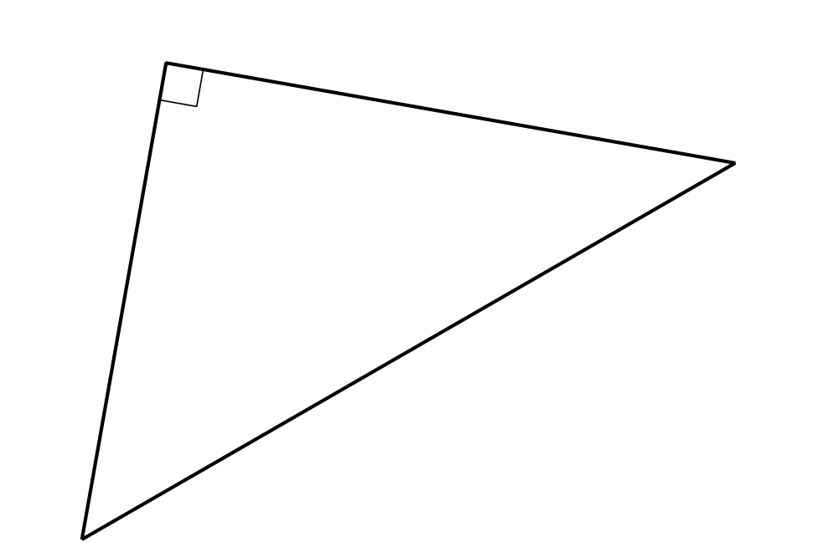
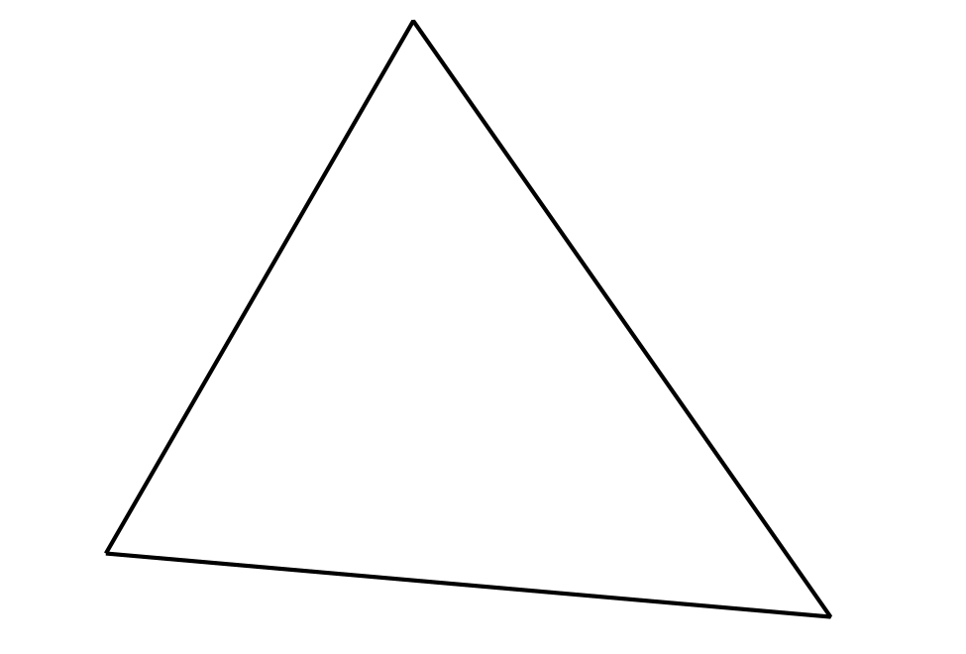

Activity Synthesis
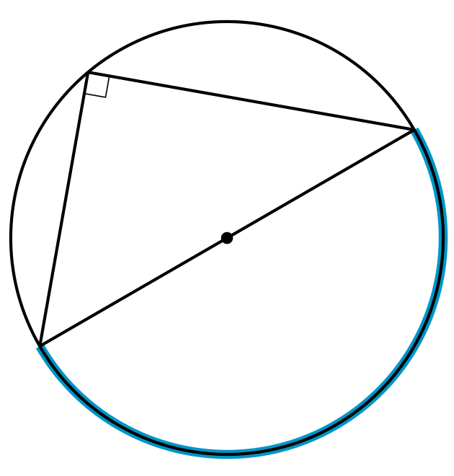
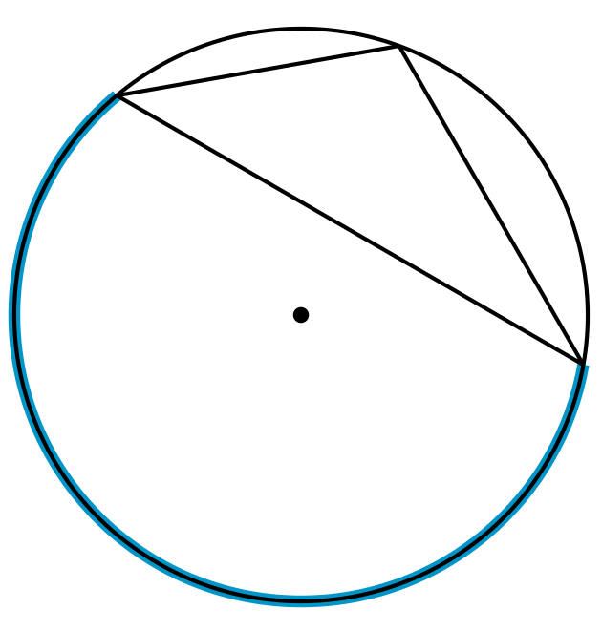
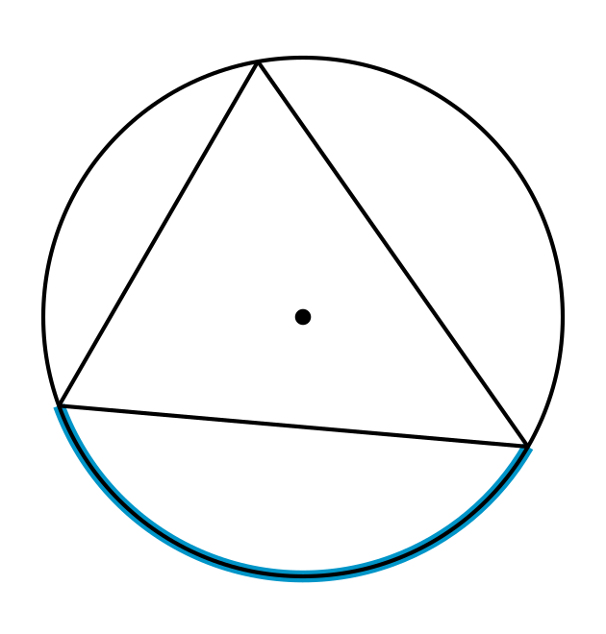

Images for Activity Synthesis
© CC BY 2019 by Illustrative Mathematics®

