Unit 6 Lesson 18: Compare Without Multiplying

WU Notice and Wonder: Expressions and Number Lines (Warm up)

Student Task Statement
What do you notice? What do you wonder?
$\frac{2}{3}×5$

1 Approximate Location

Student Task Statement
- Label each expression at its approximate location on the number line.
- Partner A
  - $\frac{2}{5}×12$
  - $\frac{5}{3}×12$
  - $\frac{7}{7}×12$
- Partner B
  - $\frac{4}{7}×12$
  - $\frac{8}{5}×12$
  - $\frac{9}{9}×12$
- 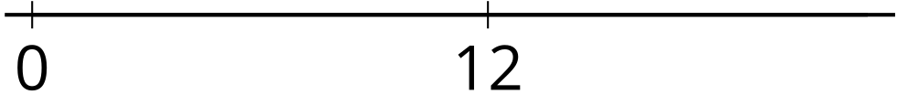
- Choose a number to put in each box to make the statement true.
  - 000011×12>12
  - 000015×12=12
  - 130000×12<12

2 An Unknown Number

Student Task Statement
- 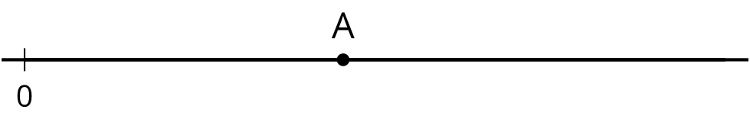
- The number A is shown on the number line. Label the approximate location of the value of each expression. Explain or show your reasoning.
  - $\frac{1}{4}×A$
  - $2×A$
  - $\frac{13}{8}×A$
  - $\frac{2}{3}×A$
- Is $\frac{13}{8}×\frac{11}{39}$ less than, greater than, or equal to $\frac{11}{39}$? Explain or show your reasoning.
- Is $\frac{2}{3}×\frac{17}{53}$ less than, greater than, or equal to $\frac{17}{53}$? Explain or show your reasoning.
© CC BY 2021 Illustrative Mathematics®

