Lesson 2: Relate Addition and Subtraction within 10
- Let’s think about the relationship between addition and subtraction.

Warm-up: What Do You Know About 10?
What do you know about 10?

2.2: Sums of 10
- For each cube tower, write as many equations as you can think of that represent the cubes.
- A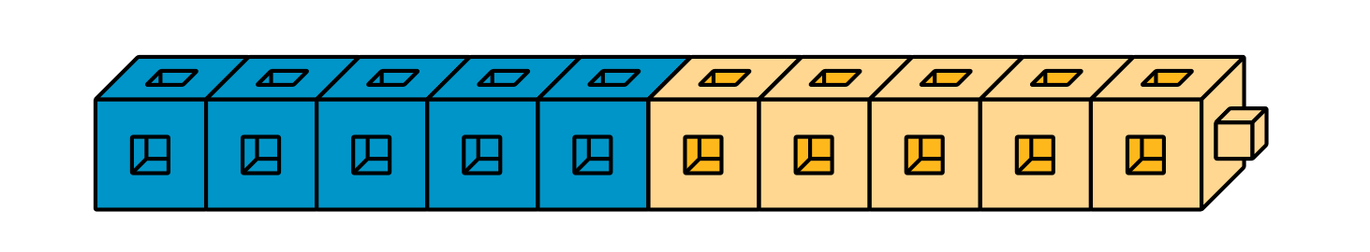
- B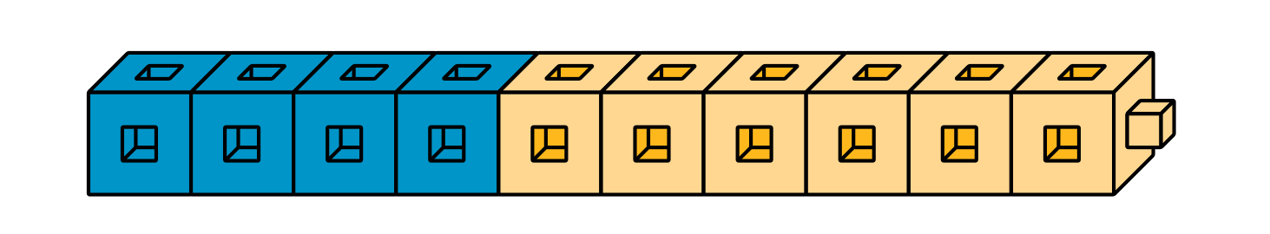
- C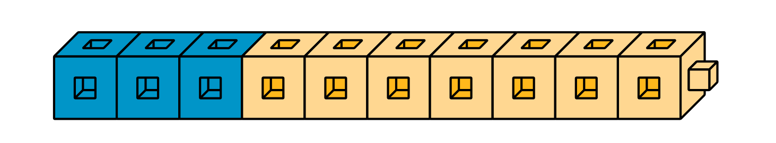
- D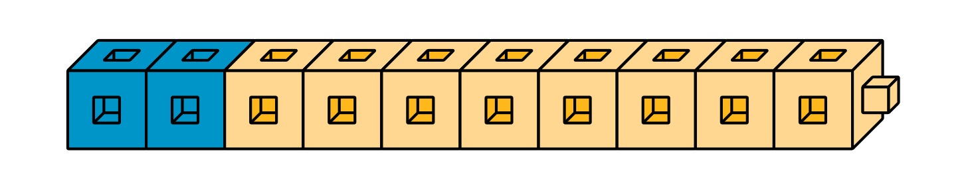
- E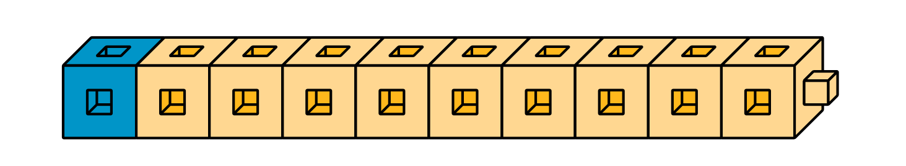
- Find the number that makes each equation true. Then write the letter of the cube tower that represents the equation.
- $3+\underset{_}{}=10$
- Letter: ___
- $10−7=\underset{_}{}$
- Letter: ___
- $10−5=\underset{_}{}$
- Letter: ___
- $2+\underset{_}{}=10$
- Letter: ___
- $10−1=\underset{_}{}$
- Letter: ___
- $10−2=\underset{_}{}$
- Letter: ___
- $\underset{_}{}+6=10$
- Letter: ___
- $\underset{_}{}+9=10$
- Letter: ___
- $5+\underset{_}{}=10$
- Letter: ___
- $10−\underset{_}{}=4$
- Letter: ___
© CC BY 2021 Illustrative Mathematics®

