Lesson 16: Identify Quarters

Standards Alignments
Addressing | 2.MD.C.8, 2.NBT.A.2, 2.NBT.B.5

Teacher-facing Learning Goals
- Find the value of a set of coins including all combinations.
- Identify and know the value of quarters.

Student-facing Learning Goals
- Let’s learn about quarters and find the value of different sets of coins.

Lesson Purpose
The purpose of this lesson is for students to identify quarters and find the total value of a set of coins including quarters.
In a previous lesson, students recognized dimes, nickels, and pennies and learned their values. They used different strategies to find the value of a mixed set of coins.
In this lesson, students recognize the quarter and learn its value. They find the value of groups of coins and look for ways to represent the same value with different coins. Throughout the lesson, students make connections between quarters and combinations of other coins and notice that if they look for ways to use coins with a larger value first, they can be more certain they are using the fewest amount of coins (MP8).
In both activities, students continue to practice finding the values of coin collections using methods for adding within 100. Throughout the lesson, look for the different ways students find the value of coins collections and organize their thinking. While some students will continue to group like coins and add to find the total value, others will count on from the largest value (25, 35, 45, 50, 55, 56, 57, 58) or look for other ways to use ten (25, 30, 40, 50, 55, 56, 57, 58).

Access for:

Students with Disabilities
- Action and Expression (Activity 2)

Instructional Routines
Choral Count (Warm-up), MLR7 Compare and Connect (Activity 1)

Materials to Copy
- Coins to Cut and Count (groups of 1): Activity 1

Lesson Timeline
Warm-up | 10 min
Activity 1 | 20 min
Activity 2 | 15 min
Lesson Synthesis | 10 min
Cool-down | 5 min

Teacher Reflection Question
Which students surprised you with their ways of organizing coins and finding total values? How can you leverage what these students know to ensure they develop strategies to solve story problems in the context of money in the upcoming lessons?

Cool-down
(to be completed at the end of the lesson) 5min
Tyler’s Pocket Change

Standards Alignments
Addressing | 2.MD.C.8, 2.NBT.B.5

Student-facing Task Statement
Tyler had 6 pennies, 2 dimes, 2 quarters, and 2 nickels in his pocket.
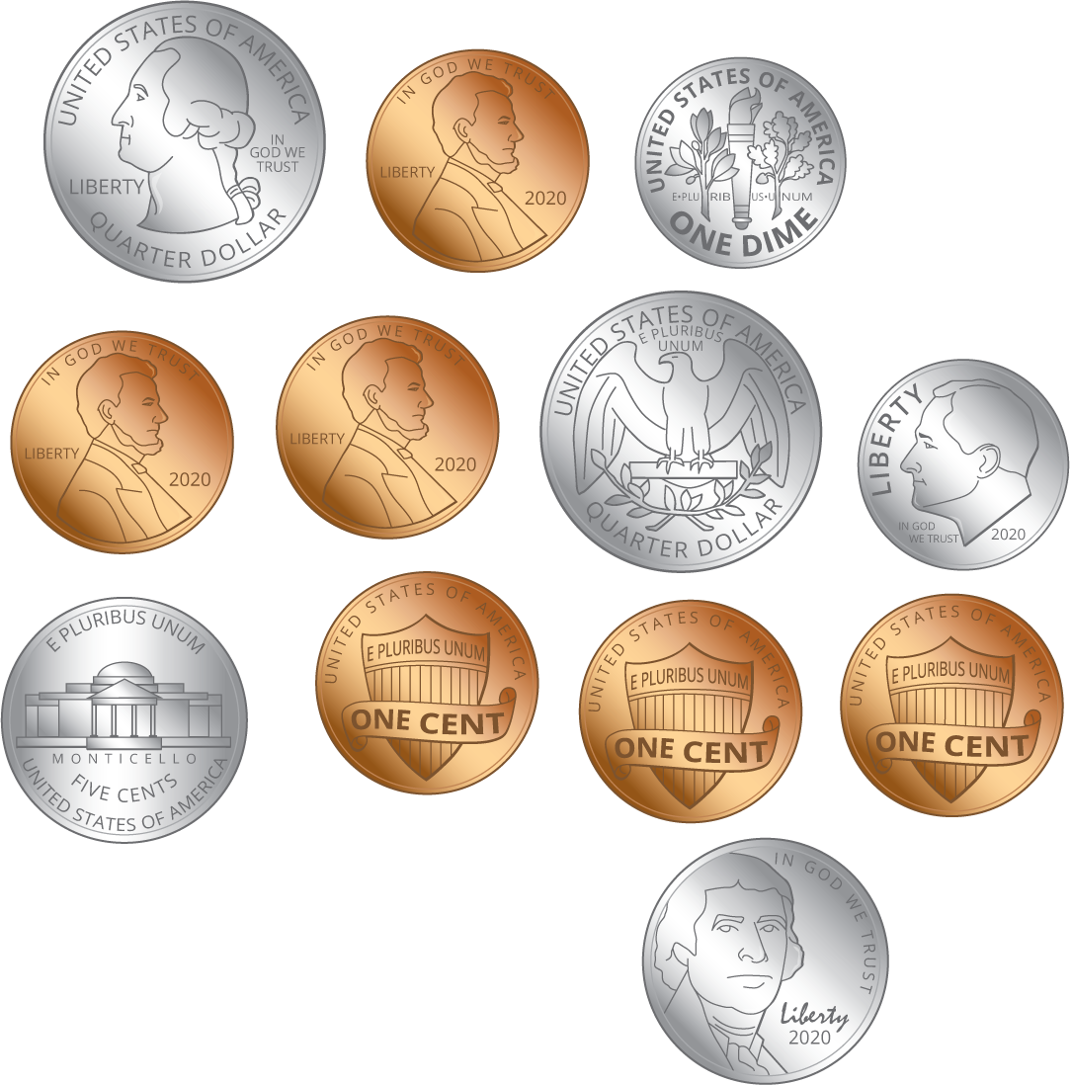
How many cents does Tyler have? Show your thinking using drawings, numbers, words, or an equation.

Student Responses
Tyler has 86¢. Sample responses:
- $25+25=50$, 50, 60, 70, 75, 80, 81, 82, 83, 84, 85, 86
- $25+25=50$, $10+10=20$, $5+5=10$, and 6 pennies, so $50+20+10+6=86$

