Lesson 1: Count Large Collections
- Let’s count objects.

Warm-up: Choral Count: Count by 10
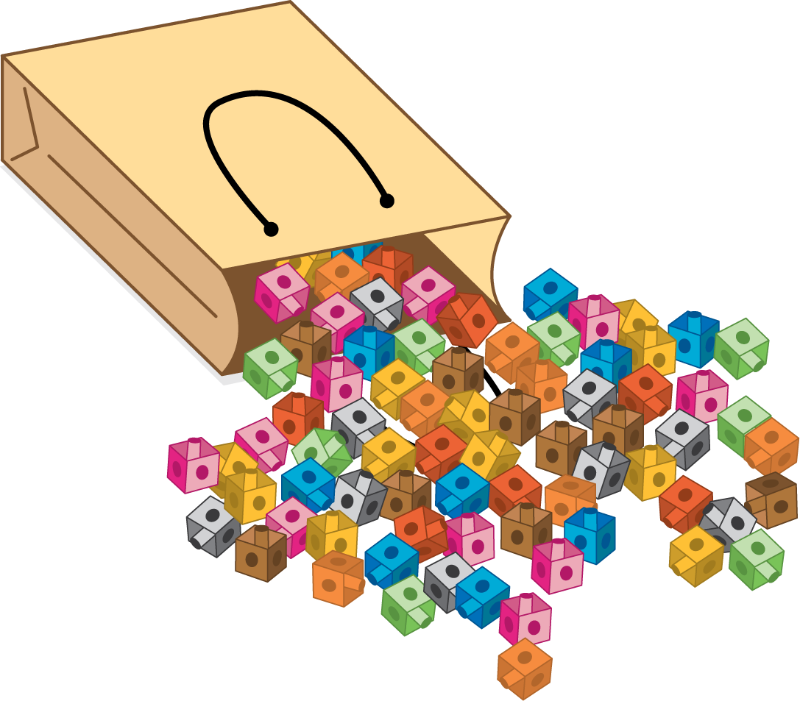

1.3: Centers: Choice Time
Choose a center.
How Close?
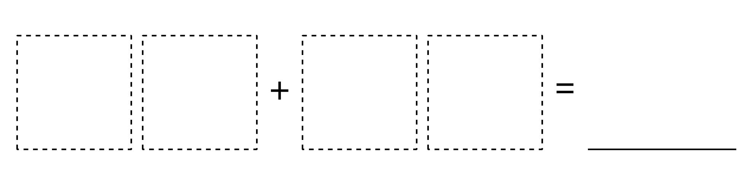
Five in a Row
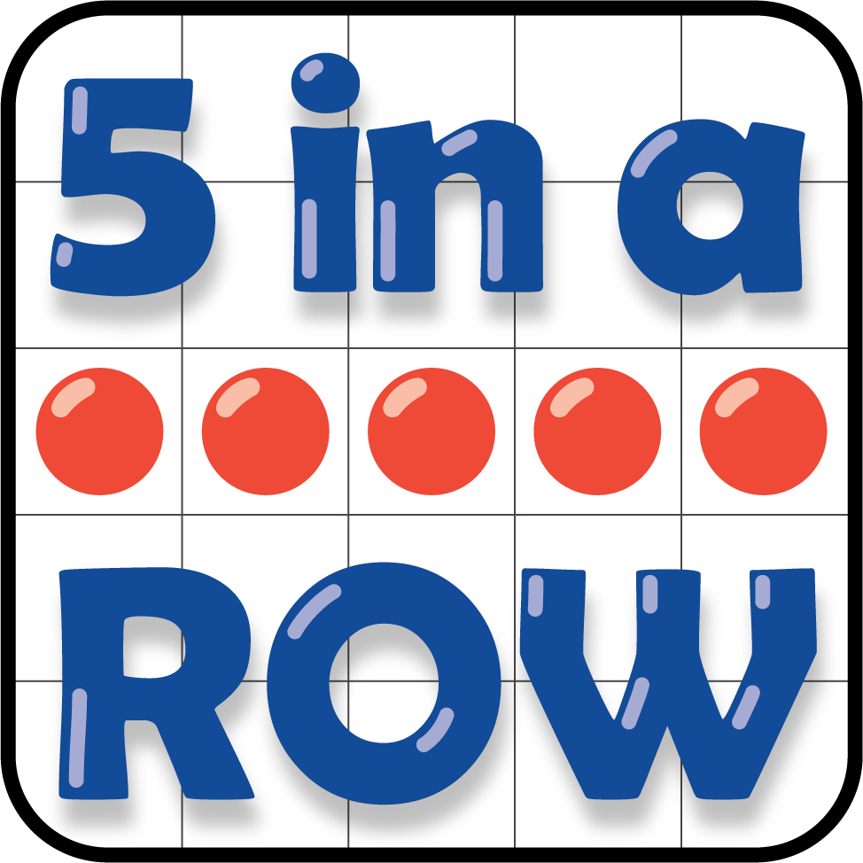
Number Puzzles
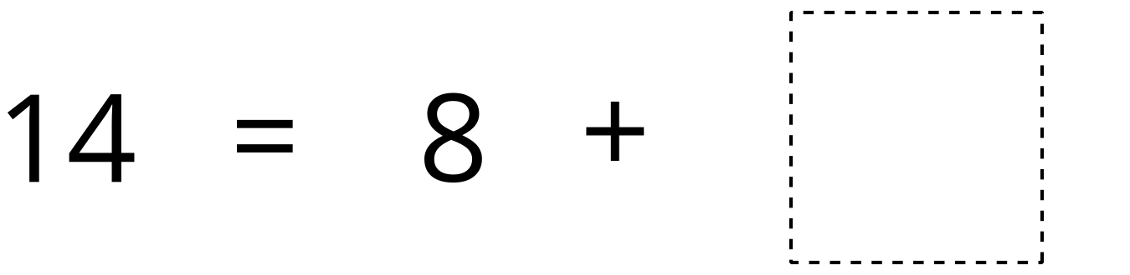
© CC BY 2021 Illustrative Mathematics®

