Unit 1 Lesson 9: Multiplication as Equal Groups

WU Number Talk: More Addition (Warm up)

Student Task Statement
Find the value of each expression mentally.
- $40+35$
- $45+35$
- $45+36$
- $34+58$

1 From Scaled Graphs to Equal Groups

Student Task Statement
Elena collected data about the kind of signs she saw on the way home. The data is shown in this picture graph:
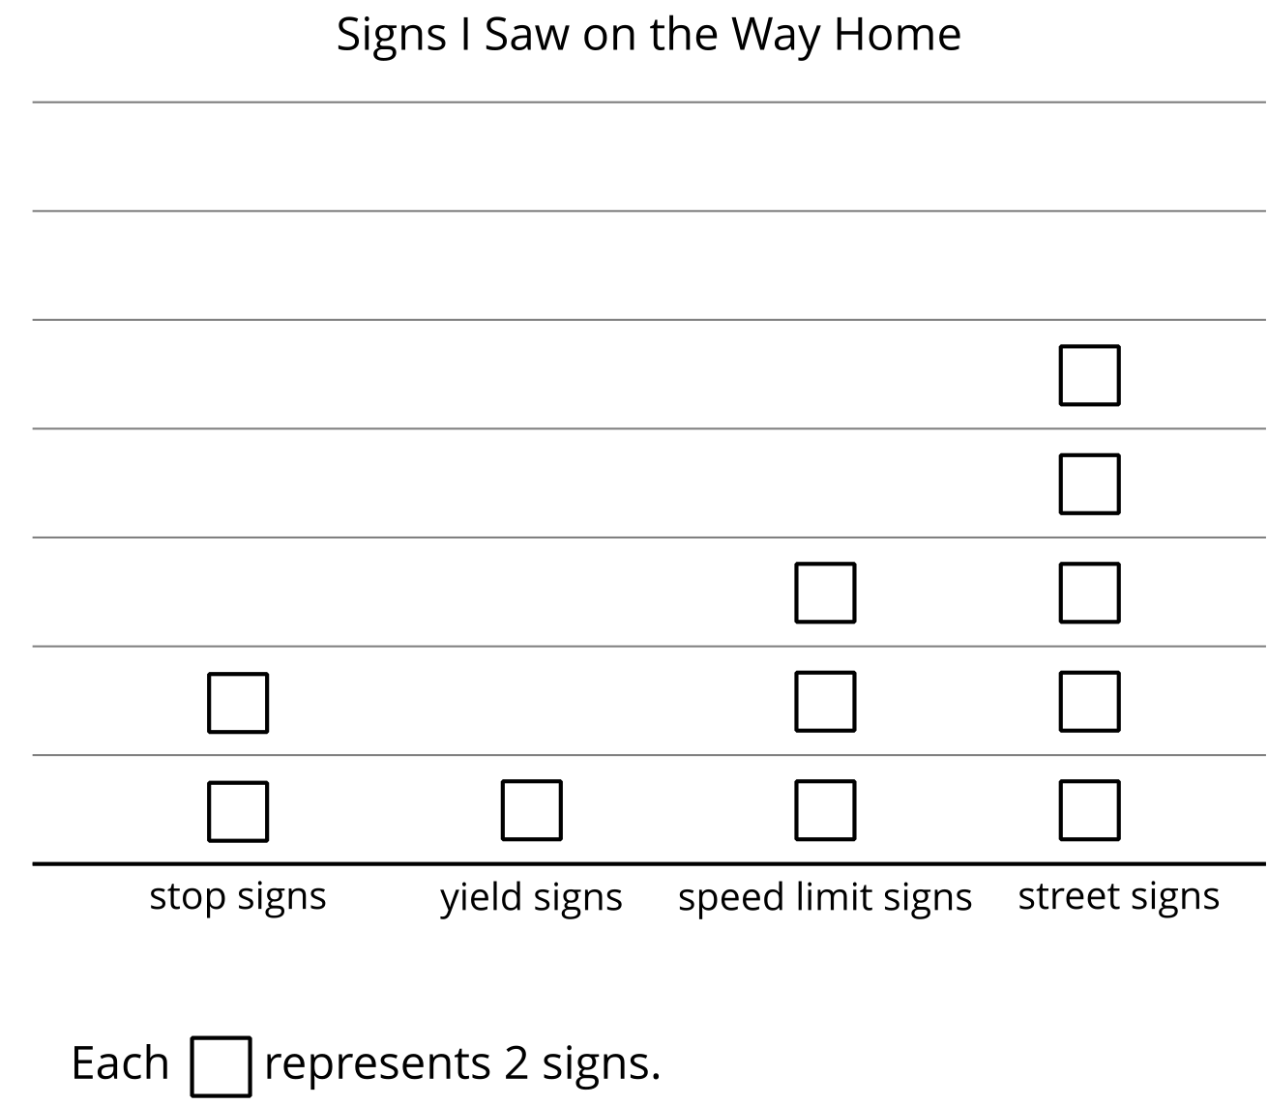
- Represent the number of speed limit signs Elena saw on the way home.
- Which statement describes the number of speed limit signs Elena saw? Explain your reasoning.
  - There are 3 pictures and each picture represents 1 speed limit sign.
  - There are 3 pictures and each picture represents 2 speed limit signs.
  - There are 2 pictures and each picture represents 2 speed limit signs.
- How could this drawing represent the street signs Elena saw on the way home?

2 Equal Group Situations

Student Task Statement
Represent each situation.
- There are 4 people wearing shoes. Each person is wearing 2 shoes.
- There are 2 boxes of markers. Each box has 10 markers.
- There are 3 basketball teams. Each team has 5 players.

Images for Activity Synthesis
© CC BY 2021 Illustrative Mathematics®

