Unit 4 Lesson 16: Round Numbers

WU Number Talk: Missing Numbers (Warm up)

Student Task Statement
Find the value that makes each equation true mentally.
- $421+\underset{_}{}=500$
- $421+\underset{_}{}=1,​000$
- $6,​421+\underset{_}{}=7,​000$
- $6,​421+\underset{_}{}=10,​000$

1 Round to What?

Student Task Statement
Noah says that 489,231 can be rounded to 500,000.
Priya says that it can be rounded to 490,000.
- Explain or show why both Noah and Priya are correct. Use a number line if it helps.
- Describe all the numbers that round to 500,000 when rounded to the nearest hundred-thousand.
- Describe all the numbers that round to 490,000 when rounded to the nearest ten-thousand.
- Name two other numbers that can also be rounded to both 500,000 and 490,000.

Activity Synthesis
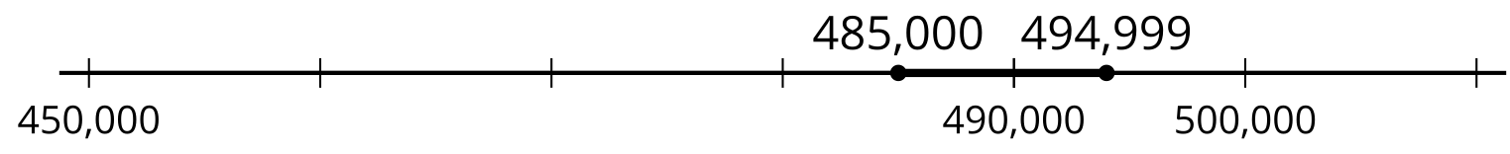

2 Some Numbers to Round

Student Task Statement
Your teacher will show you six numbers. Choose at least three numbers and round each to the nearest 100,000, 10,000, 1,000, and 100.
Record your work in the table. Use a number line if it is helpful.
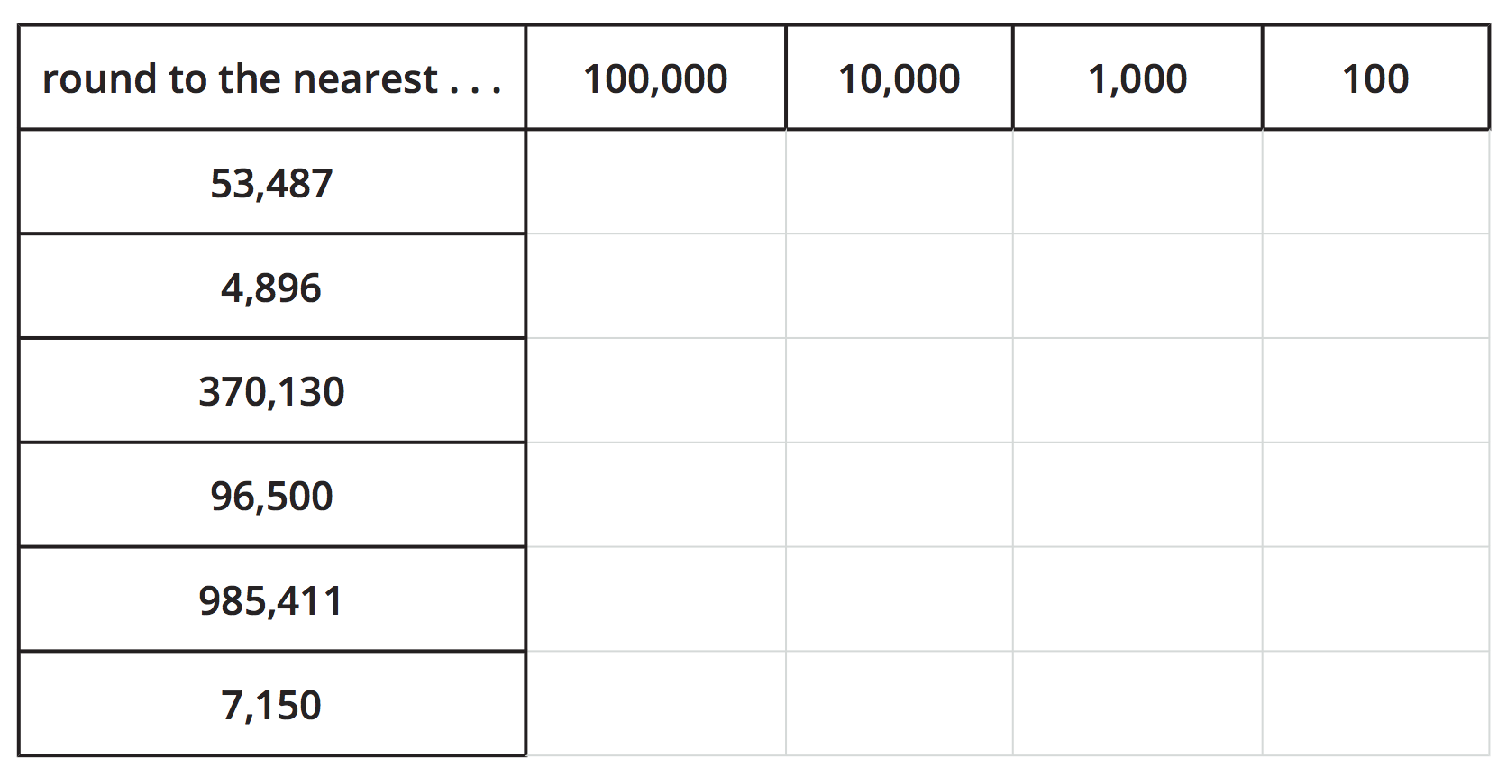

3 Rounded Populations (Optional)

Images for Launch
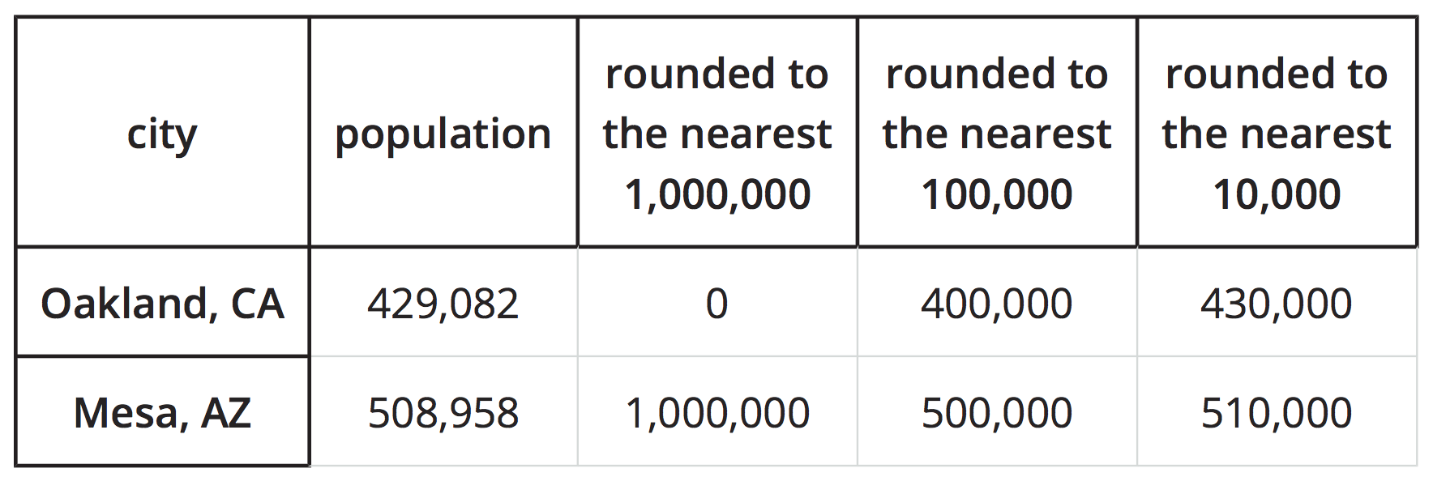

Student Task Statement
The table shows the estimated populations of two cities in the United States, based on surveys in 2018.
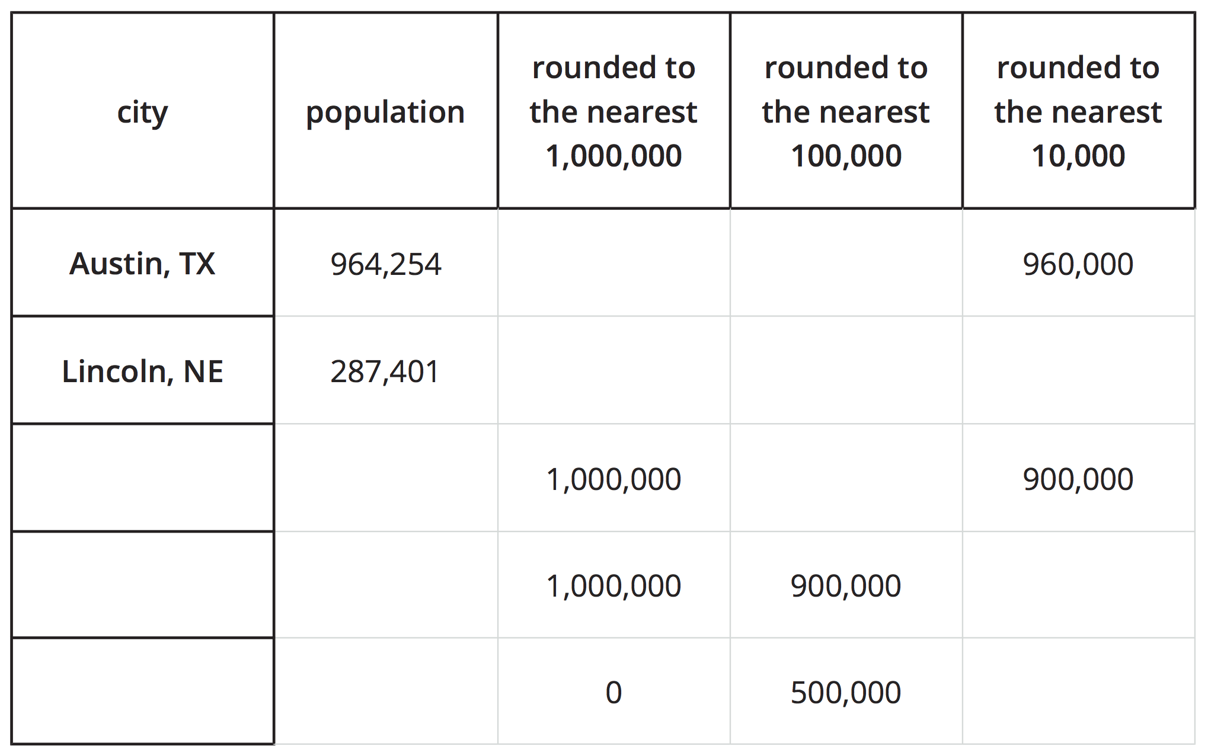
Here are three other cities and their estimated populations:
- Charlotte, NC: 872,498
- Jacksonville, FL: 903,889
- Virginia Beach, VA: 450,189
- Match each of the three cities with the rounded populations in the table.
- The table shows three ways of rounding large numbers.
  - To get a rough idea of how many people are in these cities, which ways of rounding seem appropriate?
  - To compare the populations or put them in order by size, which ways of rounding are more helpful? Less helpful?
© CC BY 2021 Illustrative Mathematics®

