Unit 5 Lesson 8 Cumulative Practice Problems
- A number line can represent positions that are north and south of a truck stop on a highway. Decide whether you want positive positions to be north or south of the truck stop. Then plot the following positions on a number line.
  - The truck stop
  - 5 miles north of the truck stop
  - 3.5 miles south of the truck stop
  - How could you distinguish between traveling west at 5 miles per hour and traveling east at 5 miles per hour without using the words “east” and “west”?
  - Four people are cycling. They each start at the same point. (0 represents their starting point.) Plot their finish points after five seconds of cycling on a number line
  - Lin cycles at 5 meters per second
  - Diego cycles at -4 meters per second
  - Elena cycles at 3 meters per second
  - Noah cycles at -6 meters per second
- Find the value of each expression.
  - $16.2+\text{-}8.4$
  - $\frac{2}{5}−\frac{3}{5}$
  - $\text{-}9.2+\text{-}7$
  - $\text{-}4\frac{3}{8}−(\text{-}1\frac{1}{4})$
- (From Unit 5, Lesson 6.)
- For each equation, write two more equations using the same numbers that express the same relationship in a different way.
  - $3+2=5$
  - $7.1+3.4=10.5$
  - $15−8=7$
  - $\frac{3}{2}+\frac{9}{5}=\frac{33}{10}$
- (From Unit 5, Lesson 5.)
- A shopper bought a watermelon, a pack of napkins, and some paper plates. In his state, there is no tax on food. The tax rate on non-food items is 5%. The total for the three items he bought was $8.25 before tax, and he paid $0.19 in tax. How much did the watermelon cost?
- (From Unit 4, Lesson 10.)
- Which graphs could not represent a proportional relationship? Explain how you decided.
- 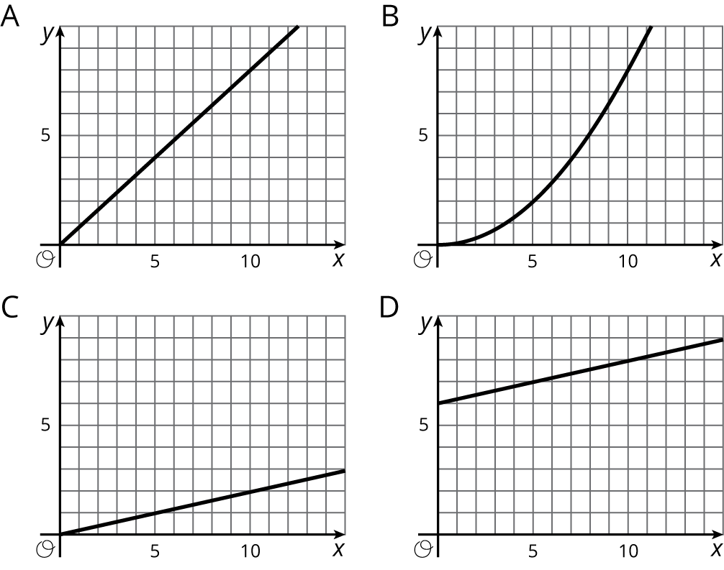
- (From Unit 2, Lesson 10.)
© CC BY Open Up Resources. Adaptations CC BY IM.

