Unit 4 Lesson 3: Division Situation Drawings

Number Talk: The More Things Change... (Warm up)

Student Task Statement
Find the value of each expression mentally.
- $120+120$
- $121+119$
- $125+115$
- $129+111$

1 Groups of Students

Student Task Statement
- What did you notice about how the students put themselves into groups of 2?
- What did you notice about how the students put themselves into 2 groups?

2 Elena’s Colored Pencils

Student Task Statement
Elena has 12 colored pencils. She has 2 boxes and wants to put the same number of colored pencils in each box. How many colored pencils will go in each box?
Which drawing matches the situation? Explain your reasoning.
A
B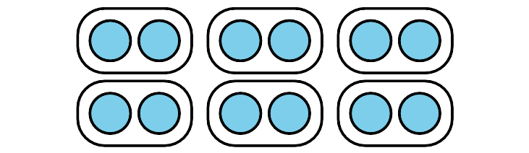
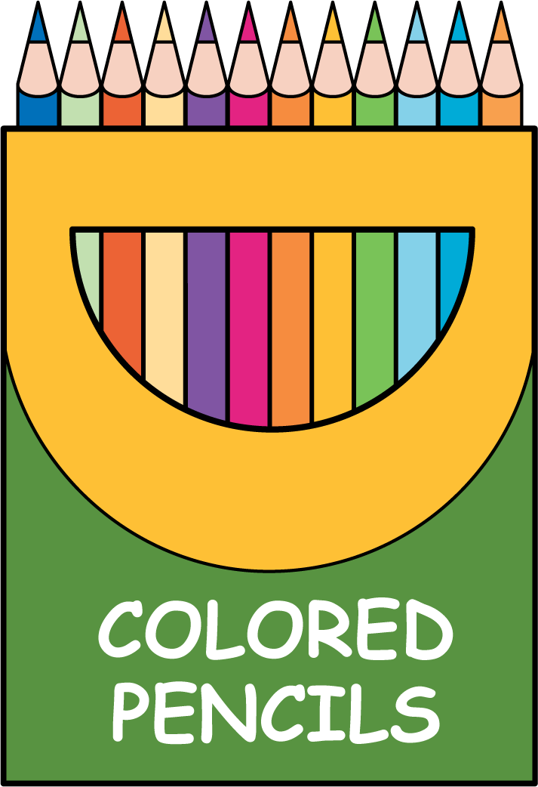

3 Which Drawing Matches?

Student Task Statement
Match each situation to a drawing. Be prepared to explain your reasoning.
- Mai has 8 markers. She puts 4 markers in each box. How many boxes of markers are there?
- Kiran has 20 pens. He puts 2 pens at each table. How many tables can he put pens on?
- Lin has 8 colored pencils. She puts them into 2 bags. Each bag has the same number of colored pencils. How many colored pencils will be in each bag?
- Priya has 15 crayons. She puts 5 crayons on each desk. How many desks will have crayons?
- Noah has 20 pencils. He puts the same number of pencils into 10 boxes. How many pencils will be in each box?
- Jada has 15 markers. She puts the same number of markers on 3 tables. How many markers will be on each table?
A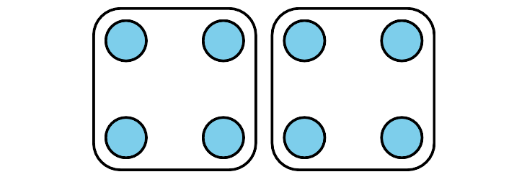
B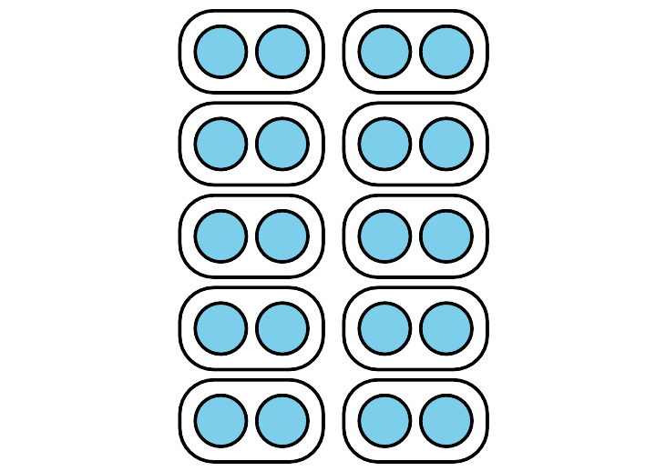
C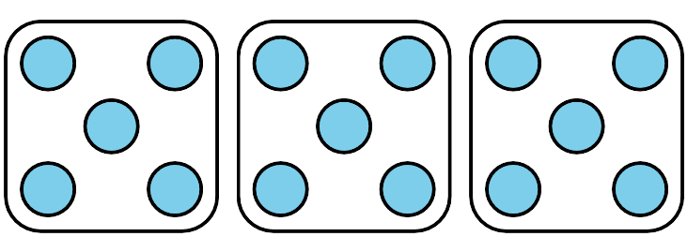

Activity Synthesis
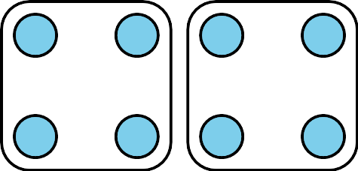

Images for Activity Synthesis
© CC BY 2021 Illustrative Mathematics®

