Lesson 2: Puntos en la cuadrícula de coordenadas

Standards Alignments
Addressing | 5.G.A.1
Building Towards | 5.G.A.1

Teacher-facing Learning Goals
- Locate and name given points on the coordinate grid by using an ordered pair of numbers, called coordinates.

Student-facing Learning Goals
- Ubiquemos puntos en la cuadrícula de coordenadas.

Lesson Purpose
The purpose of this lesson is for students to locate and describe points on the coordinate grid.
In this lesson students use the numbers on the horizontal and vertical axes to describe the location of points in the plane and then learn that these numbers are called the coordinates of points. They learn that the point $\left(5,2\right)$, for example, is on the vertical line labeled 5 and the horizontal line labeled 2. The number 5 is called the horizontal coordinate of $\left(5,2\right)$ and the number 2 is called its vertical coordinate. Students practice identifying the coordinates of points and plot points with given coordinates. It gives students a reason to attend to the location and coordinates of each point and to use language precisely to describe them (MP6).

Access for:

Students with Disabilities
- Representation (Activity 2)

Instructional Routines
MLR1 Stronger and Clearer Each Time (Activity 1), Notice and Wonder (Warm-up)

Materials to Copy
- What's the Point (groups of 2): Activity 1

Lesson Timeline
Warm-up | 10 min
Activity 1 | 20 min
Activity 2 | 15 min
Lesson Synthesis | 10 min
Cool-down | 5 min

Teacher Reflection Question
Who participated in math class today? What assumptions are you making about those who did not participate? How can you leverage each of your student’s ideas to support them in being seen and heard in tomorrow’s math class?

Cool-down
(to be completed at the end of the lesson) 5min
Coordenadas

Standards Alignments
Addressing | 5.G.A.1

Student-facing Task Statement
- ¿Cuáles son las coordenadas del punto $R$?
- 0
- 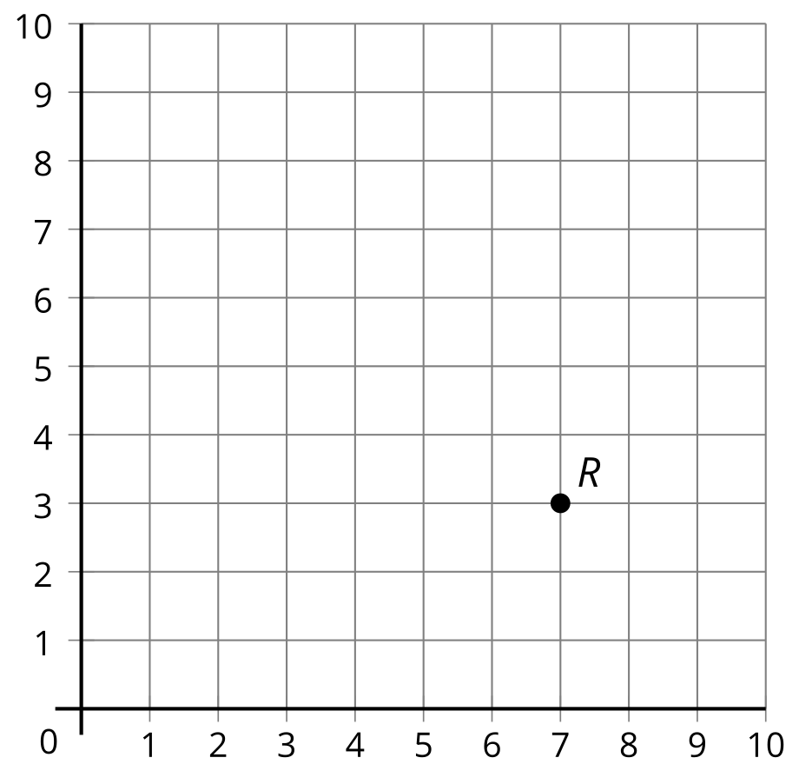
- 0
- Ubica el punto $T$ en (3,7).

Student Responses
- $\left(7,3\right)$
- 