Lesson 10: Beyond $2π$
- Let’s go around a circle more than once.

10.1: All the Way Around
Here is a unit circle with a point $A$ marked at $\left(1,0\right)$. For each angle of rotation listed here, mark the new location of $A$ on the unit circle. Be prepared to explain your reasoning.
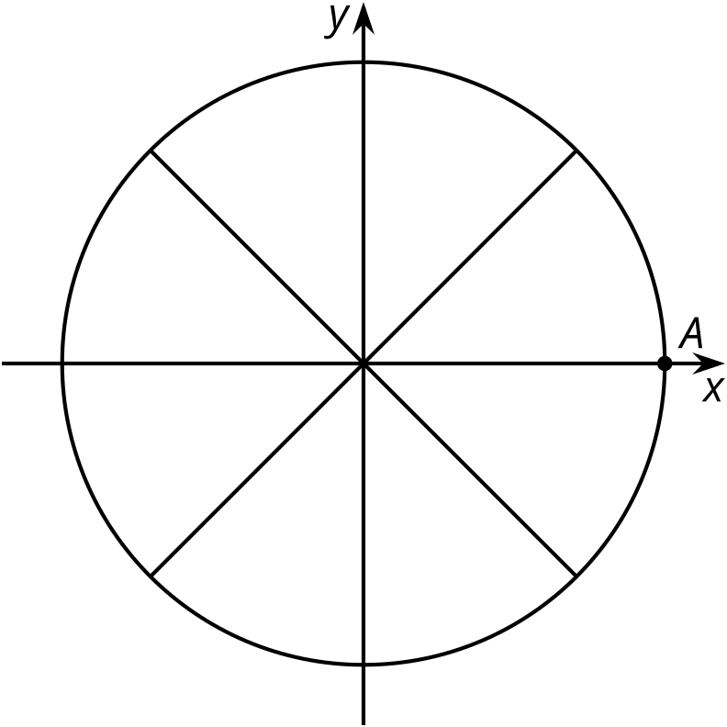
- $B$, $\frac{π}{3}$
- $C$, $\frac{4π}{3}$
- $D$, $\frac{7π}{4}$
- $E$, $\frac{5π}{2}$
- $F$, $\frac{6π}{2}$

10.2: Going Around and Around and Around
The center of a windmill is $\left(0,0\right)$ and it has 5 blades, each 1 meter in length. A point $P$ is at the end of the blade that is pointing directly to the right of the center. Here are graphs showing the horizontal and vertical distances of point $P$ relative to the center of the windmill as the blades rotate counterclockwise.
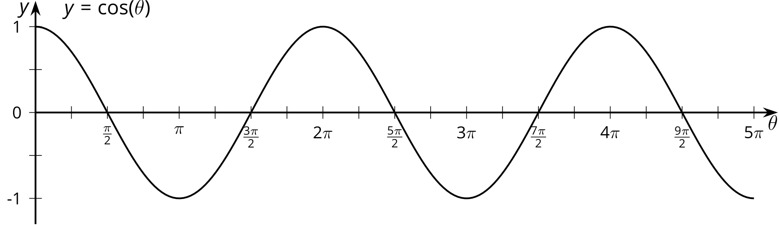
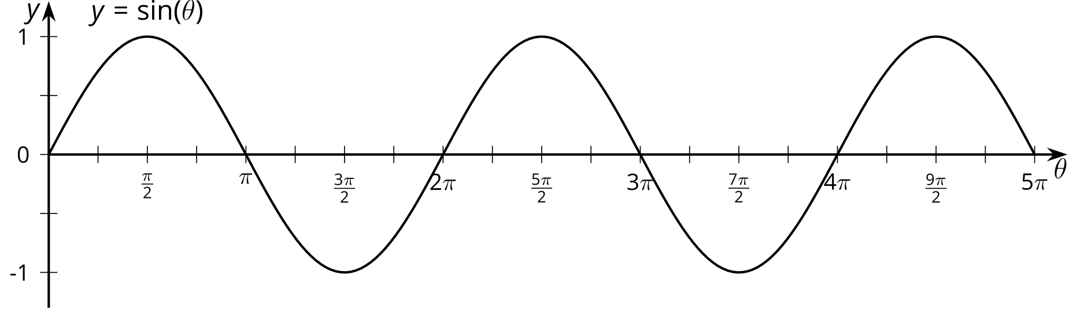
- How many full rotations are shown by the graphs? Explain how you know.
- What do the values of the graphs at $θ=3π$ mean in this context?
- List some different angles of rotation that bring $P$ to the highest point in its circle of rotation. What do you notice about these angles?
- How many angles show point $P$ at a height of 0.71 meters? Explain or show your reasoning.

10.3: Back to Where We Started
- The point $P$ on the unit circle has coordinates $\left(1,0\right)$. For each angle of rotation, state the number of rotations defined by the angle and then identify the coordinates of $P$ after the given rotation.
- 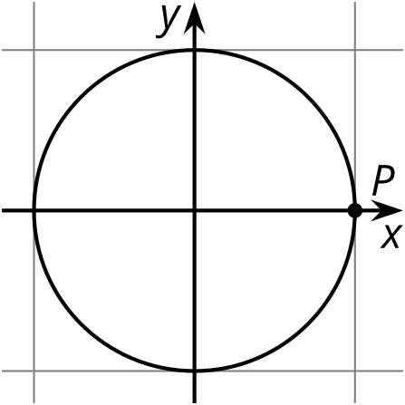
- rotation in radians | - number of rotations | - horizontal coordinate | - vertical coordinate
- $\frac{3π}{2}$ | - 0.75 | - 0 | - -1
- $\frac{25π}{12}$
- $\frac{5π}{2}$
- $\frac{7π}{3}$
- $\frac{49π}{12}$
- $5π$
- In general, if $θ$ is greater than $2π$ radians, explain how you can use the unit circle to make sense of $cos\left(θ\right)$ and $sin\left(θ\right)$.

Are you ready for more?
- For each angle of rotation in the activity, determine the minimum number of times you could repeat the rotation to end up back at the point $P$.
- Is it possible to have a rotation that no matter how many times it repeats, you never end up back exactly at $P$? Explain your reasoning.

Lesson 10 Summary
Here is a wheel with radius of 1 foot centered at $\left(0,0\right)$. What happens to point $P$ if we rotate the wheel one full circle? Two full circles? 12 full circles? To someone who didn’t watch us turn the wheel, it would look like we had not moved the wheel at all since all of these rotations take point $P$ right back to where it started.
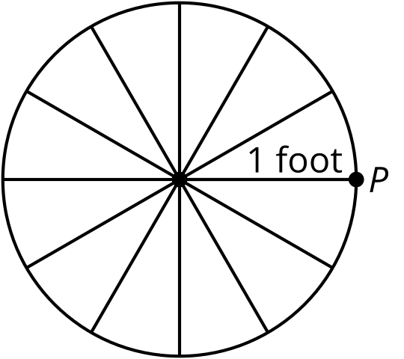
Here is a table showing different counterclockwise rotation amounts and the $x$-coordinate of the corresponding point.
Notice that when the angle measure increases by $2π$, the $x$-coordinate of point $P$ stays the same. This makes sense because $2π$ radians is a full rotation. In terms of functions, the cosine function, $cos\left(θ\right)$, gives the $x$-coordinate of the point on the unit circle corresponding to $θ$ radians. Since one full circle is $2π$ radians, this means for any input $θ$, adding multiples of $2π$ will not change the value of the output. As seen in the table, the value of $cos\left(2π\right)$ is the same as $cos\left(2π+2π\right)$, which is the same as $cos\left(2π+2π+2π\right)$, and so on.
rotations | angle measure  in radians | $x$-coordinate  of $P$
$\frac{1}{4}$ | $\frac{π}{2}$ | 0
1 | $2π$ | 1
$\frac{5}{4}$ | $\frac{5π}{2}$ | 0
2 | $4π$ | 1
$\frac{9}{4}$ | $\frac{9π}{2}$ | 0
3 | $6π$ | 1
We can also see this from the graph of $y=cos\left(θ\right)$. To see when $cos\left(θ\right)$ takes the value 1, here is a graph of $y=cos\left(x\right)$ and $y=1$. Notice that they meet each time the input $θ$ changes by $2π$ which makes sense as that represents one full rotation around the unit circle.
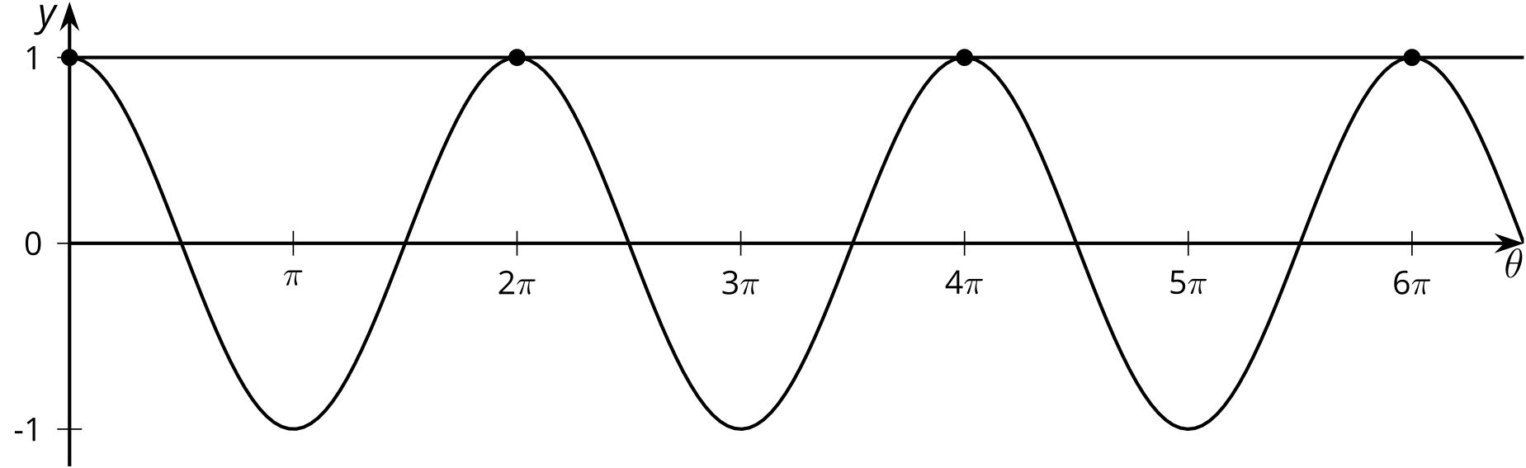
© CC BY 2019 by Illustrative Mathematics®

