Unit 6 Lesson 19: Compare to 1

WU What Do You Know About $\frac{15}{14}×\frac{23}{30}$? (Warm up)

Student Task Statement
What do you know about $\frac{15}{14}×\frac{23}{30}$?

1 Compare Fraction Products on the Number Line

Student Task Statement
- Match the expressions and number lines that show the same value.
  - $\frac{2}{5}×\frac{4}{3}$
  - $\frac{3}{4}×\frac{5}{2}$
  - $\frac{4}{3}×\frac{5}{2}$
  - $\left(1+\frac{1}{3}\right)×\frac{5}{2}$
  - $\left(1−\frac{3}{5}\right)×\frac{4}{3}$
  - $\left(1−\frac{1}{4}\right)×\frac{5}{2}$
- A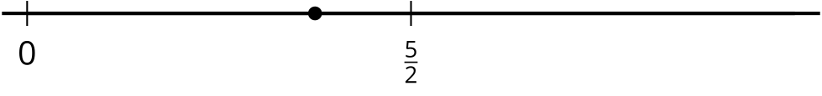
- B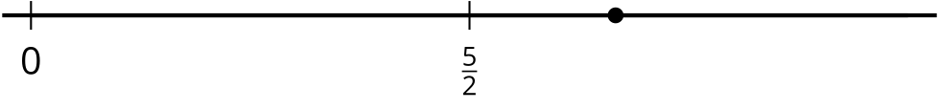
- C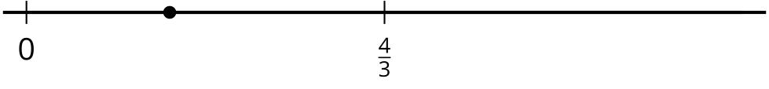
- Choose one of the expressions from each set and explain whether the value is greater than or less than the second factor.

2 True Statement

Student Task Statement
- Rewrite each expression as a sum or difference of 2 products.
  - $\left(1−\frac{2}{5}\right)×\frac{4}{7}$
  - $\left(1+\frac{1}{5}\right)×\frac{4}{7}$
  - $\left(1−\frac{3}{8}\right)×\frac{4}{7}$
  - $\left(1+\frac{1}{8}\right)×\frac{4}{7}$
- Fill in each blank with $<$ or $>$ to make the inequality true.
  - $\left(1−\frac{2}{5}\right)×\frac{4}{7} \underset{_}{} \frac{4}{7}$
  - $\left(1+\frac{1}{5}\right)×\frac{4}{7} \underset{_}{} \frac{4}{7}$
  - $\left(1−\frac{3}{8}\right)×\frac{4}{7} \underset{_}{} \frac{4}{7}$
  - $\left(1+\frac{1}{8}\right)×\frac{4}{7} \underset{_}{} \frac{4}{7}$
- Describe the value of the product when $\frac{4}{7}$ is multiplied by a fraction greater than 1. Explain your reasoning.
- Describe the value of the product when $\frac{4}{7}$ is multiplied by a fraction less than 1. Explain your reasoning.
© CC BY 2021 Illustrative Mathematics®

