Lesson 19: Fraction Games
- Let’s multiply and divide with fractions.

Warm-up: Estimation Exploration: Multiply Fractions
$28×2\frac{8}{9}$
Record an estimate that is:
too low | about right | too high

19.1: Largest Product or Quotient
For each expression, work with your partner to decide what is the greatest product or quotient you can make with the numbers 1, 2, 3, 4, 5, and 6. For each expression, you can only use each number once. Explain or show your reasoning.
- 00000000000×0000000000
- 0000÷100000
- 100000÷00000

19.2: Smallest Product or Quotient
For each expression, work with your partner to decide what is the smallest product or quotient you can make with the numbers 1, 2, 3, 4, 5, and 6. You can only use each number once for each expression. Explain or show your reasoning.
- 00000000000×0000000000
- 0000÷100000
- 100000÷00000

Section Summary
Section Summary
We used the relationship between multiplication and division to write both multiplication and division equations to represent the same situation. For example, there are 2 pounds of beef in the package. Each burger uses $\frac{1}{4}$ pound. How many burgers will the package make? We can write $2÷\frac{1}{4}=8$ and $8×\frac{1}{4}=2$ to represent the situation.
We also wrote multiplication and division equations to represent the same diagram. For example:
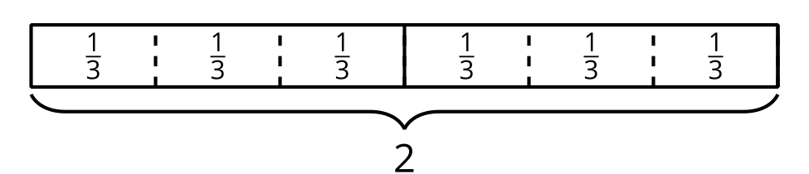
We can write $6×\frac{1}{3}=2$ because the diagram shows 6 groups of $\frac{1}{3}$ and the total value is 2. We can also write $2÷\frac{1}{3}=6$ because the diagram shows that the number of groups of $\frac{1}{3}$ in 2 is 6.
© CC BY 2021 Illustrative Mathematics®

