Lesson 17: Let’s Make a Dollar

Standards Alignments
Addressing | 2.MD.C.8, 2.NBT.B.5, 2.NBT.B.6

Teacher-facing Learning Goals
- Find combinations of coins that have a value of 100 cents.
- Understand that a dollar has the same value as 100 cents.

Student-facing Learning Goals
- Let’s make a dollar.

Lesson Purpose
The purpose of this lesson is for students to add and subtract within 100 to find values of100 cents and recognize a dollar as the same value as 100 cents.
In previous lessons, students learned the values of quarters, dimes, nickels, and pennies. They used strategies for adding within 100 to find the total value of a set of coins and found different combinations of coins that have the same value.
In this lesson, students find different combinations of coins that have a value of 100 cents. They learn that a dollar has the same value as 100 cents. Thinking about 1 dollar and 100 cents as the same amount connects to students understanding that a hundred is the same as 10 tens or 100 ones. They can use this understanding to support making a dollar out of dimes and other coin denominations.
Students count groups of coins that have a value that is more than 100 cents. Students may count coins to make 100 cents, and then count the value of the coins that are left over. Students record the value of the coins as “1 dollar and _____ cents.” In grade 2, students will not write dollars and cents using decimal notation, as this notation is reserved for their study of decimals and fractions in grade 4 and beyond.

Access for:

Students with Disabilities
- Engagement (Activity 2)

English Learners
- MLR8 (Activity 1)

Instructional Routines
Number Talk (Warm-up)

Lesson Timeline
Warm-up | 10 min
Activity 1 | 15 min
Activity 2 | 20 min
Lesson Synthesis | 10 min
Cool-down | 5 min

Teacher Reflection Question
How did students' understanding of base-ten units and place value support them as they combined coins to make 100 cents or a dollar? How can you help make these connections more clear in upcoming lessons?

Cool-down
(to be completed at the end of the lesson) 5min
Dollars and Cents

Standards Alignments
Addressing | 2.MD.C.8, 2.NBT.B.5

Student-facing Task Statement
What is the total value of these coins? _________________________
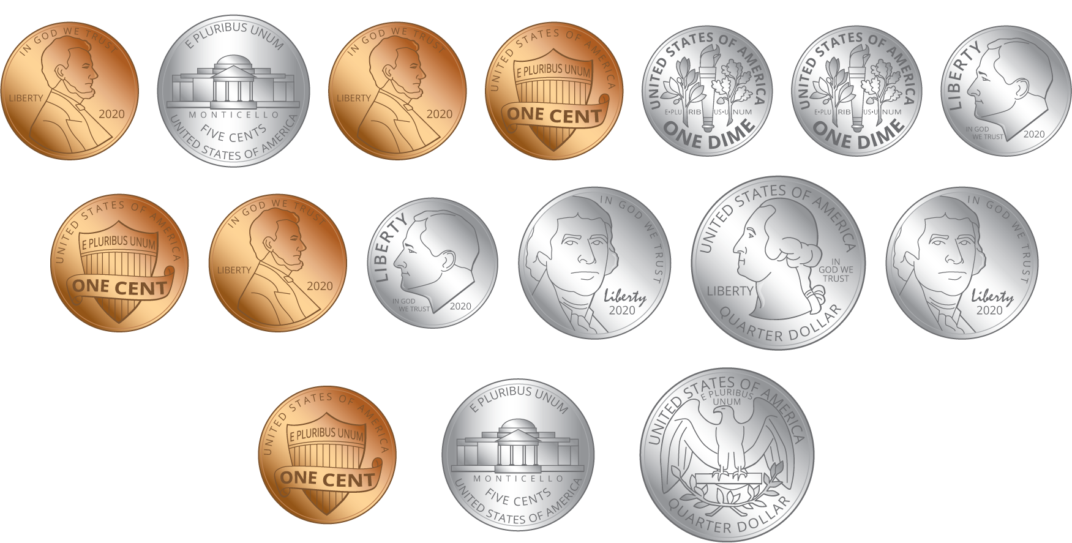
Show your thinking.

Student Responses
1 dollar and 16 cents or 116 cents
Sample response:
Students circle 2 quarters, 4 dimes, and 2 nickels.
$25+25=50$
$50+\left(10+10+10+10\right)=90$
$90+\left(5+5\right)=100$
I have 2 nickels, which is 10 cents, and 6 pennies left.
So there’s a dollar and 16 cents.

