Lesson 2: Match Representations of Tens
- Let’s match different representations of numbers.

Warm-up: Estimation Exploration: Cubes and Towers
Round 1: How many cubes?
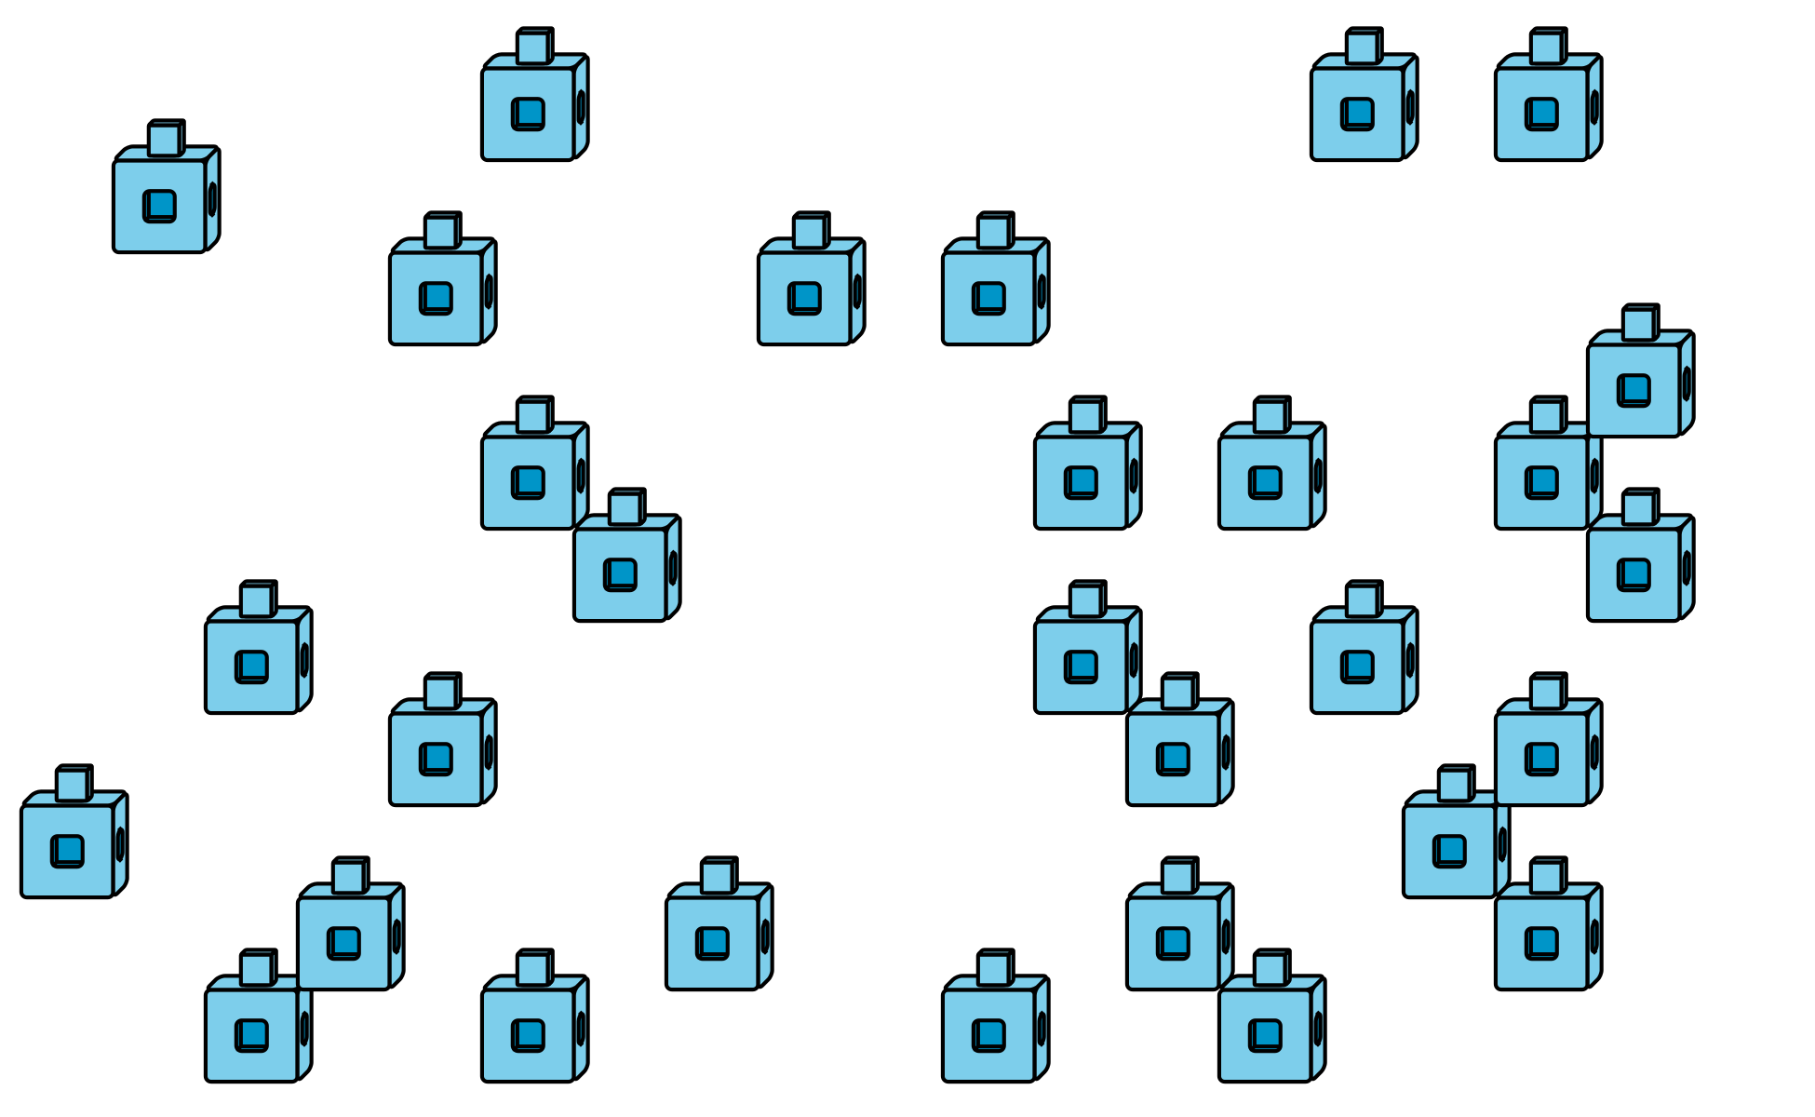
Record an estimate that is:
too low | about right | too high
Round 2: How many cubes?
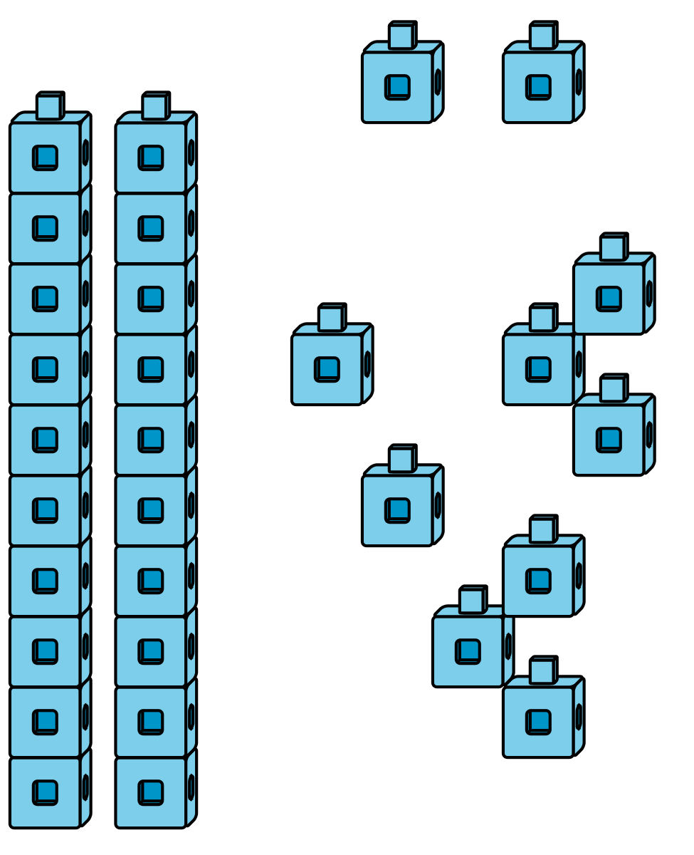
Record an estimate that is:
too low | about right | too high
© CC BY 2021 Illustrative Mathematics®

