Unit 1 Lesson 10: Drawings, Situations, and Diagrams, Oh My!

WU Notice and Wonder: Socks (Warm up)

Student Task Statement
What do you notice? What do you wonder?
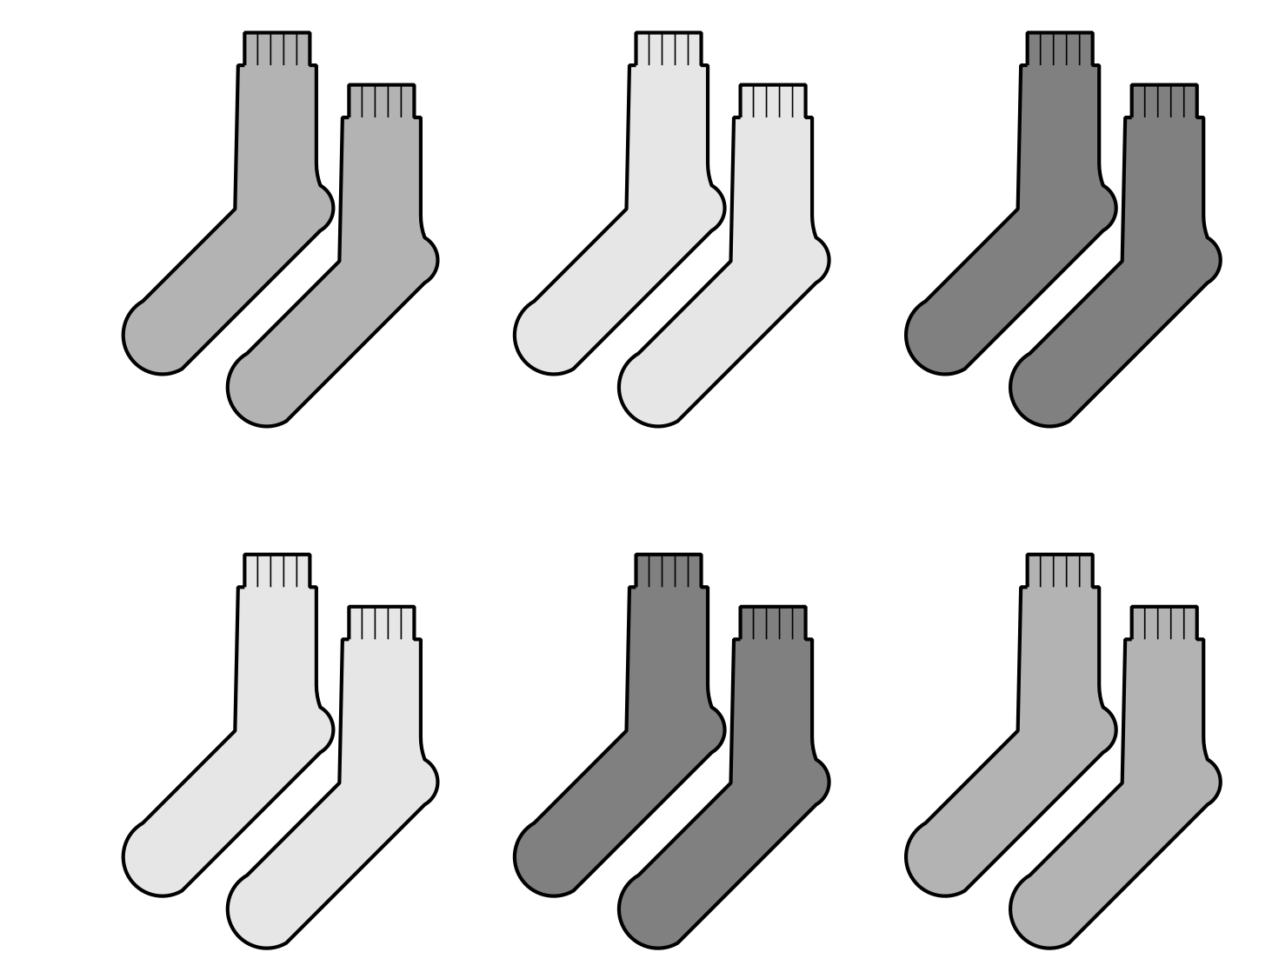

1 Scaled Picture Graph to Diagram

Student Task Statement
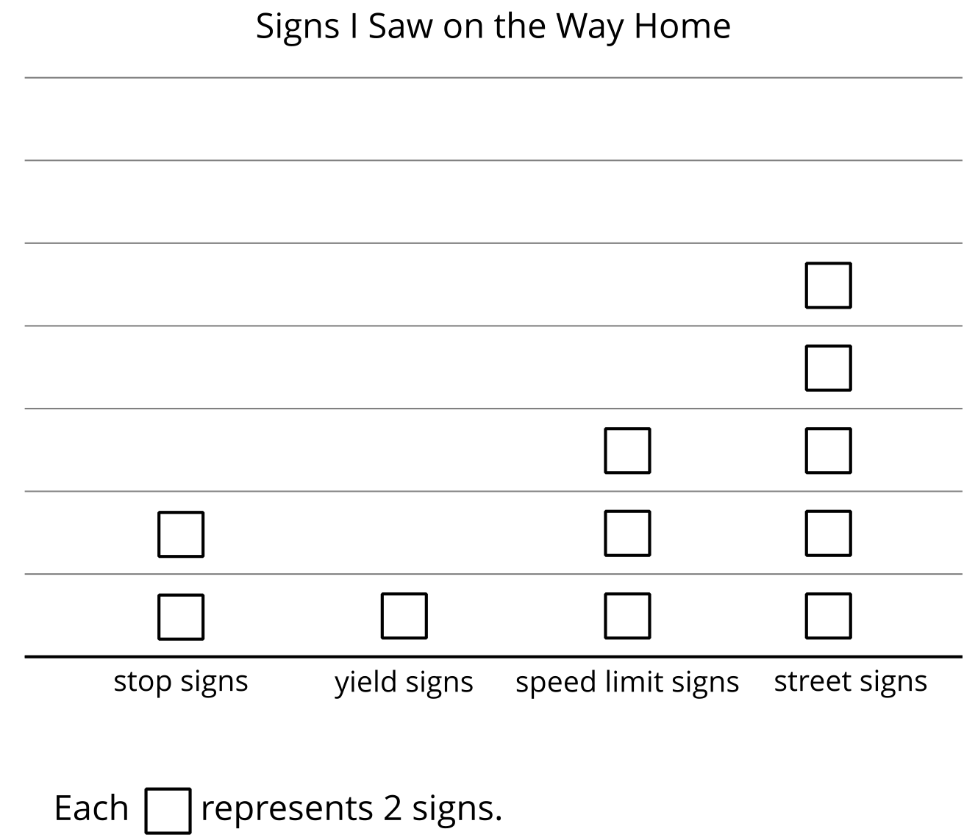
- How does the diagram show the speed limit signs that Elena saw on the way home?
- Represent the data from another category in the graph with your own drawing or diagram.

2 Card Sort: Equal Groups

Student Task Statement
- Your teacher will give you a set of cards that show drawings, situations, and diagrams. Find the cards that match. Be ready to explain your reasoning.
- 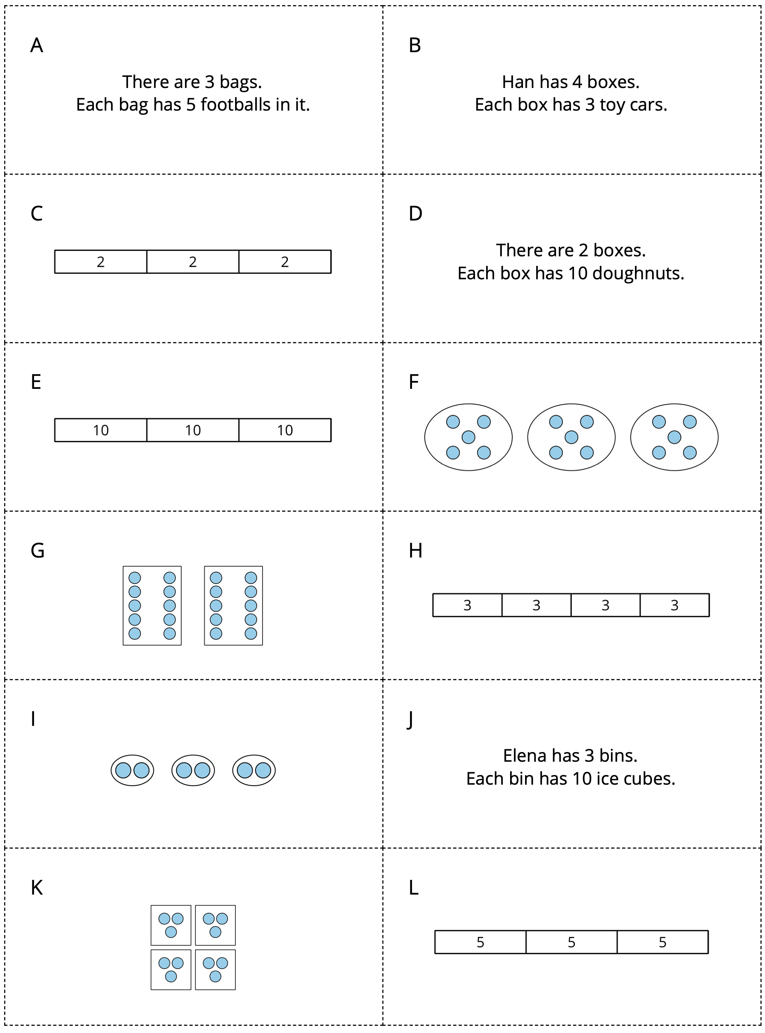
- Create a drawing or diagram for each situation.
  - There are 4 bags. Each bag has 2 strawberries.
  - There are 4 hands. Each hand has 5 fingers.

Images for Activity Synthesis
© CC BY 2021 Illustrative Mathematics®

