Lesson 6: Relate Fractions to Benchmarks
- Let’s compare the size of fractions to $\frac{1}{2}$ and to 1.

Warm-up: Notice and Wonder: A Point on a Number Line
What do you notice? What do you wonder?

6.1: Greater Than or Less Than 1?
For each diagram:
a. Name a fraction the point represents.
b. Is that fraction greater than or less than 1?
c. How far is it from 1?

- ​​​​​​
  - 00000
  - 00000
  - 00000

- ​​​​​​
  - 00000
  - 00000
  - 00000

- ​​​​​​
  - 00000
  - 00000
  - 00000

- ​​​​​​
  - 00000
  - 00000
  - 00000

6.2: Card Sort: Where Do They Belong?
Sort the cards from your teacher into three groups: less than $\frac{1}{2}$, equal to $\frac{1}{2}$, and greater than $\frac{1}{2}$. Be prepared to explain how you know.
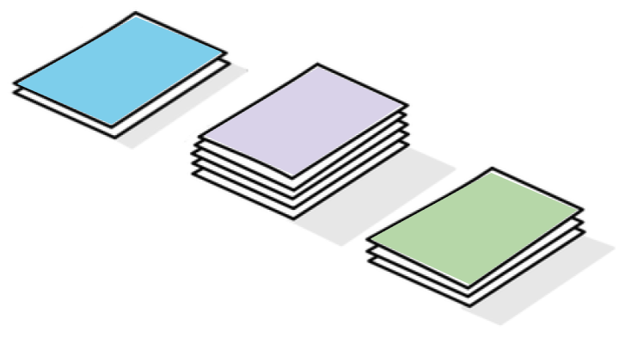
Record your sorting results here after you have discussed them with another group.
less than $\frac{1}{2}$ | equal to $\frac{1}{2}$ | greater than $\frac{1}{2}$
Complete the following sentences after class discussion:
- A fraction is less than $\frac{1}{2}$ when . . .
- A fraction is greater than $\frac{1}{2}$ when . . .
- A fraction is between $\frac{1}{2}$ and 1 when . . .

6.3: Greater Than or Less Than $\frac{1}{2}$?
For each diagram:
a. Name a fraction the point represents.
b. Is that fraction greater than or less than $\frac{1}{2}$?
c. How far is it from $\frac{1}{2}$?

  - 00000
  - 00000
  - 00000

  - 00000
  - 00000
  - 00000

  - 00000
  - 00000
  - 00000

  - 00000
  - 00000
  - 00000

Section Summary
Section Summary
In this section, we used fraction strips to represent fractions with denominators of 2, 3, 4, 5, 6, 8, 10, and 12. We also used the strips to reason about relationships between fifths and tenths, and between sixths and twelfths.
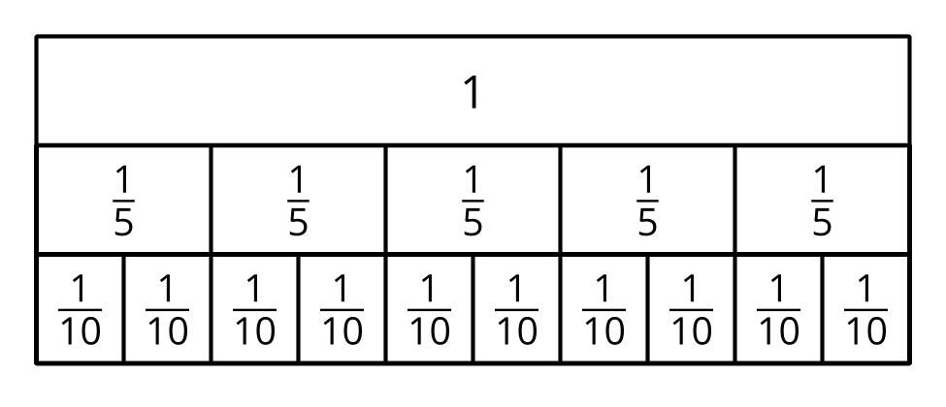
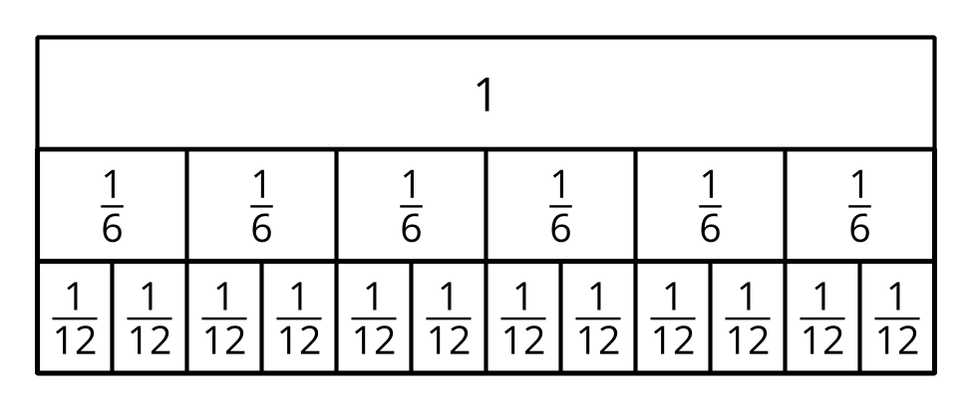
We learned that 2 tenths are equivalent to 1 fifth, or that splitting 5 fifths into two will produce 10 equal parts or tenths. When the denominator is larger, there are more parts in a whole.
We used what we learned about fraction strips to partition number lines and represent different fractions.
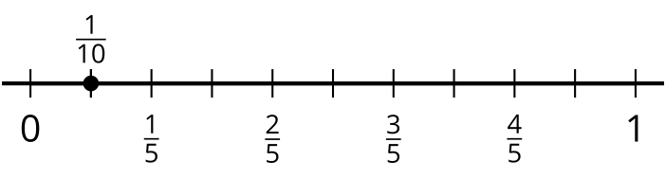
© CC BY 2021 Illustrative Mathematics®

