Unit 4 Lesson 17: Apply Rounding

WU Notice and Wonder: Plane Altitudes (Warm up)

Student Task Statement
What do you notice? What do you wonder?
plane | altitude (feet)
WN11 | 35,625
SK51 | 28,999
VT35 | 15,450
BQ64 | 36,000
AL16 | 31,000
AB25 | 35,175
CL48 | 16,600
WN90 | 30,775
NM44 | 30,245

1 Apart in the Air

Student Task Statement
- Altitude is the vertical distance from sea level. Here are the altitudes of ten planes.
- plane | - altitude (feet)
- WN11 | - 35,625
- SK51 | - 28,999
- VT35 | - 15,450
- BQ64 | - 36,000
- AL16 | - 31,000
- AB25 | - 35,175
- CL48 | - 16,600
- WN90 | - 30,775
- NM44 | - 30,245
- 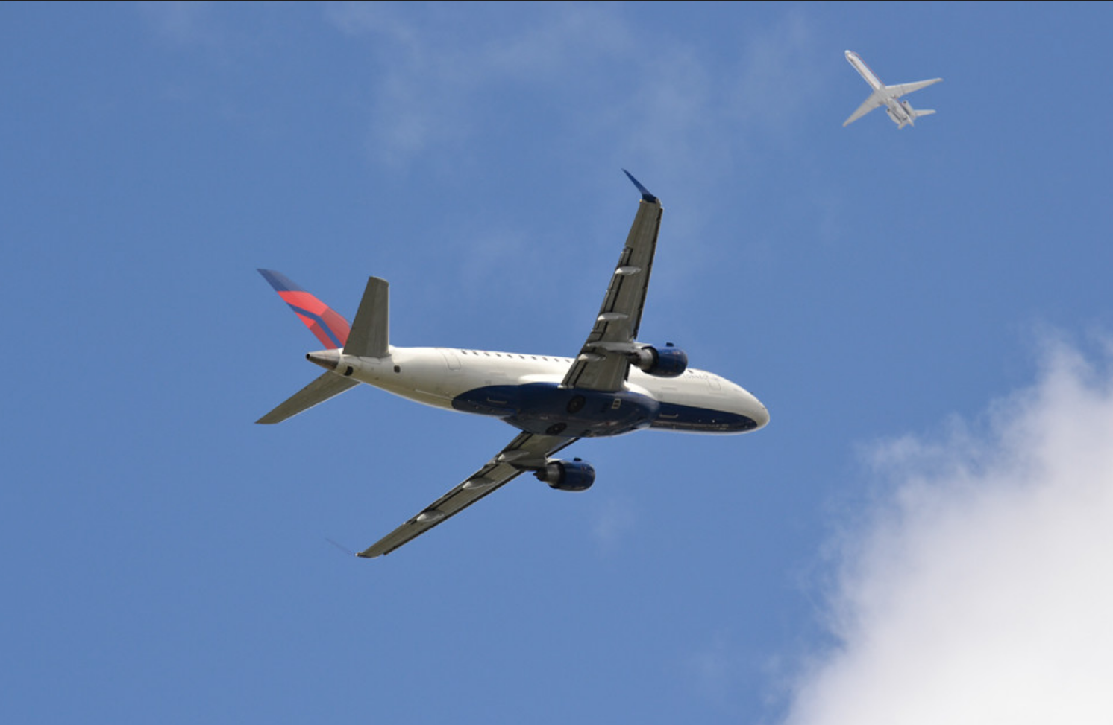

- Which planes are flying at about 30,000 feet? Explain or show your reasoning.
- Planes flying over the same area need to stay at least 1,000 feet apart in altitude.
- Mai said that one way to tell if planes are too close is to round each plane's altitude to the nearest thousand. Do you agree that this is a reliable strategy?
- In the last column, round each altitude to the nearest thousand. Use the rounded values to explain why or why not.

2 Safe or Unsafe?

Student Task Statement
Use the altitude data table from earlier for the following problems.
- Look at the column showing exact altitudes.
  - Find two or more numbers that are within 1,000 feet of one another. Mark them with a circle or a color.
  - Find another set of numbers that are within 1,000 feet of one another. Mark them with a square or a different color.
  - Based on what you just did, which planes are too close to one another?
- 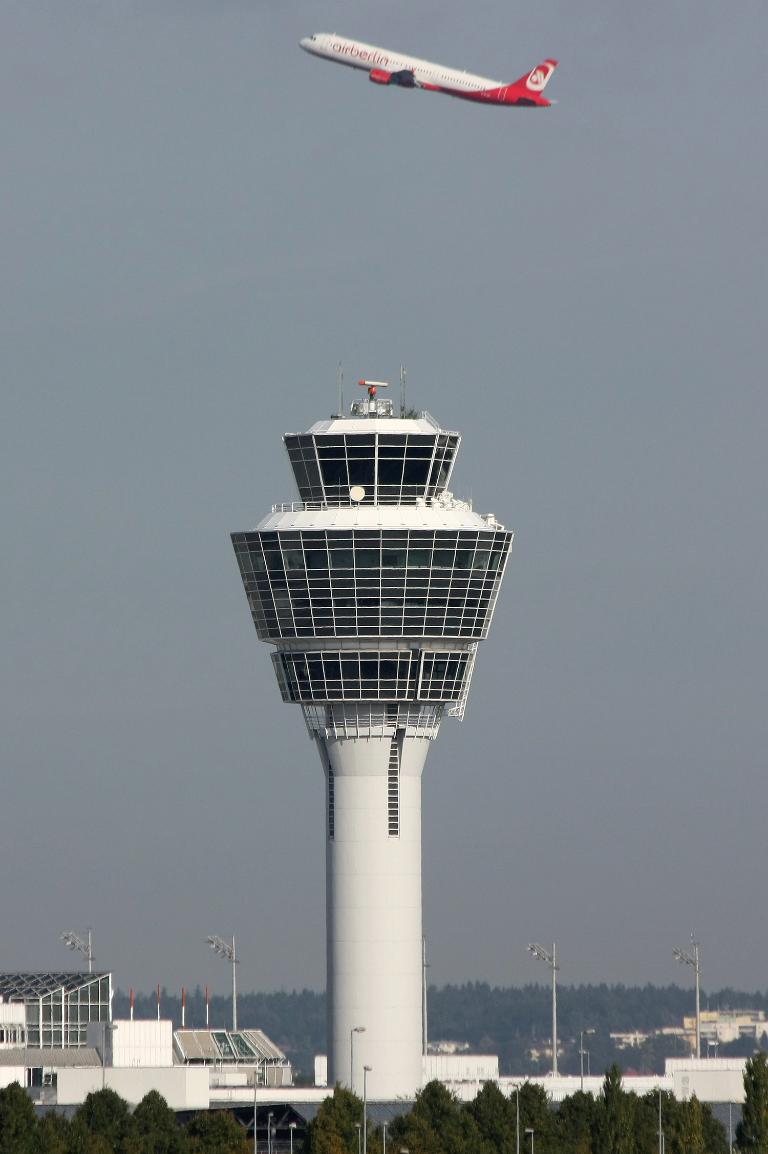
- Repeat what you just did with the rounded numbers in the last column. If we look there, which planes are too close to one another?
- Which set of altitude data should air traffic controllers use to keep airplanes safe while in the air? Explain your reasoning.
- Are there better ways to round these altitudes, or should we not round at all? Explain or show your reasoning.

3 No-phone Zone? (Optional)

Student Task Statement
In some countries, cell phone use is allowed on a flight only when the plane is at a certain altitude, usually around 40,000 feet.
Here are six planes and their altitudes.
plane | altitude (feet)
A | 40,990
B | 39,524
C | 36,138
D | 40,201
E | 35,472
F | 30,956
Jada says the passengers in all planes except for plane F can use their phones.
Elena says only those in B and D can do so.
Do you agree with either of them? Explain your reasoning.
© CC BY 2021 Illustrative Mathematics®

