Lesson 18: Money Problems

Standards Alignments
Addressing | 2.MD.C.8, 2.NBT.B.5, 2.OA.A.1

Teacher-facing Learning Goals
- Solve addition and subtraction story problems in the context of money.

Student-facing Learning Goals
- Let’s solve problems with money.

Lesson Purpose
The purpose of this lesson is for students to use addition and subtraction to solve story problems in the context of money.
In previous lessons, students used addition to find the total value of a set of coins and identified 100 cents as a dollar.
In this lesson, students solve story problems in the context of money. In the first activity, students continue practicing finding the value of a collection of coins and use the coins and their total value to solve problems in the context of a class store. In the second activity, students add and subtract values in cents in the same context, but are not provided images of coins. The second activity also gives students an opportunity to solve two-step story problems where the first step is not explicitly stated.

Access for:

Students with Disabilities
- Engagement (Activity 1)

English Learners
- MLR5 (Activity 1)

Instructional Routines
How Many Do You See? (Warm-up)

Lesson Timeline
Warm-up | 10 min
Activity 1 | 15 min
Activity 2 | 20 min
Lesson Synthesis | 10 min
Cool-down | 5 min

Teacher Reflection Question
Reflect on who participated in math class today. What assumptions are you making about those who did not participate? How can you leverage each of your student’s ideas to support them in being seen and heard in tomorrow’s math class?

Cool-down
(to be completed at the end of the lesson) 5min
Mai’s Supplies

Standards Alignments
Addressing | 2.MD.C.8

Student-facing Task Statement
- Mai has these coins to buy school supplies:
- 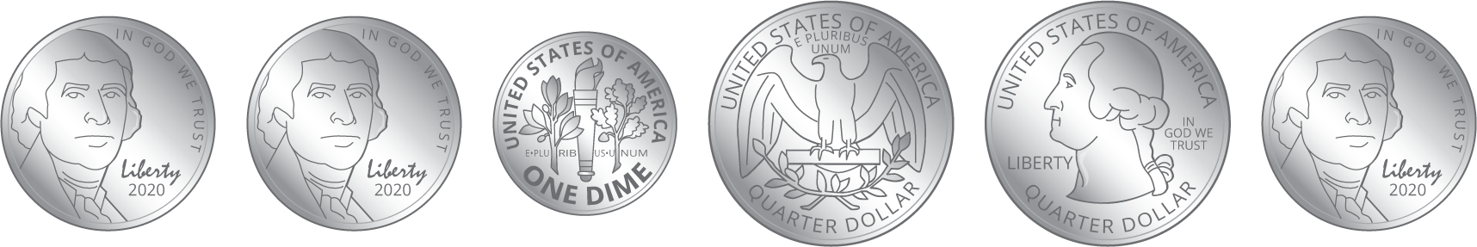
  - How much money does Mai have for supplies?
  - If Mai buys a pencil for 27¢, how much money will she have left?
Show your thinking using drawings, numbers, words, or an equation. If it helps, you can use a diagram.

Student Responses

  - 75¢ Sample response:
$25+25=50$
$50+10=60$
$60+15=75$
  - 48¢ Sample responses:
$75−27=48$
$75−20=55$
$55−5=50$
$50−2=48$

