Unit 1 Lesson 11: Multiplication Expressions

WU Choral Count: Twos and Fives (Warm up)

Student Task Statement

1 Multiplication Expression Match

Student Task Statement
Your teacher will give you a card showing a drawing, a diagram, or a situation.
Match it to one of the expressions posted around the room. Be prepared to explain your reasoning.

2 Expressions to Drawings and Diagrams

Student Task Statement
- Create a drawing or diagram for each expression. Explain your reasoning.
  - $5×2$
  - $3×4$
  - $3×10$
- Write your own expression and matching diagram. Explain your reasoning.

3 Write Multiplication Expressions

Student Task Statement
Write a multiplication expression to match each representation. Explain your reasoning.

- 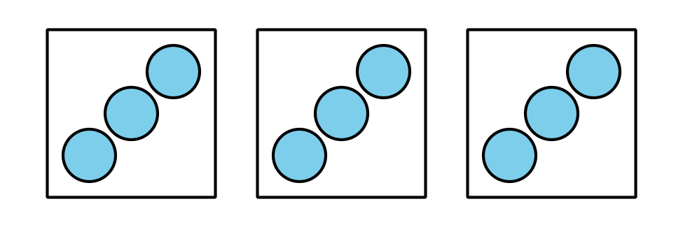

- There were 2 packs of water. Each pack had 6 bottles of water.
© CC BY 2021 Illustrative Mathematics®

