Unit 4 Lesson 18: Standard Algorithm to Add and Subtract

WU Estimation Exploration: What’s the Difference? (Warm up)

Student Task Statement
Estimate the difference: $42,​050−3,​790$.
Record an estimate that is:
too low | about right | too high

1 Weekly Steps

Student Task Statement
A teacher uses an app on her cell phone to track her physical activity. Here is the data on the number of steps over 5 school days.
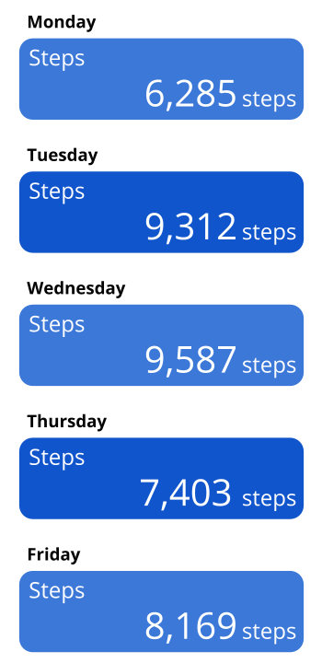
For each question, show your reasoning.
- On which two days did she take the most steps? Over those two days, how many steps did she take altogether?
- What is the difference in the number of steps she took on her most active day and on her least active day?
- Between Wednesday and Thursday, her activity level dropped. How many fewer steps did she take on Thursday than Wednesday?

2 Steps During the Weekend

Student Task Statement
The teacher also keeps track of the number of steps she took during the weekend. The data from Saturday and Sunday of that same week are shown.
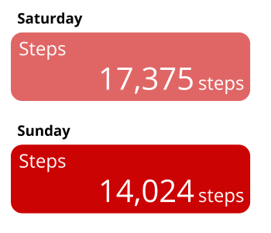
Here are two strategies to compute the total number of steps she took over the weekend.
Strategy A
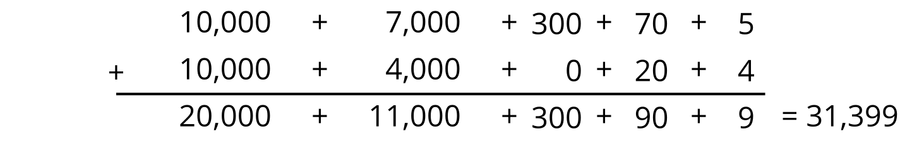
Strategy B
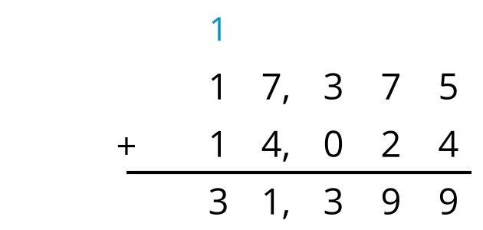
- Analyze the strategies. Discuss with your partner:
  - What is happening in each strategy?
  - How are they alike? How are they different?
- Use both strategies to find the difference between the number of steps the teacher took on Saturday and on Sunday.
- During another week, the teacher took 26,815 steps during the weekdays and 11,403 steps during the weekend. Use both strategies to find the total number of steps she took that week.
© CC BY 2021 Illustrative Mathematics®

