Lesson 3 Practice Problems
- Select all the equations that represent the hanger.
- 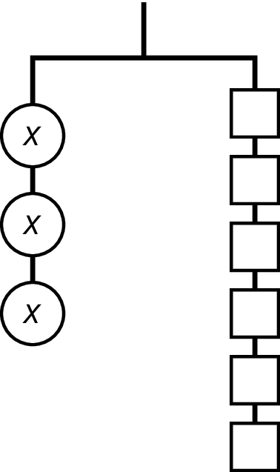
  - $x+x+x=1+1+1+1+1+1$
  - $x⋅x⋅x=6$
  - $3x=6$
  - $x+3=6$
  - $x⋅x⋅x=1⋅1⋅1⋅1⋅1⋅1$
- Write an equation to represent each hanger.
- 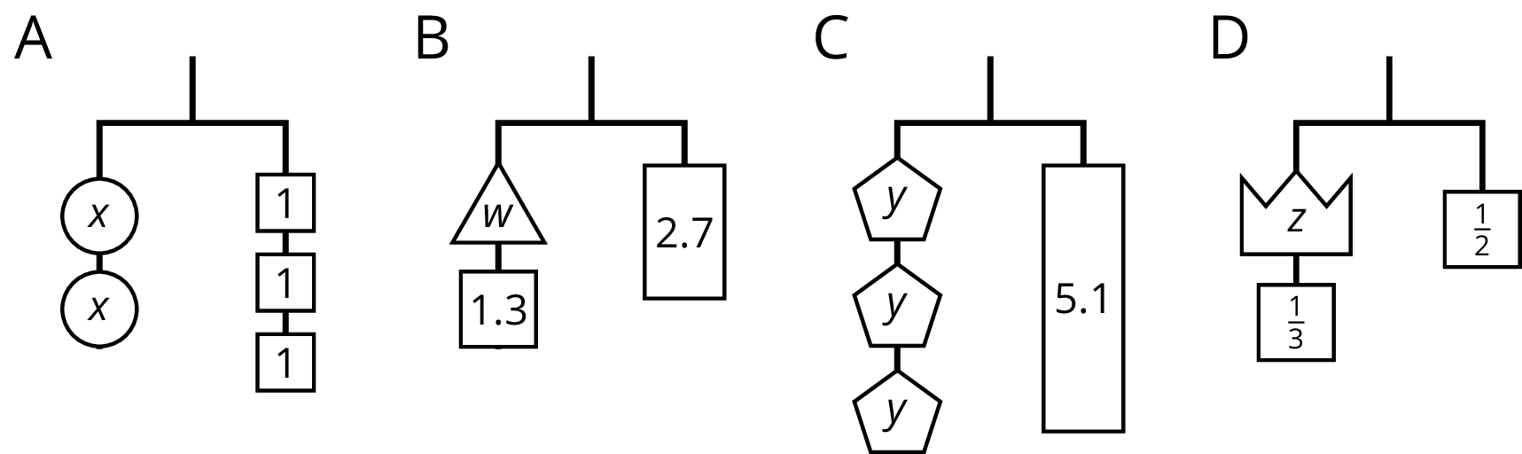

  - Write an equation to represent the hanger.
  - Explain how to reason with the hanger to find the value of $x$.
  - Explain how to reason with the equation to find the value of $x$.
- 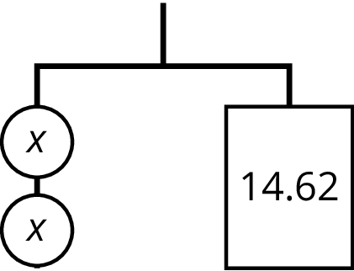
- Andre says that $x$ is 7 because he can move the two 1s with the $x$ to the other side.
- 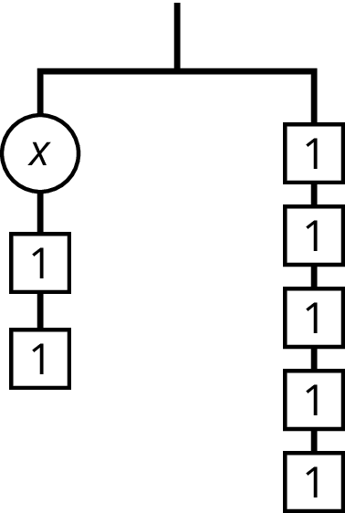
- Do you agree with Andre? Explain your reasoning.
- Match each equation to one of the diagrams.
  - $12−m=4$
  - $12=4⋅m$
  - $m−4=12$
  - $\frac{m}{4}=12$
- 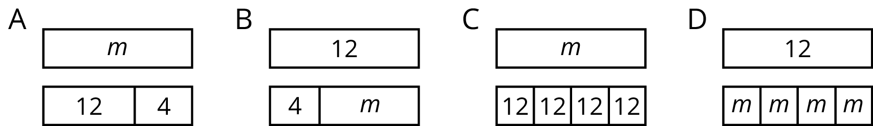
- (From Unit 6, Lesson 1.)
- The area of a rectangle is 14 square units. It has side lengths $x$ and $y$. Given each value for $x$, find $y$.
  - $x=2\frac{1}{3}$
  - $x=4\frac{1}{5}$
  - $x=\frac{7}{6}$
- (From Unit 4, Lesson 13.)
- Lin needs to save up $20 for a new game. How much money does she have if she has saved each percentage of her goal. Explain your reasoning.
  - 25%
  - 75%
  - 125%
- (From Unit 3, Lesson 11.)
© CC BY Open Up Resources. Adaptations CC BY IM.

