Unit 8 Lesson 18 Cumulative Practice Problems
- Lin wants to know if students in elementary school generally spend more time playing outdoors than students in middle school. She selects a random sample of size 20 from each population of students and asks them how many hours they played outdoors last week. Suppose that the MAD for each of her samples is about 3 hours.
- Select all pairs of sample means for which Lin could conclude there is a meaningful difference between the two populations.
  - elementary school: 12 hours, middle school: 10 hours
  - elementary school: 14 hours, middle school: 9 hours
  - elementary school: 13 hours, middle school: 6 hours
  - elementary school: 13 hours, middle school: 10 hours
  - elementary school: 7 hours, middle school: 15 hours
- These two box plots show the distances of a standing jump, in inches, for a random sample of 10-year-olds and a random sample of 15-year-olds.
- 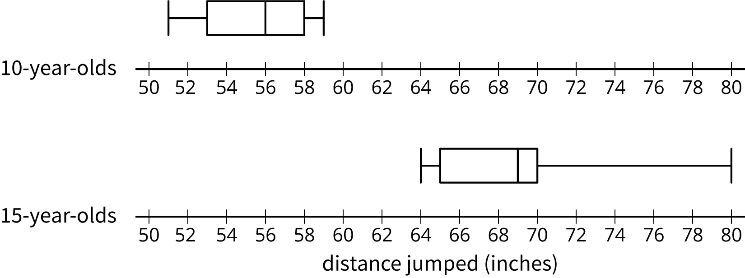
- Is there a meaningful difference in median distance for the two populations? Explain how you know.
- The median income for a sample of people from Chicago is about $60,000 and the median income for a sample of people from Kansas City is about $46,000, but researchers have determined there is not a meaningful difference in the medians. Explain why the researchers might be correct.
- A farmer grows 5,000 pumpkins each year. The pumpkins are priced according to their weight, so the farmer would like to estimate the mean weight of the pumpkins he grew this year. He randomly selects 8 pumpkins and weighs them. Here are the weights (in pounds) of these pumpkins:
- 2.9 | - 6.8 | - 7.3 | - 7.7 | - 8.9 | - 10.6 | - 12.3 | - 15.3

  - Estimate the mean weight of the pumpkins the farmer grew.
  - This dot plot shows the mean weight of 100 samples of eight pumpkins, similar to the one above.
  - 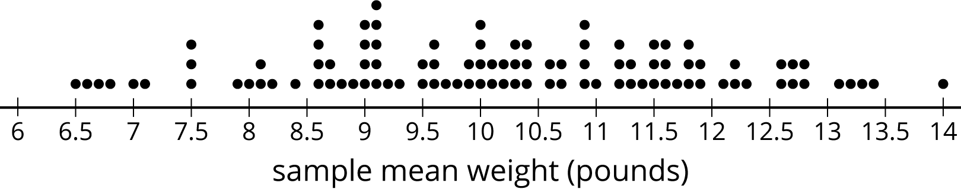
  - What appears to be the mean weight of the 5,000 pumpkins?
  - What does the dot plot of the sample means suggest about how accurate an estimate based on a single sample of 8 pumpkins might be?
  - What do you think the farmer might do to get a more accurate estimate of the population mean?
- (From Unit 8, Lesson 17.)
© CC BY Open Up Resources. Adaptations CC BY IM.

