Lesson 16 Practice Problems
- A vending machine has 5 colors (white, red, green, blue, and yellow) of gumballs and an equal chance of dispensing each. A second machine has 4 different animal-shaped rubber bands (lion, elephant, horse, and alligator) and an equal chance of dispensing each. If you buy one item from each machine, what is the probability of getting a yellow gumball and a lion band?
- The numbers 1 through 10 are put in one bag. The numbers 5 through 14 are put in another bag. When you pick one number from each bag, what is the probability you get the same number?
- When rolling 3 standard number cubes, the probability of getting all three numbers to match is $\frac{6}{216}$. What is the probability that the three numbers do not all match? Explain your reasoning.
- For each event, write the sample space and tell how many outcomes there are.
  - Roll a standard number cube. Then flip a quarter.
  - Select a month. Then select 2020 or 2025.
- (From Unit 8, Lesson 15.)
- On a graph of the area of a square vs. its perimeter, a few points are plotted.
- 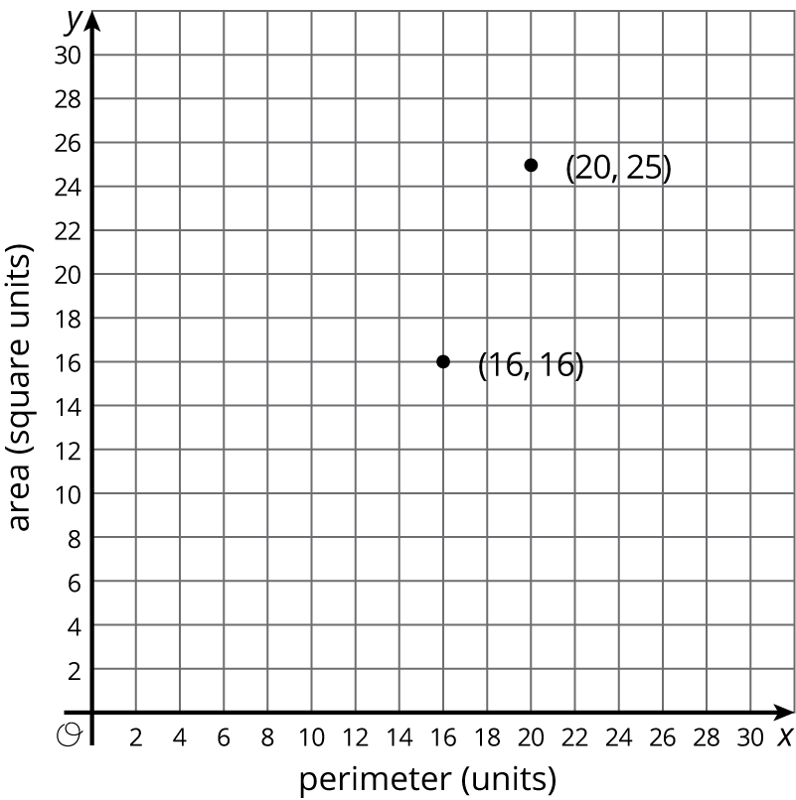
  - Add some more ordered pairs to the graph.
  - Is there a proportional relationship between the area and perimeter of a square? Explain how you know.
- (From Unit 5, Lesson 7.)
© CC BY Open Up Resources. Adaptations CC BY IM.

