Unit 4 Lesson 5: Write Division Expressions

Number Talk: What’s the Same? (Warm up)

Student Task Statement
Find the value of each expression mentally.
- $225−100$
- $227−102$
- $230−105$
- $220−95$

1 Card Sort: All about Bugs

Student Task Statement
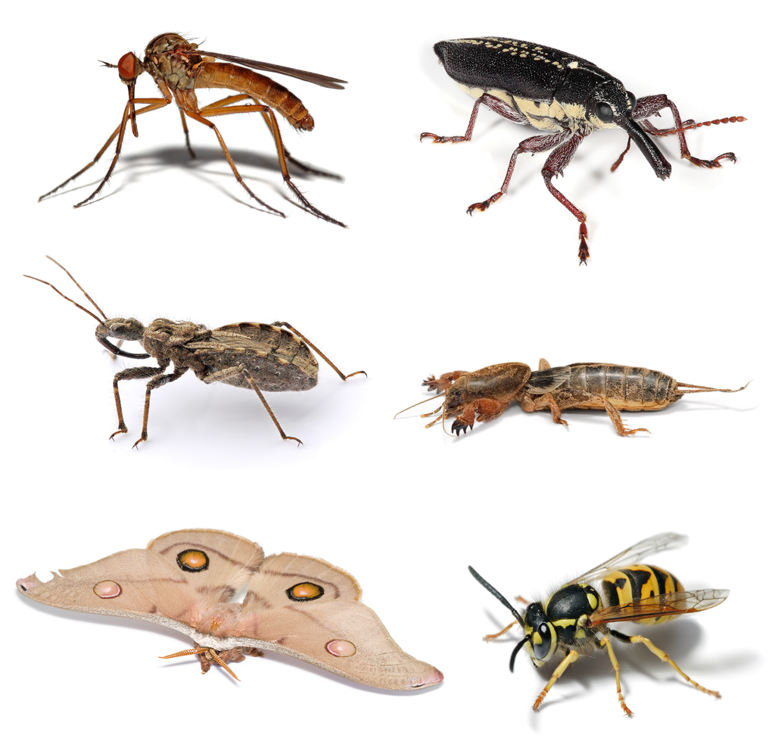
- Your teacher will give you a set of cards that show situations. Sort the cards into 2 categories of your choosing. Be prepared to explain the meaning of your categories.
- A. Mole crickets have special legs for digging. Ten special legs belong to 5 mole crickets. How many special legs does each mole cricket have?
- B. A beetle has a pair of antennae for sensing heat, touch, smell, and more. If there are 8 antennae, how many beetles are there?
- 00
- C. Fourteen antennae belong to a group of bees. If each bee has 2 antennae, how many bees are there?
- D. There are 12 wings. If each dragonfly has 4 wings, how many dragonflies are there?
- 00
- E. Thirty legs belong to 5 ants. If all the ants have the same number of legs, how many legs does each ant have?
- F. There are 50 spots on 5 butterflies. If each butterfly has the same number of spots, how many spots does each butterfly have?
- Write a division expression to represent each situation. Be ready to explain your reasoning.

2 Solve a Buggy Problem

Student Task Statement
Your teacher will assign a problem to your group.
Create a visual display that shows your thinking and your solution to the problem.
© CC BY 2021 Illustrative Mathematics®

