Lesson 4: Clasifiquemos cuadriláteros

Standards Alignments
Addressing | 5.G.B.3, 5.G.B.4
Building Towards | 5.G.B.3

Teacher-facing Learning Goals
- Classify quadrilaterals based on angle measurements and side lengths.

Student-facing Learning Goals
- Clasifiquemos cuadriláteros.

Lesson Purpose
The purpose of this lesson is for students to sort quadrilaterals and begin to notice the hierarchy and subcategories of quadrilaterals.
In grade 3, students understand that different shapes may share attributes. They learn that shapes with four sides are part of a larger category of shapes, called quadrilaterals. In grade 4, students classify two-dimensional shapes by attributes, such as angle sizes, and the presence of perpendicular or parallel lines containing the sides.
In this lesson, students sort quadrilaterals into categories in a way that makes sense to them, with an emphasis on side lengths, angles, perpendicular sides, and parallel sides. Students may begin to notice some relationships between categories of quadrilaterals. For example, they might notice that squares have 4 right angles like rectangles and their opposite sides are parallel like parallelograms. These relationships will be brought out more fully in the next several lessons. Students should have access to straight edges, protractors, and patty paper throughout this lesson.

Access for:

Students with Disabilities
- Representation (Activity 1)

Instructional Routines
MLR2 Collect and Display (Activity 1), What Do You Know About _____? (Warm-up)

Materials to Gather
- Dry erase markers: Activity 1
- Sheet protectors: Activity 1

Materials to Copy
- Guess Which One (groups of 2): Activity 1
- Card Sort Quadrilaterals (Grade 5) (groups of 2): Activity 2

Required Preparation

Lesson Timeline
Warm-up | 10 min
Activity 1 | 15 min
Activity 2 | 20 min
Lesson Synthesis | 10 min
Cool-down | 5 min

Teacher Reflection Question
In the next lesson, students consider subcategories within the hierarchy of quadrilaterals. Did students discuss subcategories or a hierarchy during today’s lesson? What questions can you ask tomorrow to encourage students to think about a hierarchy?

Cool-down
(to be completed at the end of the lesson) 5min
Escoge dos

Student-facing Task Statement
- Escoge dos cuadriláteros. ¿Cómo se llaman?
- 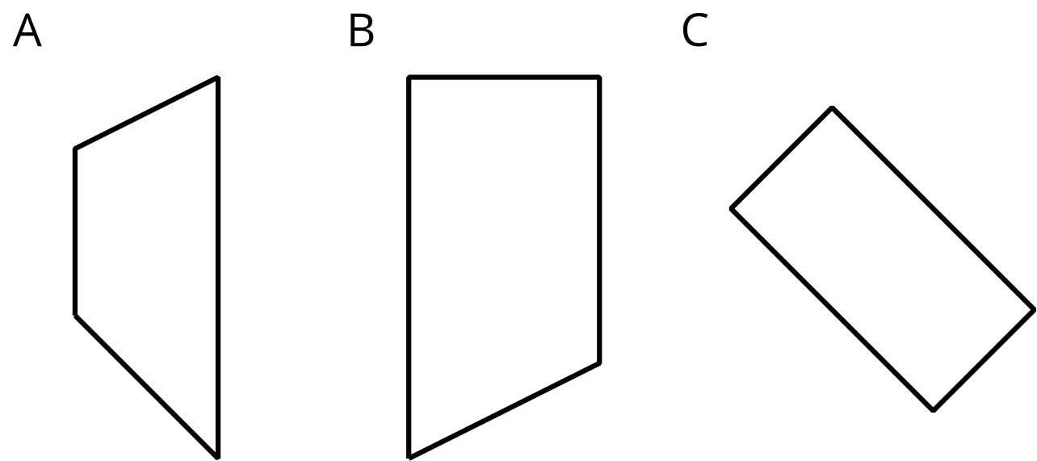
- Nombra una característica que tengan los dos cuadriláteros.
- ¿En qué son diferentes las dos figuras?

Student Responses
- A: trapezoid, B: trapezoid or right trapezoid, C: rectangle, parallelogram, or trapezoid (based on one of the definitions of trapezoid that is inclusive of parallelograms)
- A and B: Both are trapezoids. Only B has right angles.
- B and C: Both are quadrilaterals that have at least one pair of opposite sides that are parallel and at least one angle that is 90 degrees. However, they are different because C has all angles that are 90 degrees. C also has two pairs of opposite sides that have equal measure.
A and C: Both are quadrilaterals that have at least one pair of opposite sides that are parallel. C has two pairs of opposite sides parallel. C has all four angles that are 90 degrees whereas A has four angles that are all different measures.

