Lesson 15 Practice Problems
- A rectangle has side lengths of 6 units and 3 units. Could you make a quadrilateral that is not identical using the same four side lengths? If so, describe it.
- Come up with an example of three side lengths that can not possibly make a triangle, and explain how you know.
- In the diagram, the length of segment $AB$ is 10 units and the radius of the circle centered at $A$ is 4 units. Use this to create two unique triangles, each with a side of length 10 and a side of length 4. Label the sides that have length 10 and 4.
- 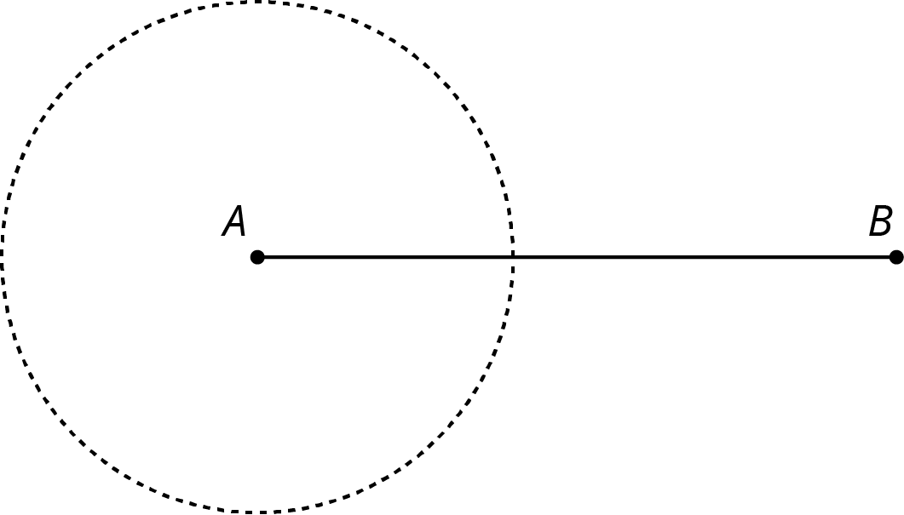
- Select all the sets of three side lengths that will make a triangle.
  - 3, 4, 8
  - 7, 6, 12
  - 5, 11, 13
  - 4, 6, 12
  - 4, 6, 10
- Based on signal strength, a person knows their lost phone is exactly 47 feet from the nearest cell tower. The person is currently standing 23 feet from the same cell tower. What is the closest the phone could be to the person? What is the furthest their phone could be from them?
- Here is quadrilateral $ABCD$.

- 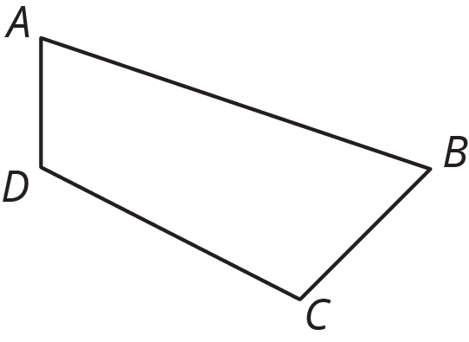

- Draw the image of quadrilateral $ABCD$ after each rotation using $B$ as center.
  - 90 degrees clockwise
  - 120 degrees clockwise
  - 30 degrees counterclockwise
- (From Unit 1, Lesson 2.)
© CC BY Open Up Resources. Adaptations CC BY IM.

