Unit 1 Lesson 12: Represent and Solve Multiplication Problems

WU How Many Do You See: Lots of Dots (Warm up)

Student Task Statement
How many do you see? How do you see them?

1 Tyler’s Boxes

Student Task Statement
Tyler has 3 boxes. He has 5 baseballs in each box. How many baseballs does he have altogether? Show your thinking using diagrams, symbols, or other representations.
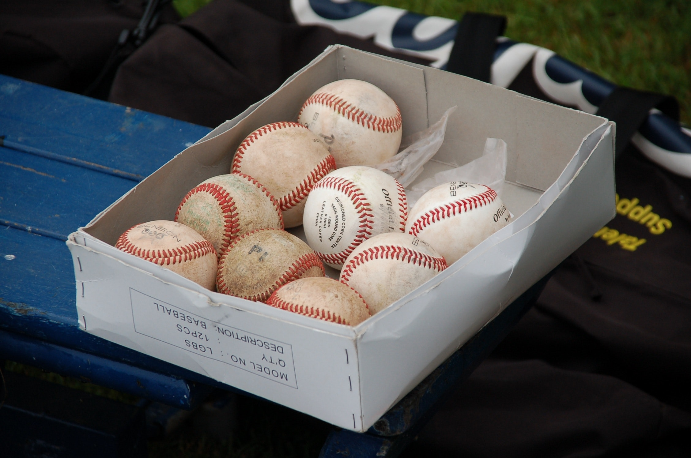

2 Solve Equal Groups Problems

Student Task Statement
Solve each problem. Show your thinking using diagrams, symbols, or other representations.
- There are 4 soccer fields. Two teams are on each field. How many teams are there altogether?
- There are 7 windows. Each window has 2 pieces of glass. How many pieces of glass are there in the windows?
- Jada has 5 bags. Each bag has 10 earrings. How many earrings does Jada have?
- Kiran has 4 boxes. Each box has 5 pencils in it. How many pencils does Kiran have?
- Andre has 3 bags of carrots. Each bag has 10 carrots. How many carrots does Andre have?
© CC BY 2021 Illustrative Mathematics®

