Unit 4 Lesson 19: Compose and Decompose to Add and Subtract

WU Number Talk: Subtract Fractions (Warm up)

Student Task Statement
Find the value of each expression mentally.
- $2\frac{3}{4}−1\frac{1}{4}$
- $1\frac{1}{4}−\frac{3}{4}$
- $5\frac{1}{8}−2\frac{3}{8}$
- $3\frac{2}{10}−2\frac{7}{10}$

1 Find and Check Sums

Student Task Statement
- Find the value of each sum.
- a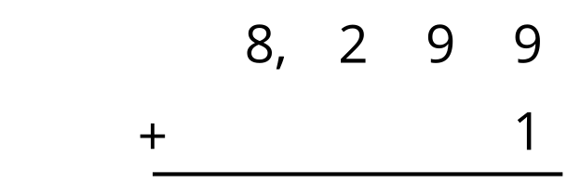
- b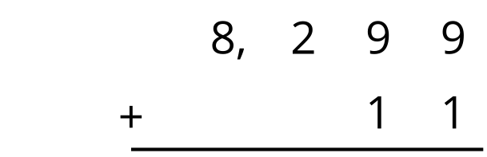
- c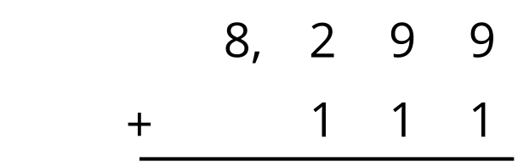
- d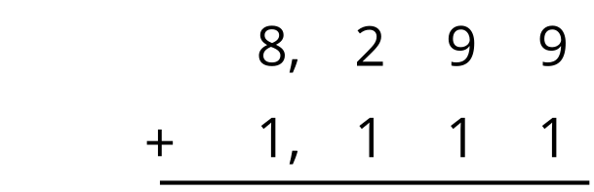
- Use the expanded form of both 8,299 and 1,111 to check the value you found for the last sum.
- Each computation shown has at least one error. Find the errors and show the correct calculation.
- a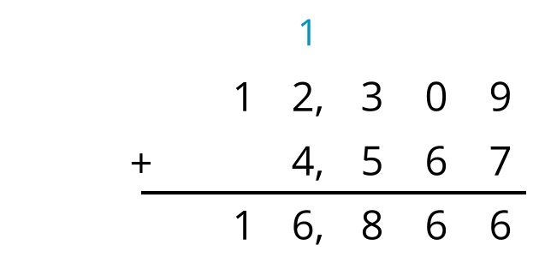
- b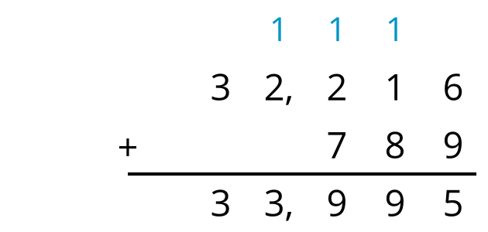
- c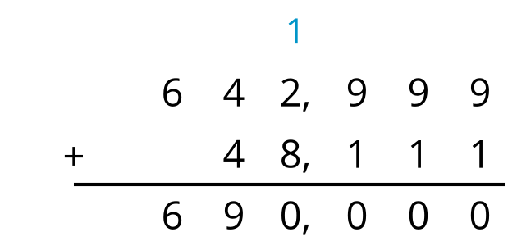
- d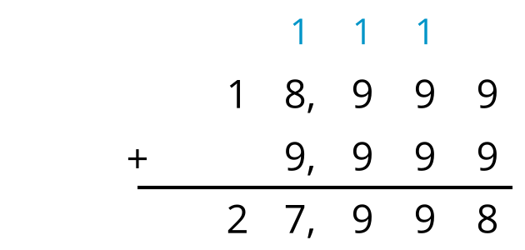

2 Priya’s Family Heirlooms

Student Task Statement
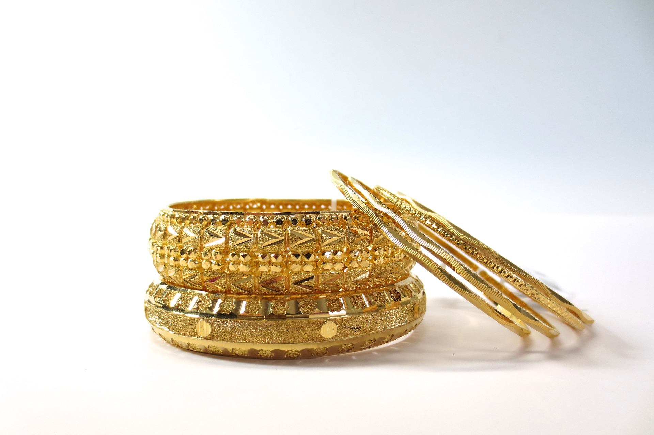
Priya’s mom wore an heirloom bracelet at her wedding in 1996. The bracelet was made in 1947.
Priya subtracted to find out how old the bracelet was when her parents were married.
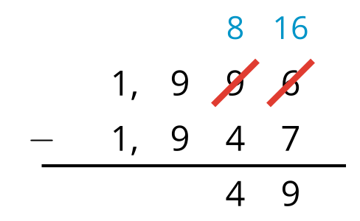
Priya learned that her grandmother had also worn the bracelet at her wedding 24 years earlier.
Priya subtracted to find out when her grandparents were married.​​​​​
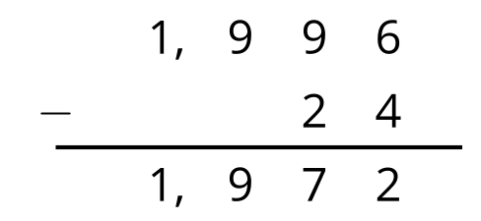
- Are both calculations correct? Why does one calculation have some numbers crossed out and some new numbers, but the other one does not? Explain your reasoning.
- Priya’s grandmother wore an heirloom necklace and earring set that was 63 years old when she was married in 1972.
  - If Priya uses the standard algorithm to subtract $1972−63$ will she need to decompose a unit? Explain your reasoning.
  - Use the standard algorithm to subtract $1972−63$ and find the year the necklace was made.
- Create a subtraction problem that would not require decomposing a unit to subtract. Then solve the problem.
- 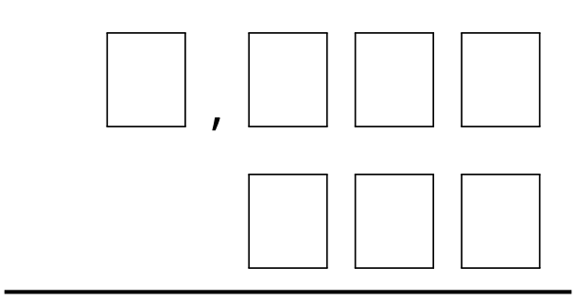

Images for Activity Synthesis
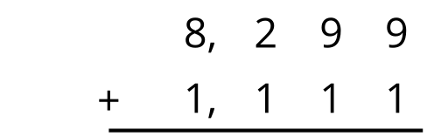
© CC BY 2021 Illustrative Mathematics®

