Unit 6 Lesson 3: Reasoning about Equations with Tape Diagrams

1 Find Equivalent Expressions (Warm up)

Student Task Statement
Select all the expressions that are equivalent to $7\left(2−3n\right)$. Explain how you know each expression you select is equivalent.
- $9−10n$
- $14−3n$
- $14−21n$
- $\left(2−3n\right)⋅7$
- $7⋅2⋅\left(\text{-}3n\right)$

2 Matching Equations to Tape Diagrams

Student Task Statement
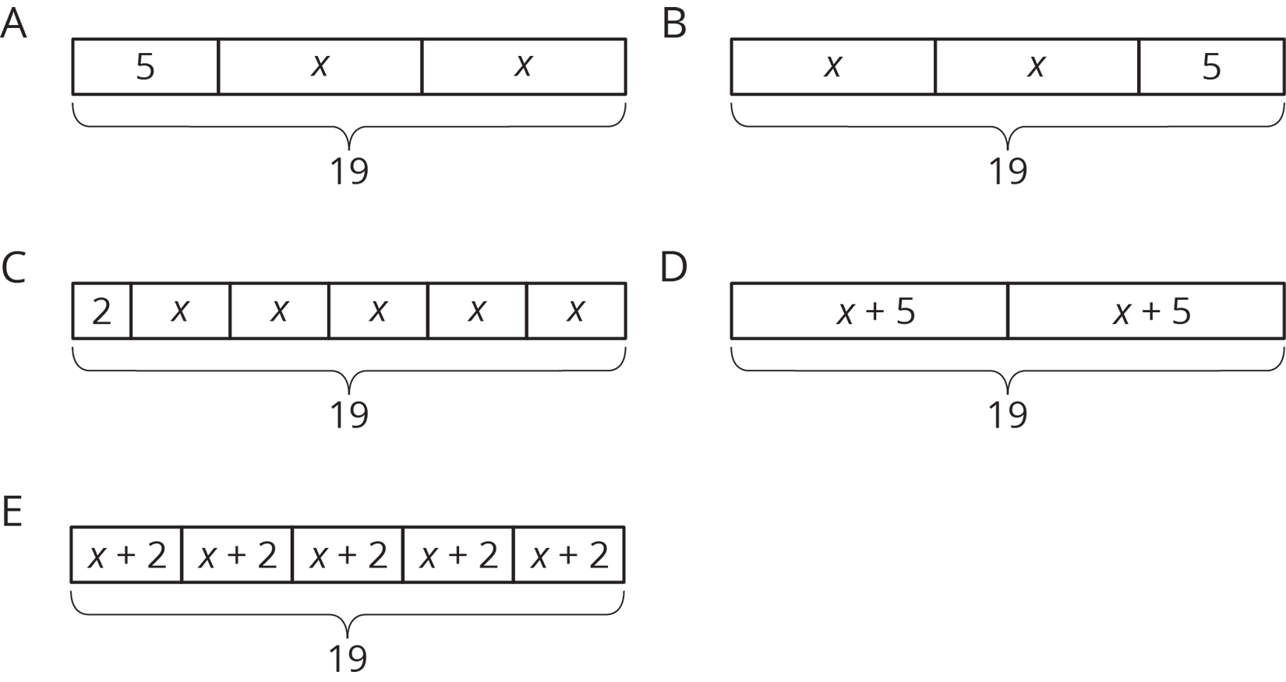

- Match each equation to one of the tape diagrams. Be prepared to explain how the equation matches the diagram.
- Sort the equations into categories of your choosing. Explain the criteria for each category.
- $2x+5=19$
- $2+5x=19$
- $2\left(x+5\right)=19$
- $5\left(x+2\right)=19$
- $19=5+2x$
- $\left(x+5\right)⋅2=19$
- $19=\left(x+2\right)⋅5$
- $19÷2=x+5$
- $19−2=5x$

3 Drawing Tape Diagrams to Represent Equations

Student Task Statement
- $114=3x+18$
- $114=3\left(y+18\right)$
- Draw a tape diagram to match each equation.
- Use any method to find values for $x$ and $y$ that make the equations true.
© CC BY Open Up Resources. Adaptations CC BY IM.

