Lesson 9: Applying Area of Circles
Let’s find the areas of shapes made up of circles.

9.1: Still Irrigating the Field
The area of this field is about 500,000 m². What is the field’s area to the nearest square meter? Assume that the side lengths of the square are exactly 800 m.
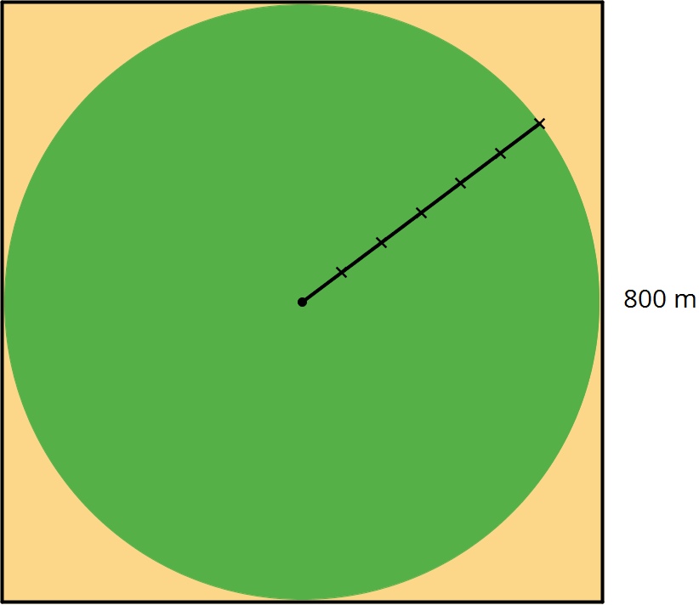
- 502,400 m²
- 502,640 m²
- 502,655 m²
- 502,656 m²
- 502,857 m²

9.2: Comparing Areas Made of Circles
- Each square has a side length of 12 units. Compare the areas of the shaded regions in the 3 figures. Which figure has the largest shaded region? Explain or show your reasoning.
- 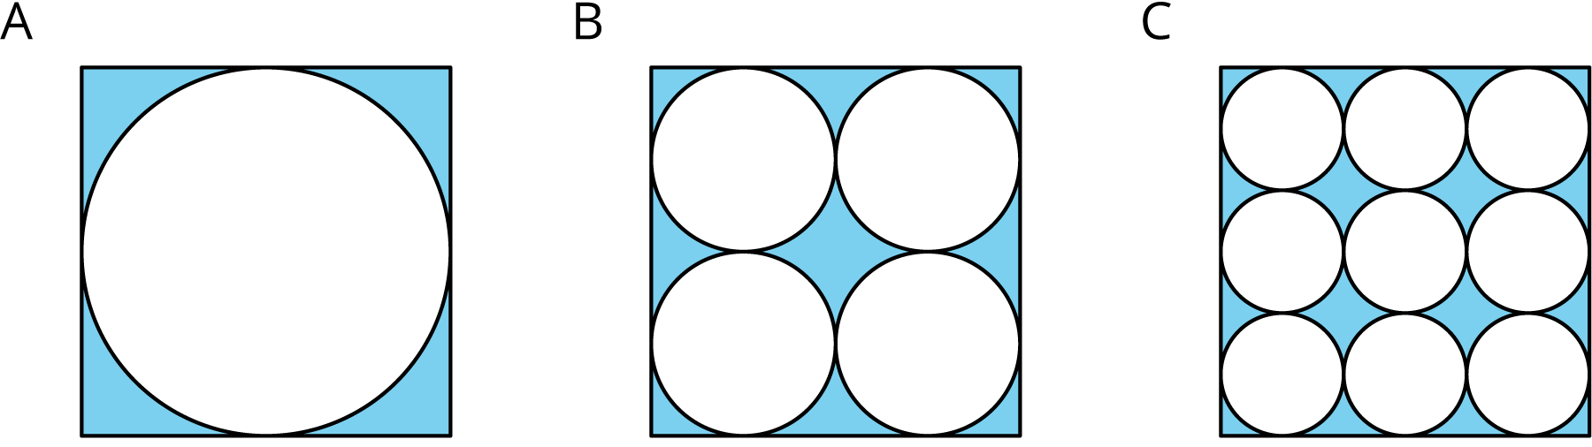
- Each square in Figures D and E has a side length of 1 unit. Compare the area of the two figures. Which figure has more area? How much more? Explain or show your reasoning.
- 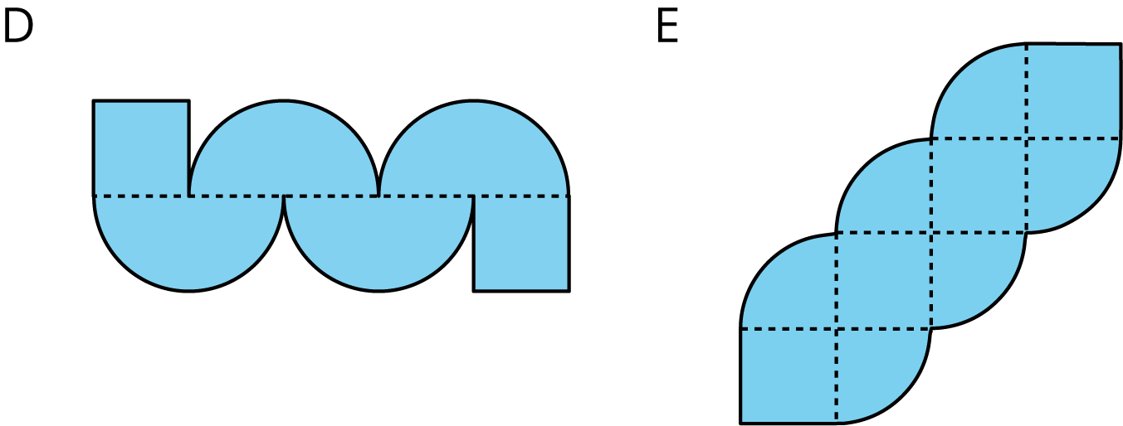

Are you ready for more?
Which figure has a longer perimeter, Figure D or Figure E? How much longer?

9.3: The Running Track Revisited
The field inside a running track is made up of a rectangle 84.39 m long and 73 m wide, together with a half-circle at each end. The running lanes are 9.76 m wide all the way around.
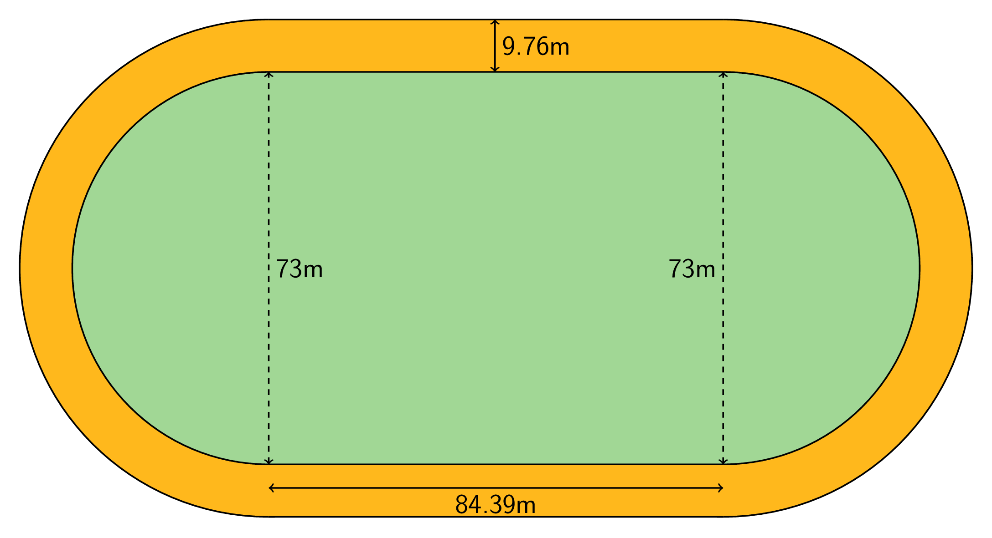
What is the area of the running track that goes around the field? Explain or show your reasoning.

Lesson 9 Summary
The relationship between $A$, the area of a circle, and $r$, its radius, is $A=πr^{2}$. We can use this to find the area of a circle if we know the radius. For example, if a circle has a radius of 10 cm, then the area is $π⋅{10}^{2}$ or $100π$ cm². We can also use the formula to find the radius of a circle if we know the area. For example, if a circle has an area of $49π$ m² then its radius is 7 m and its diameter is 14 m.
Sometimes instead of leaving $π$ in expressions for the area, a numerical approximation can be helpful. For the examples above, a circle of radius 10 cm has area about 314 cm². In a similar way, a circle with area 154 m² has radius about 7 m.
We can also figure out the area of a fraction of a circle. For example, the figure shows a circle divided into 3 pieces of equal area. The shaded part has an area of $\frac{1}{3}πr^{2}$.
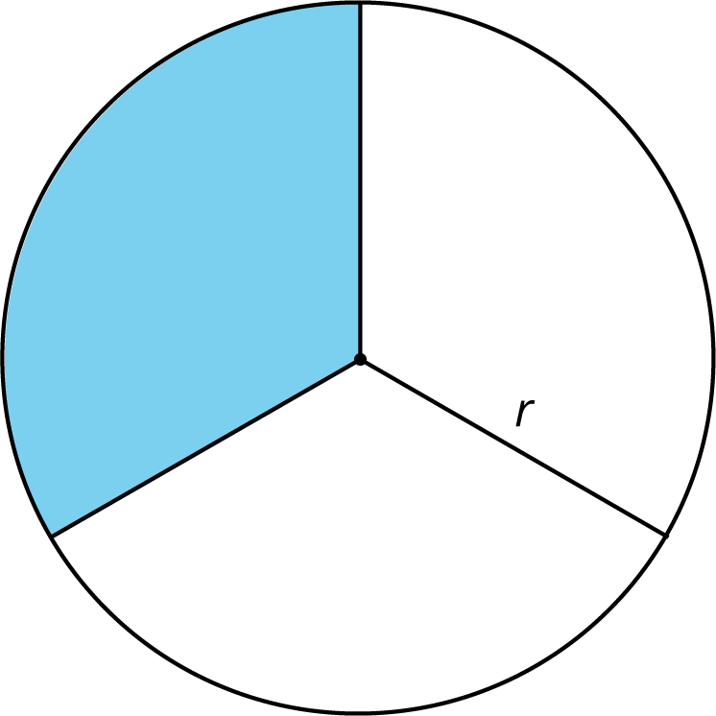
© CC BY Open Up Resources. Adaptations CC BY IM.

