Unit 4 Lesson 6: Division as an Unknown Factor

Notice and Wonder: Missing Numbers (Warm up)

Student Task Statement
What do you notice? What do you wonder?
$3×?=12$
$12÷3=?$

1 Equations about Onions

Student Task Statement
A farmer puts 14 onions into 2 bags, with the same number of onions in each bag.
Lin says the situation should be represented by the equation:
2×3=14
Mai says the situation should be represented by the equation:
14÷2=3
Whose equation do you agree with? Be ready to explain your reasoning.

2 At the Farmers' Market

Student Task Statement
Complete each row. Be prepared to explain your reasoning.
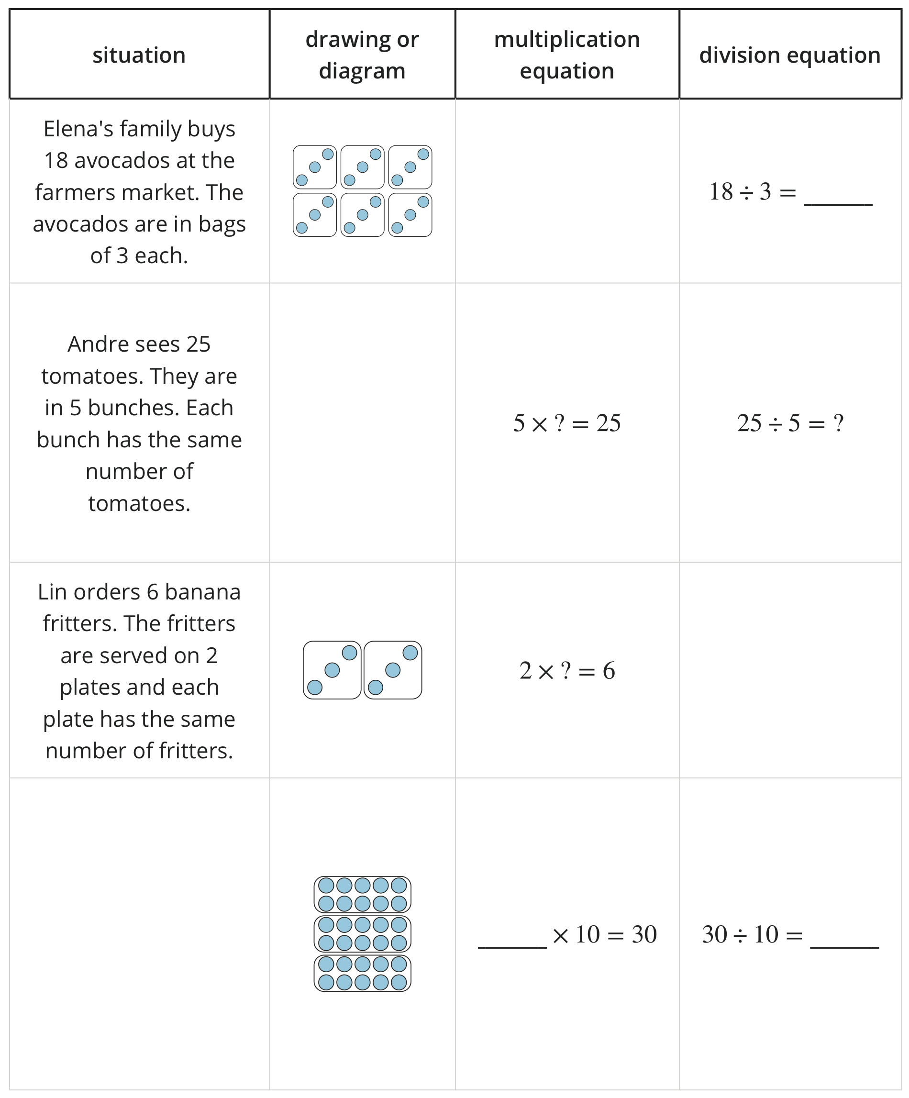
© CC BY 2021 Illustrative Mathematics®

