Lesson 7 Practice Problems
- A lemonade recipe calls for $\frac{1}{4}$ cup of lemon juice for every cup of water.
  - Use the table to answer these questions.
    - What does $x$ represent?
    - What does $y$ represent?
    - Is there a proportional relationship between $x$ and $y$?
  - Plot the pairs in the table in a coordinate plane.
- $x$ | - $y$
- 1 | - $\frac{1}{4}$
- 2 | - $\frac{1}{2}$
- 3 | - $\frac{3}{4}$
- 4 | - 1
- There is a proportional relationship between the number of months a person has had a streaming movie subscription and the total amount of money they have paid for the subscription. The cost for 6 months is $47.94. The point $(6,47.94)$ is shown on the graph below.
- 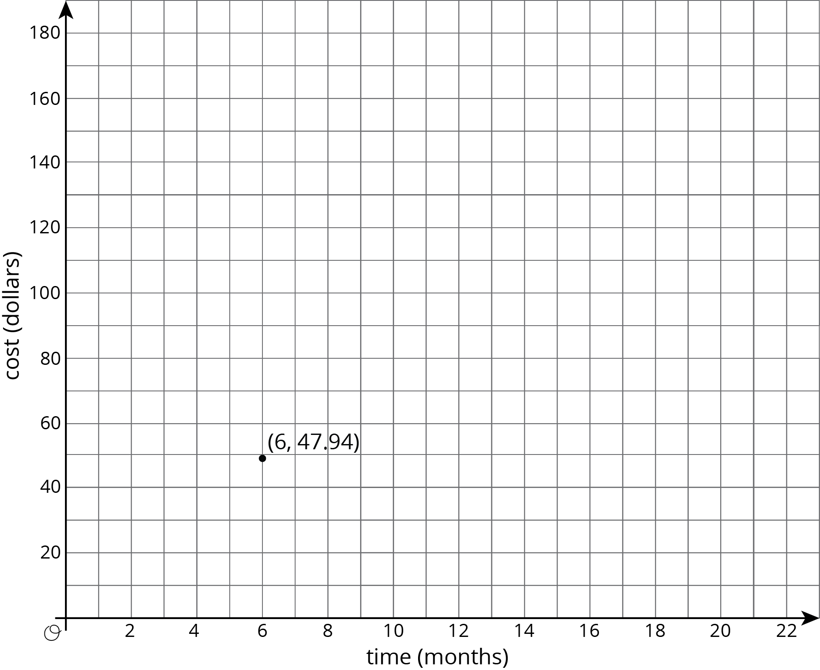
  - What is the constant of proportionality in this relationship?
  - What does the constant of proportionality tell us about the situation?
  - Add at least three more points to the graph and label them with their coordinates.
  - Write an equation that represents the relationship between $C$, the total cost of the subscription, and $m$, the number of months.
- The graph shows the amounts of almonds, in grams, for different amounts of oats, in cups, in a granola mix. Label the point $(1,k)$ on the graph, find the value of $k$, and explain its meaning.
- 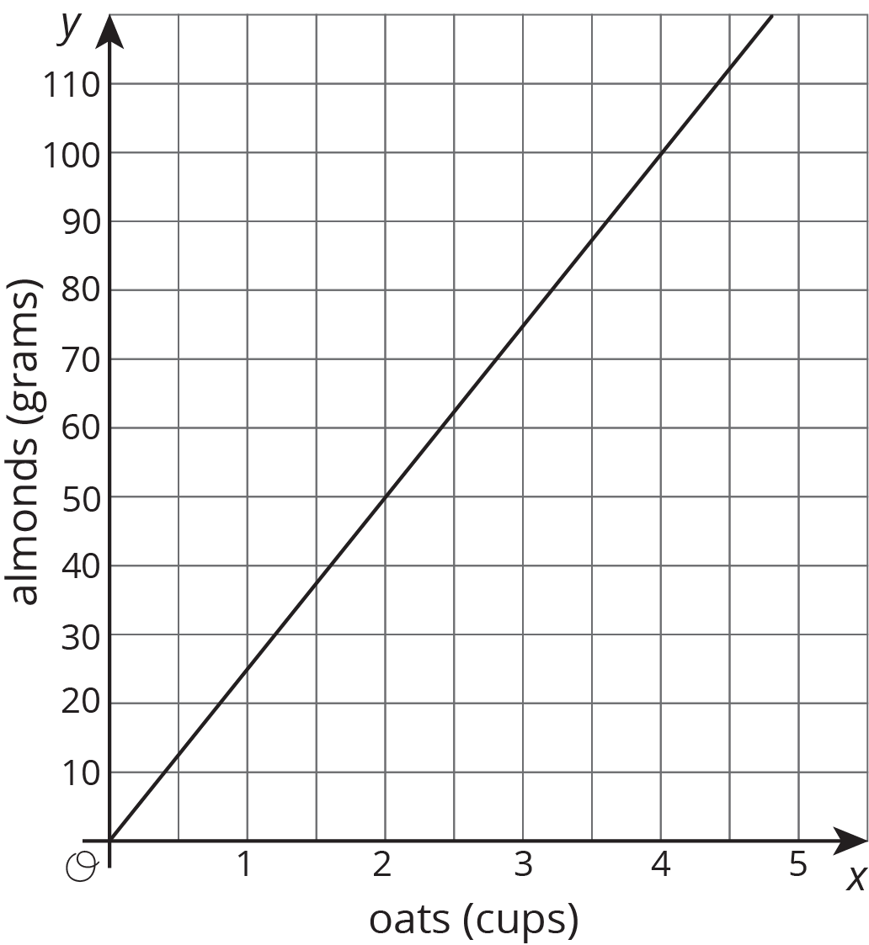

- Select all the pieces of information that would tell you $x$ and $y$ have a proportional relationship. Let $y$ represent the distance in meters between a rock and a turtle's current position and $x$ represent the time in minutes the turtle has been moving.
  - $y=3x$
  - After 4 minutes, the turtle has walked 12 feet away from the rock.
  - The turtle walks for a bit, then stops for a minute before walking again.
  - The turtle walks away from the rock at a constant rate.
- (From Unit 5, Lesson 6.)
- What information do you need to know to write an equation relating two quantities that have a proportional relationship?
- (From Unit 5, Lesson 6.)
© CC BY Open Up Resources. Adaptations CC BY IM.

