Unit 2 Lesson 3: Congruent Triangles, Part 1

1 True or . . . Sometimes True?: Triangles (Warm up)

Images for Launch

Student Task Statement
If triangle $ABC$ is congruent to triangle $A^{′}B^{′}C^{′}$. . .
- What must be true?
- What could possibly be true?
- What definitely can’t be true?

2 Invisible Triangles

Images for Launch
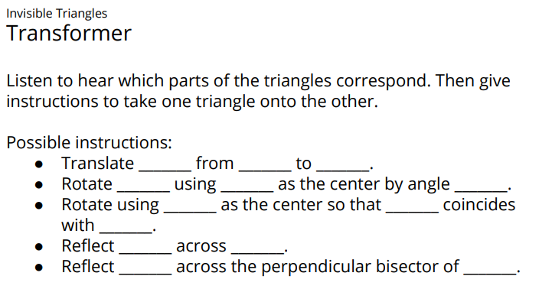

Student Task Statement
Player 1: You are the transformer. Take the transformer card.
Player 2: Select a triangle card. Do not show it to anyone. Study the diagram to figure out which sides and which angles correspond. Tell Player 1 what you have figured out.
Player 1: Take notes about what they tell you so that you know which parts of their triangles correspond. Think of a sequence of rigid motions you could tell your partner to get them to take one of their triangles onto the other. Be specific in your language. The notes on your card can help with this.
Player 2: Listen to the instructions from the transformer. Use tracing paper to follow their instructions. Draw the image after each step. Let them know when they have lined up 1, 2, or all 3 vertices on your triangles.

Activity Synthesis

$\overline{AB}≅\overline{DE},\overline{AC}≅\overline{DF},\overline{BC}≅\overline{EF},∠A≅∠D,∠B≅∠E,∠C≅∠F$

3 Why Do They Coincide?

Student Task Statement
Noah and Priya were playing Invisible Triangles. For card 3, Priya told Noah that in triangles $ABC$ and $DEF$:
- $\overline{AB}≅\overline{DE}$
- $\overline{AC}≅\overline{DF}$
- $\overline{BC}≅\overline{EF}$
- $∠A≅∠D$
- $∠B≅∠E$
- $∠C≅∠F$
Here are the steps Noah had to tell Priya to do before all 3 vertices coincided:
- Translate triangle $ABC$ by the directed line segment from $A$ to $D$.
- Rotate the image, triangle $A^{′}B^{′}C^{′}$, using $D$ as the center, so that rays $A^{″}B^{″}$ and $DE$ line up.
- Reflect the image, triangle $A^{″}B^{″}C^{″}$, across line $DE$.
After those steps, the triangles were lined up perfectly. Now Noah and Priya are working on explaining why their steps worked, and they need some help. Answer their questions.
First, we translate triangle $ABC$ by the directed line segment from $A$ to $D$. Point $A^{′}$ will coincide with $D$ because we defined our transformation that way. Then, rotate the image, triangle $A^{′}B^{′}C^{′}$, by the angle $B^{′}DE$, so that rays $A^{″}B^{″}$ and $DE$ line up.
- We know that rays $A^{″}B^{″}$ and $DE$ line up because we said they had to, but why do points $B^{″}$ and $E$ have to be in the exact same place?
- Finally, reflect the image, triangle $A^{″}B^{″}C^{″}$ across $DE$.
  - How do we know that now, the image of ray $A^{″}C^{″}$ and ray $DF$ will line up?
  - How do we know that the image of point $C^{″}$ and point $F$ will line up exactly?

Images for Activity Synthesis

$\overline{AB}≅\overline{DE},\overline{BC}≅\overline{EF},\overline{AC}≅\overline{DF},$ $∠A≅∠D,∠B≅∠E,∠C≅∠F$ so $△ABC≅△DEF$
© CC BY 2019 by Illustrative Mathematics®

