Lesson 5: Trapecios

Standards Alignments
Addressing | 5.G.B.4
Building Towards | 5.G.B.3

Teacher-facing Learning Goals
- Compare different definitions for trapezoids, and use them to identify trapezoids.

Student-facing Learning Goals
- Exploremos trapecios.

Lesson Purpose
The purpose of this lesson is for students to explore two different definitions of trapezoid.
The purpose of this lesson is for students to explore trapezoids and agree on a definition of trapezoids for this course. In the first activity, students see two different definitions for a trapezoid both of which are commonly used, one that excludes parallelograms and one that includes parallelograms. The exclusive definition of a trapezoid states that a trapezoid has exactly one pair of opposite sides that are parallel. The inclusive definition states that a trapezoid has at least one pair of opposite sides that are parallel. In the second activity, students recognize that we have chosen to use the inclusive definition of a trapezoid. Students should have access to straight edges, protractors, and patty paper throughout this lesson.

Access for:

Students with Disabilities
- Engagement (Activity 2)

English Learners
- MLR8 (Activity 2)

Instructional Routines
What Do You Know About _____? (Warm-up)

Lesson Timeline
Warm-up | 10 min
Activity 1 | 20 min
Activity 2 | 15 min
Lesson Synthesis | 10 min
Cool-down | 5 min

Teacher Reflection Question
Did students notice the difference in the definitions of the trapezoid? How did they explain that difference in terms of the hierarchy on the anchor chart?

Cool-down
(to be completed at the end of the lesson) 5min
¿Cuáles son trapecios?

Standards Alignments
Addressing | 5.G.B.4

Student-facing Task Statement
- ¿Qué debe cumplir un cuadrilátero para ser un trapecio?
- ¿Cuáles de las siguientes figuras son trapecios? Muestra o explica cómo razonaste.
- 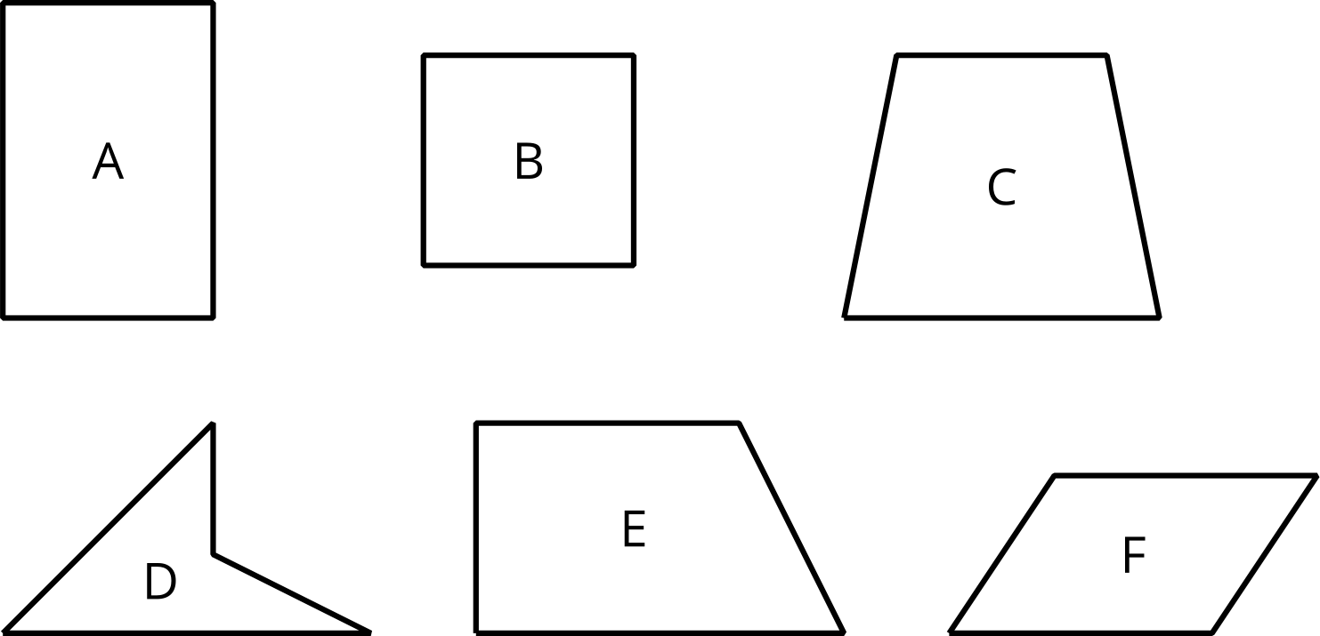

Student Responses
- A quadrilateral is a trapezoid if it has at least one pair of opposite sides that are parallel.
- All of the shapes except D are trapezoids because they have at least one pair of opposite sides that are parallel.

