Unit 7 Lesson 9: Part to Whole

1 What’s Your Angle? (Warm up)

Student Task Statement
A circle has radius 10 centimeters. Suppose an arc on the circle has length $π$ centimeters. What is the measure of the central angle whose radii define the arc?

2 Enough Information?

Student Task Statement
The central angle of this shaded sector measures 45 degrees, and the sector’s area is $32π$ square inches.
Kiran says, “We can find the area of the whole circle, the arc length of the sector, and the circumference of the circle with this information.”
Priya says, “But how? We don’t know the circle’s radius!”
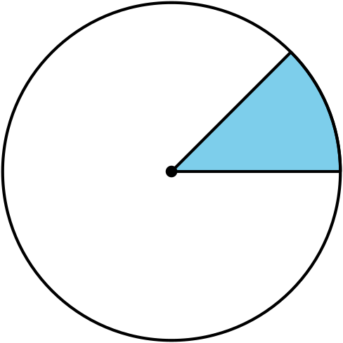
Do you agree with either of them? Explain or show your reasoning. Calculate as many of the values Kiran mentioned as possible.

3 Info Gap: From Sector to Circle

Student Task Statement
Your teacher will give you either a problem card or a data card. Do not show or read your card to your partner.
If your teacher gives you the data card:
- Silently read the information on your card.
- Ask your partner, “What specific information do you need?” and wait for your partner to ask for information. Only give information that is on your card. (Do not figure out anything for your partner!)
- Before telling your partner the information, ask, “Why do you need to know (that piece of information)?”
- Read the problem card, and solve the problem independently.
- Share the data card, and discuss your reasoning.
If your teacher gives you the problem card:
- Silently read your card and think about what information you need to answer the question.
- Ask your partner for the specific information that you need.
- Explain to your partner how you are using the information to solve the problem.
- When you have enough information, share the problem card with your partner, and solve the problem independently.
- Read the data card, and discuss your reasoning.
Pause here so your teacher can review your work. Ask your teacher for a new set of cards and repeat the activity, trading roles with your partner.
© CC BY 2019 by Illustrative Mathematics®

