Lesson 10 Practice Problems
- What percentage of a dollar is the value of each coin combination?
  - 4 dimes
  - 1 nickel and 3 pennies
  - 5 quarters and 1 dime

  - List three different combinations of coins, each with a value of 30% of a dollar.
  - List two different combinations of coins, each with a value of 140% of a dollar.
- The United States government used to make coins of many different values. For each coin, state its worth as a percentage of $1.
- 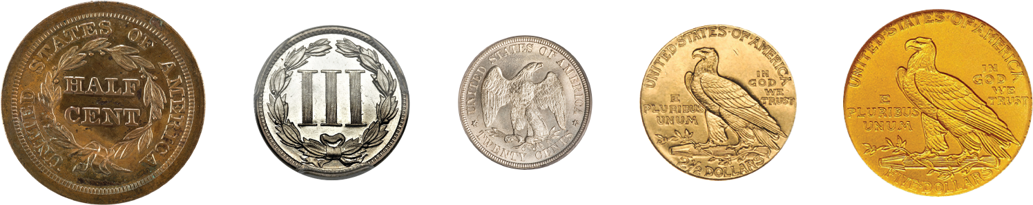
- $\frac{1}{2}$ cent
- 3 cents
- 20 cents
- $$2\frac{1}{2}$
- $5
- Complete the double number to line show percentages of $50.
- 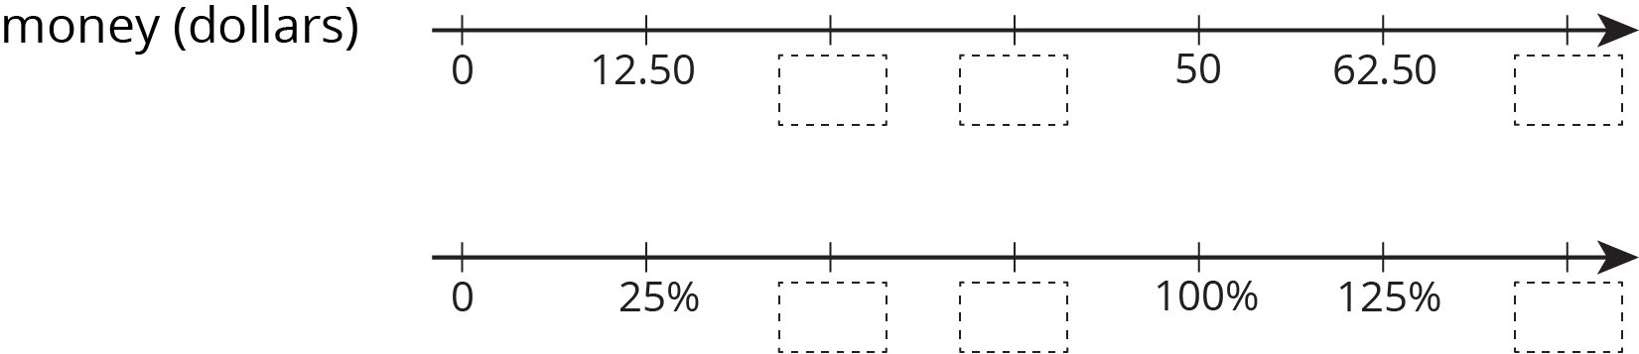
- Elena bought 8 tokens for $4.40. At this rate:
  - How many tokens could she buy with $6.05?
  - How much do 19 tokens cost?
- (From Unit 3, Lesson 9.)
- A snail travels 10 cm in 4 minutes. At this rate:
  - How long will it take the snail to travel 24 cm?
  - How far does the snail travel in 6 minutes?
- (From Unit 3, Lesson 8.)

  - 3 tacos cost $18. Complete the table to show the cost of 4, 5, and 6 tacos at the same rate.
- number of tacos | - cost in dollars | - rate in dollars per taco
- 3 | - 18
  - 4
  - 5
  - 6
  - If you buy $t$ tacos for $c$ dollars, what is the unit rate?
- (From Unit 3, Lesson 7.)
© CC BY Open Up Resources. Adaptations CC BY IM.

