Lesson 5: Center Day 1
- Let’s add and subtract.

Warm-up: Which One Doesn’t Belong: Tens
Which one doesn’t belong?
A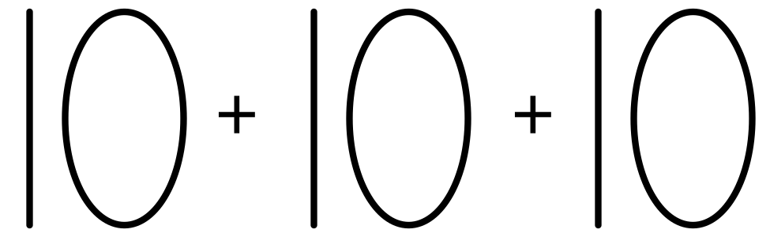
B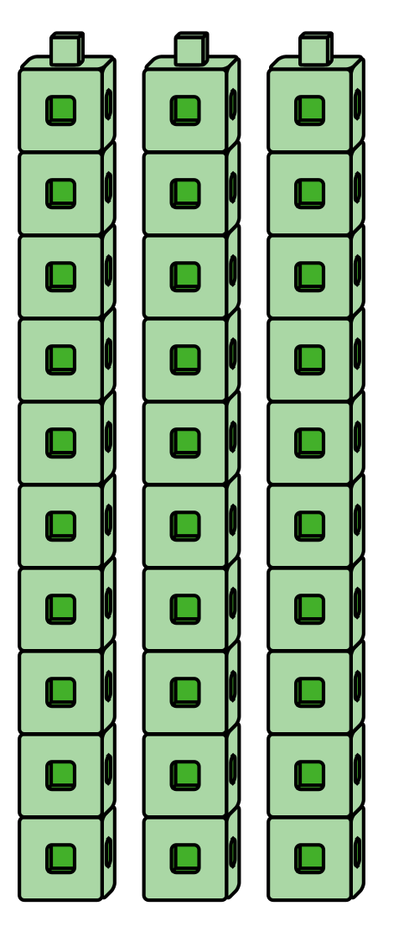
C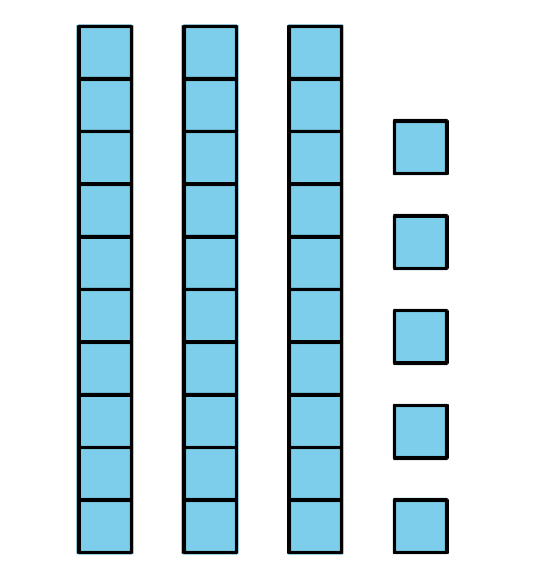
D

5.2: Centers: Choice Time
Choose a center.
Five in a Row
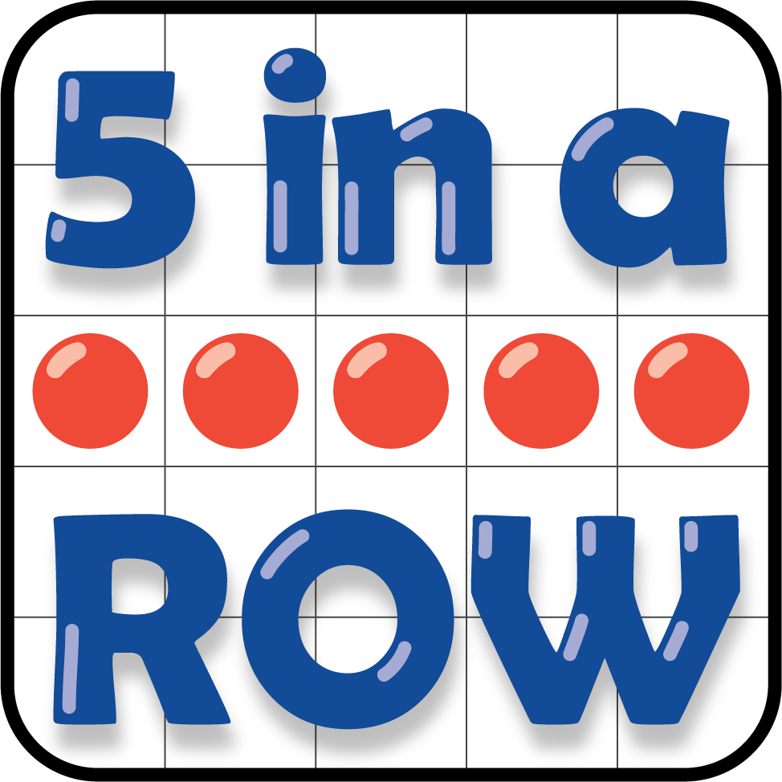
How Close?
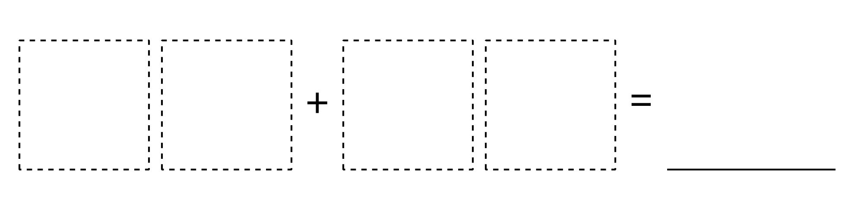
Number Puzzles
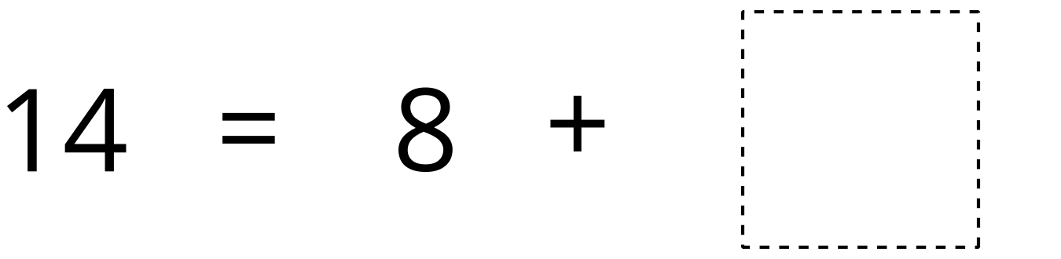
© CC BY 2021 Illustrative Mathematics®

