Lesson 9: Explain Equivalence
- Let’s talk about how we know whether two fractions are equivalent.

Warm-up: Number Talk: Familiar Numbers
Find the value of each expression mentally.
- $10×6$
- $10×12$
- $10×24$
- $5×24$

9.1: Pointed Discussion
Andre, Lin, and Clare are representing $\frac{70}{100}$ on a number line.
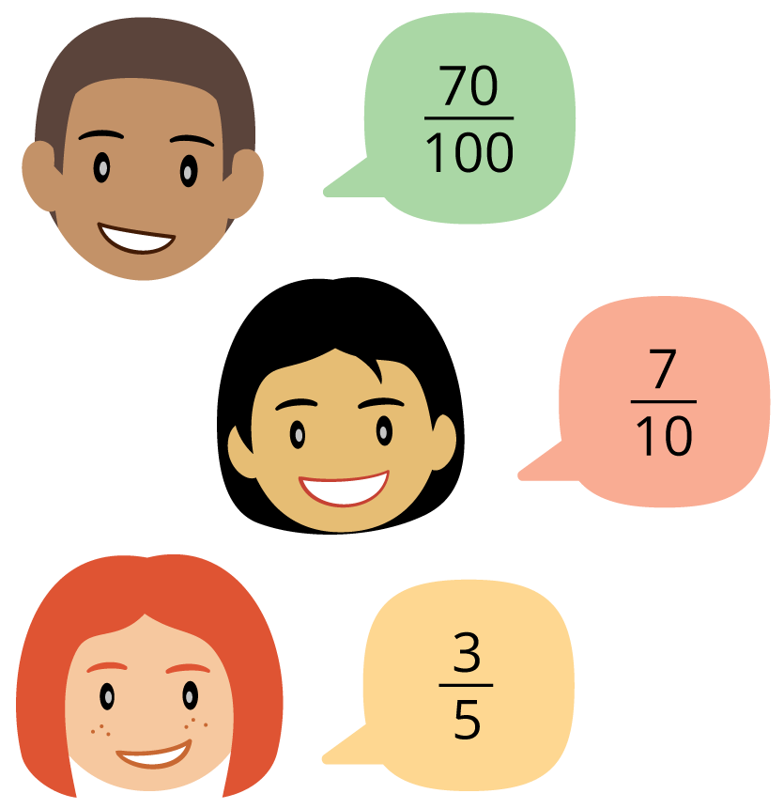
- Andre said, “Oh, no! We’ll need to partition the line into 100 equal parts and count 70 parts just to mark one point!”
- Lin said, “What if we mark $\frac{7}{10}$ instead? We could partition the line into just 10 parts and count 7 parts.”
- Clare said, “What if we partition the line into 5 parts and mark $\frac{3}{5}$?”
Do you agree with any of them? Explain or show your reasoning.

9.2: How Do You Know?
Around the room you will find six posters, each showing either two or three fractions.
With your group, visit at least two posters: one with two fractions and one with three fractions.
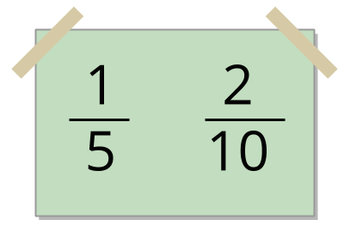
For the set of 2 fractions:
- Explain or show how you know the fractions are equivalent.
- Write a new equivalent fraction on a sticky note and add it to the poster. Think of a fraction that hasn’t already been written by someone else.
- We visited poster __________, which shows __________ and __________.
- New equivalent fraction: __________
For the set of 3 fractions:
- Identify 2 fractions that are equivalent. Explain your reasoning.
- We visited poster __________, which shows __________, __________, and __________.
© CC BY 2021 Illustrative Mathematics®

